DEMOCRATIC ORGANIZATIONS – eTwinning project - YOURIGHTS

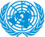
The United Nations is an international organization founded in 1945. It is currently made up of 193 Member States. The mission and work of the United Nations are guided by the purposes and principles contained in its founding Charter. The United Nations can take action on the issues confronting humanity in the 21st century, such as peace and security, climate change, sustainable development, human rights, disarmament, terrorism, humanitarian and health emergencies, gender equality, governance, food production, and more. There are six official languages of the UN. These are Arabic, Chinese, English, French, Russian and Spanish. United Nations Headquarters are in New York City, USA. The present president of the United Nations General Assembly is María Fernanda Espinosa Garcés of Ecuador.
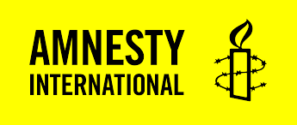
Amnesty International is a global movement of more than 7 million people in over 150 countries and territories who campaign to end abuses of human rights. It has its headquarters in London, England. In 1961, a global movement for human rights begins. British lawyer Peter Benenson launches the ‘Appeal for Amnesty’ in the Observer newspaper, after two Portuguese students are jailed for raising a toast to freedom. This was the year and this was the man who gave birth to an extraordinary movement, and to an extraordinary social change.
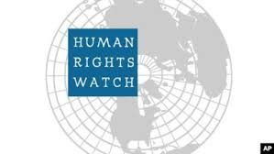
Human Rights Watch was founded in 1978 as “Helsinki Watch,” when we began investigating rights abuses in countries that signed the Helsinki Accords, most notably those behind the Iron Curtain. The headquarters of the organization are in New York, USA. Human Rights Watch investigates and reports on abuses happening in all corners of the world. There are roughly 450 people of 70-plus nationalities who are country experts, lawyers, journalists, and others who work to protect the most risk, from vulnerable minorities and civilians in wartime, to refugees and children in need. The executive president of Human Rights Watch organization is Kenneth Roth.
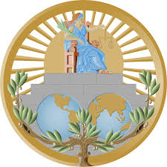
The International Court of Justice (ICJ) is the principal judicial organ of the United Nations (UN). It was established in June 1945 by the Charter of the United Nations and began work in April 1946. The seat of the Court is at the Peace Palace in Hague (Netherlands). Of the six principal organs of the United Nations, it is the only one not located in New York (United States of America). The Court’s role is to settle, in accordance with international law, legal disputes submitted to it by States and to give advisory opinions on legal questions referred to it by authorized United Nations organs and specialized agencies. On 6 February 2018, the Court elected Judge Abdulqawi Ahmed Yusuf (Somalia) as President and Judge Xue Hanqin (China) as Vice-President.
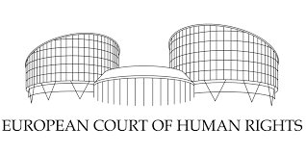
The European Court of Human Rights (ECtHR) is a regional human rights judicial body based in Strasbourg, France, created under the auspices of the Council of Europe. The Court began operating in 1959 and has delivered more than 10,000 judgments regarding alleged violations of the European Convention on Human Rights. The current president of the organization is Guido Raimondi from Italy.
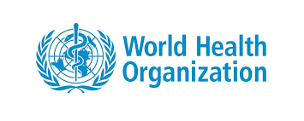
The World Health Organization (WHO) is a specialized agency of the United Nations that is concerned with international public health. It was established on 7 April 1948, and is headquartered in Geneva, Switzerland. World Health Organization was set up after diplomats met to form the United Nations in 1945 and discussed about the necessity of a global health organization. The current Director-General of the WHO is Tedros Adhanom, who started his five-year term on 1 July 2017. Since its establishment, WHO has played a leading role in the eradication of smallpox. Its current priorities include communicable diseases, in particular HIV/AIDS, Ebola, malaria and tuberculosis.

