**How Much Is Earth’s Climate Changing Right Now?**

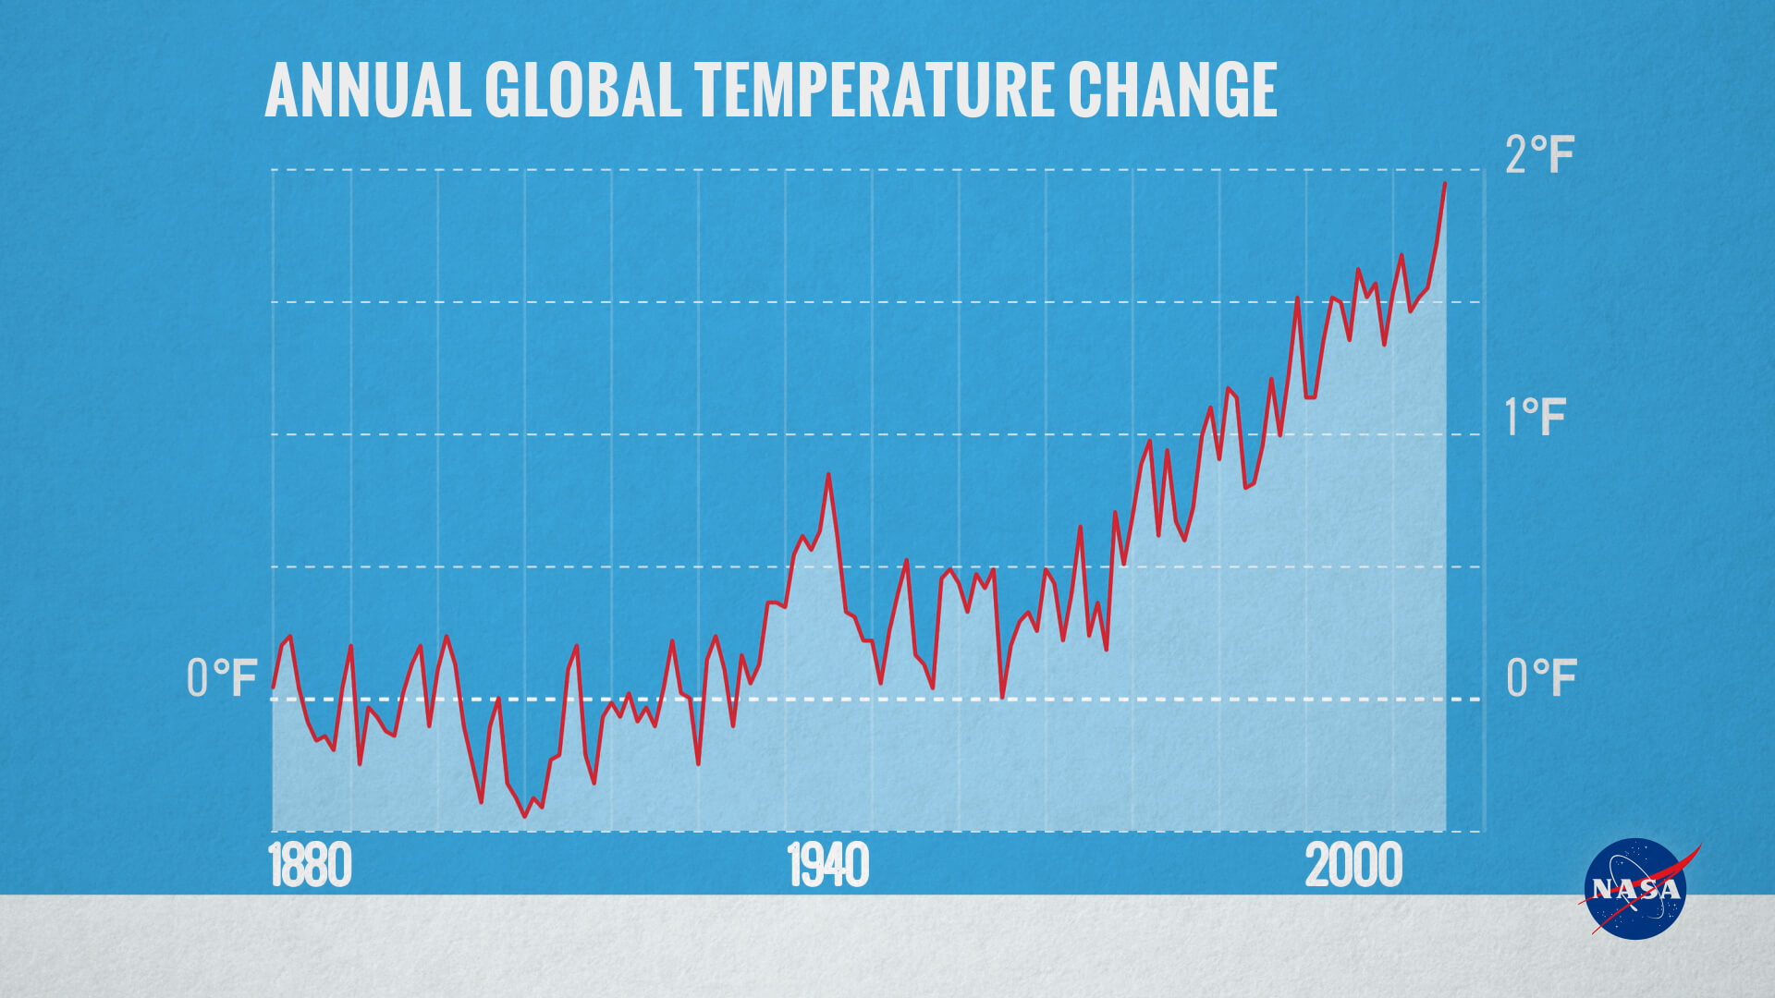

*Graph of change in annual global temperatures, compared to the average of global annual temperatures from 1880-1899. Credit: NASA's Goddard Space Flight Center*

Some parts of Earth are warming faster than others. But on average, global air temperatures near Earth's surface have gone up about 2 degrees Fahrenheit in the past 100 years. In fact, the past five years have been the warmest five years in centuries.

Many people, including scientists, are concerned about this warming. As Earth’s climate continues to warm, the intensity and amount of rainfall during storms such as hurricanes is expected to increase. Droughts and heat waves are also expected to become more intense as the climate warms.

When the whole Earth’s temperature changes by one or two degrees, that change can have big impacts on the health of Earth's plants and animals, too