What Is Climate Change?
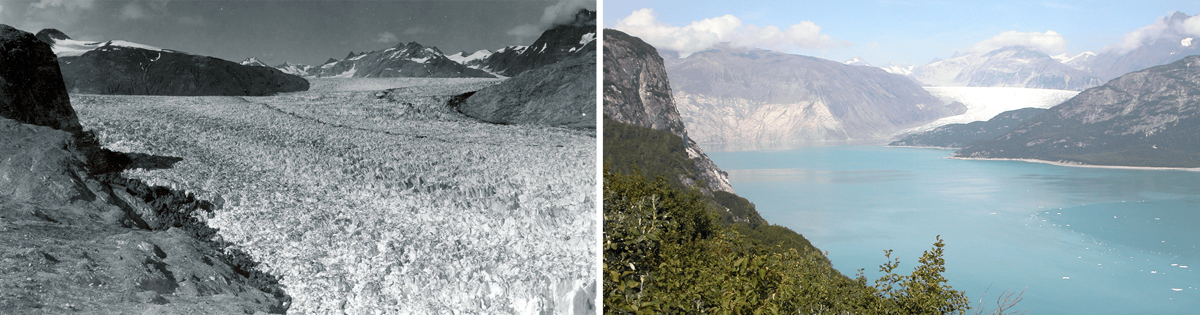
Alaska's Muir glacier in August 1941 and August 2004. Significant changes occurred in the 63 years between these two photos. Credit: USGS
Climate change describes a change in the average conditions — such as temperature and rainfall — in a region over a long period of time. For example, 20,000 years ago, much of the United States was covered in glaciers. In the United States today, we have a warmer climate and fewer glaciers.
Global climate change refers to the average long-term changes over the entire Earth. These include warming temperatures and changes in precipitation, as well as the effects of Earth’s warming, such as:
- Rising sea levels
- Shrinking mountain glaciers
- Ice melting at a faster rate than usual in Greenland, Antarctica and the Arctic
- Changes in flower and plant blooming times.

