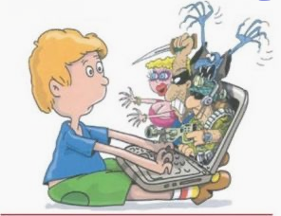

Internet can be dangerous
Benedetta e Giulia
1F - Zippilli

