ANIMAL BIODIVERSITY ON OUR PLANET
CLASSE 1F
ZIPPILLI

SEA ANIMALS:

Mussels  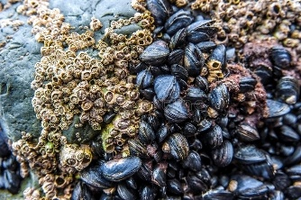 | Cozze
Whale | Balena
Dolphin | Delfino
Seal | Foca 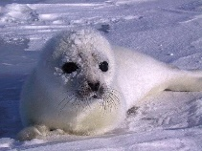
Crab | Granchio
Seagull | Gabbiano
Octopus  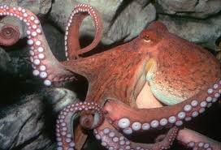 | Polpo
Shark | Squalo
Marine turtle | Tartaruga marina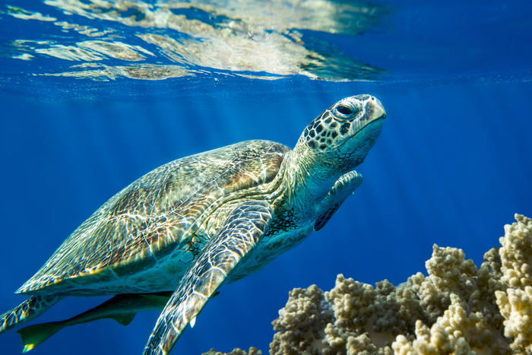

INSECT:

ANIMALE | ENGLISH | ITALIANO
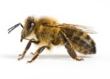 | BEE | APE
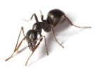 | ANT | FORMICA
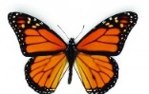 | BUTTERFLY | FARFALLA
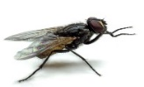 | FLY | MOSCA
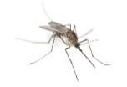 | MOSQUITO | ZANZARA
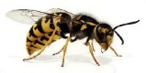 | WASP | VESPA

Woodland animals:
Animali del bosco:
Immagine | Italiano | Inglese
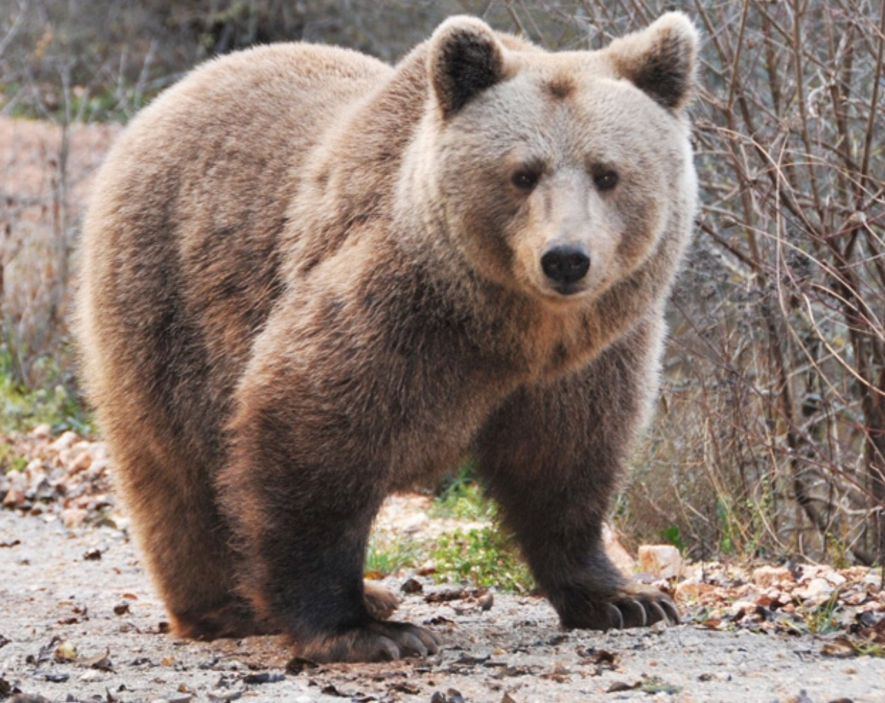 | ORSO | BEARD
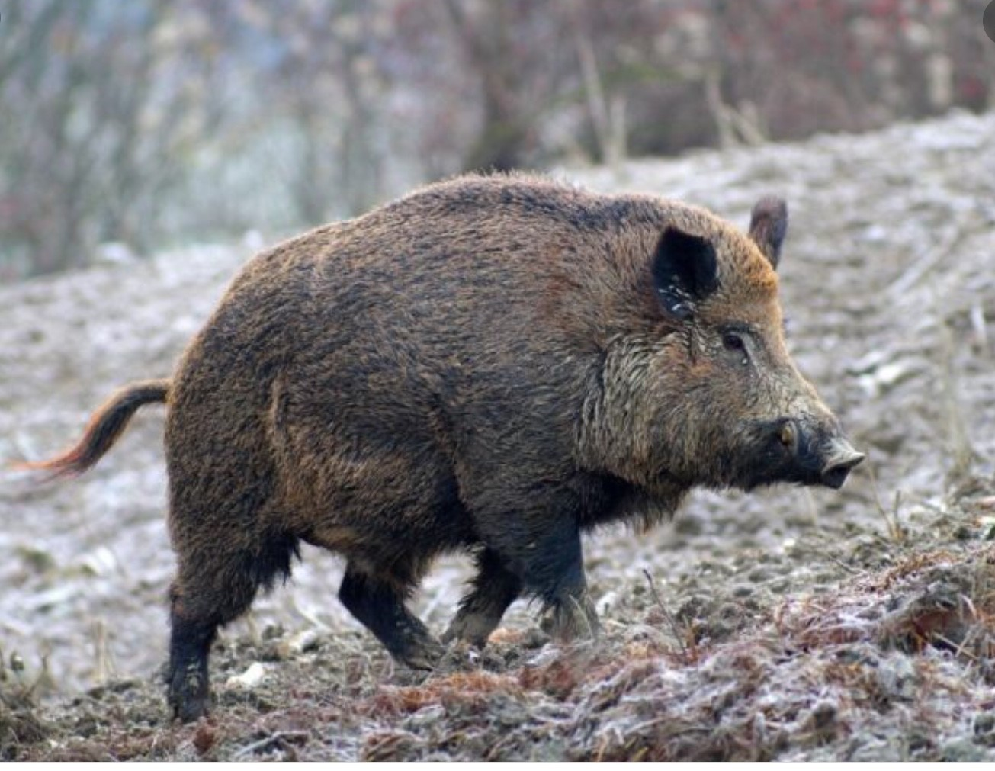 | CINGHIALE | BOAR
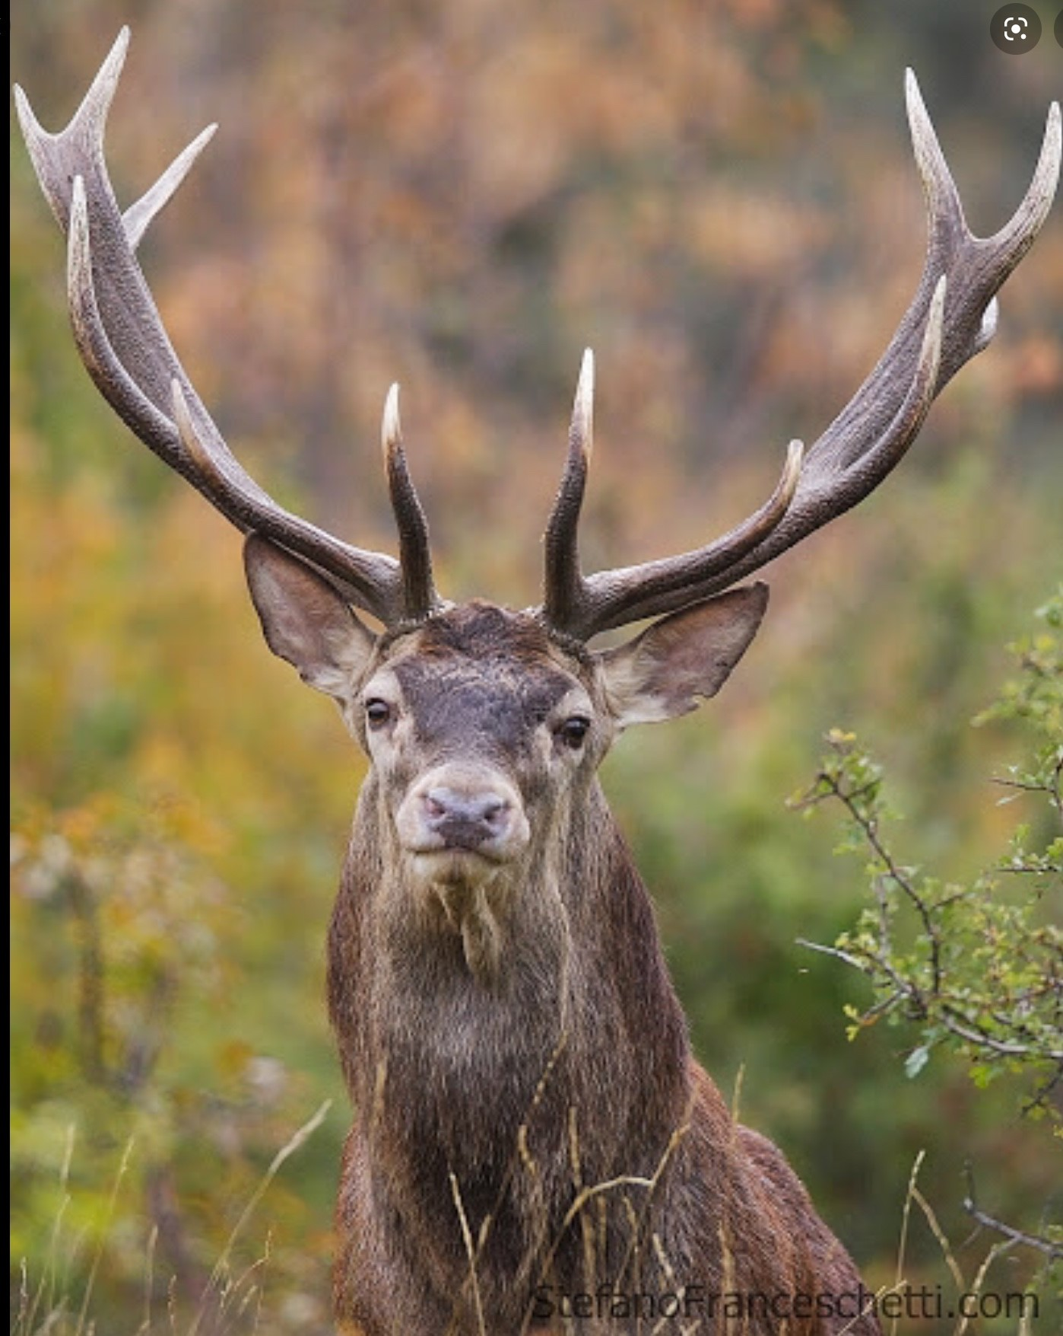 | CERVO | DEER
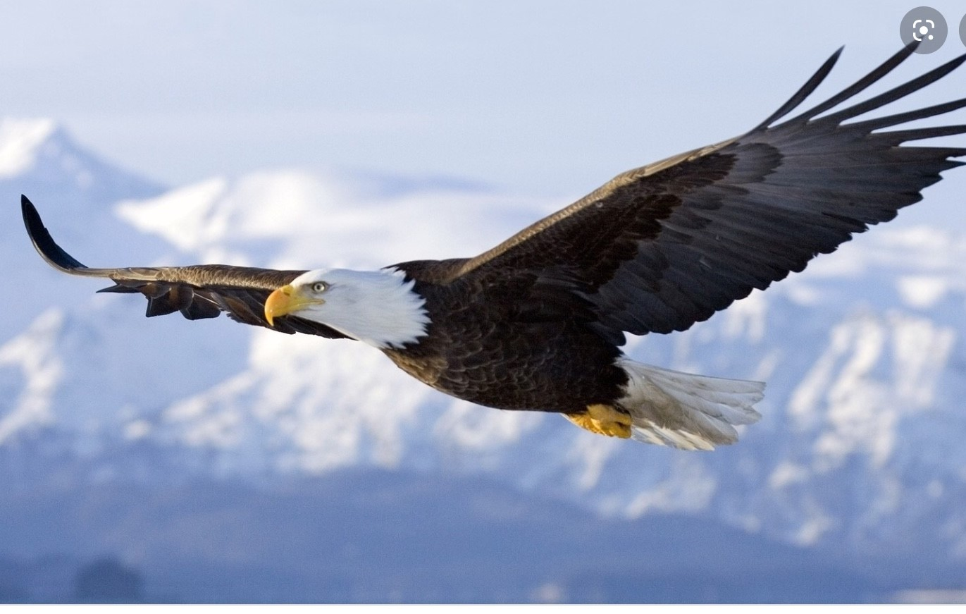 | L’AQUILA | EAGLE

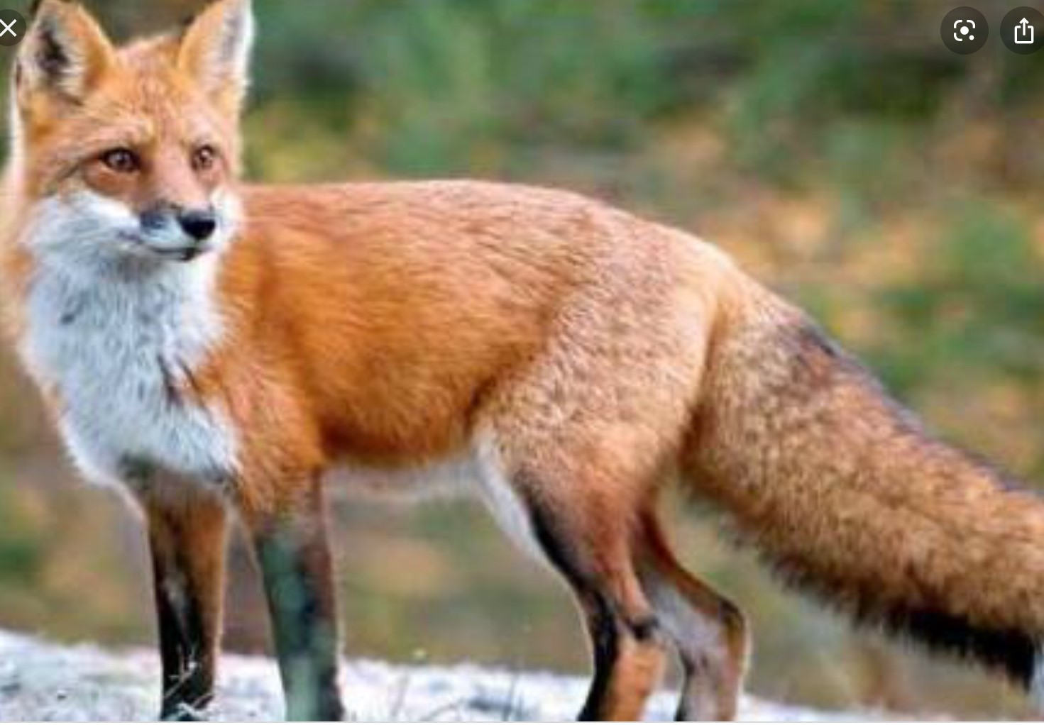 | VOLPE | FOX
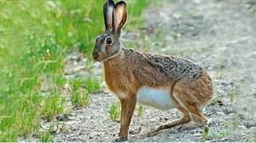 | LEPRE | HARE
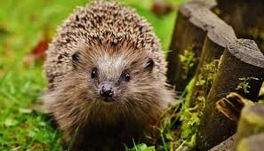 | RICCIO | HEDGEHOG
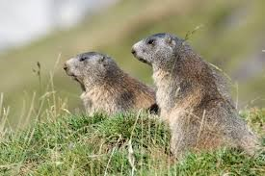 | MARMOTTA | MARMOT
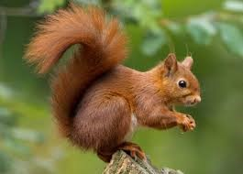 | SCOIATTOLO | SQUIREL
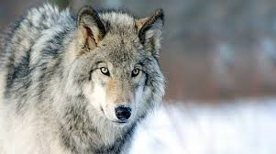 | LUPO | WOLF

WILD ANIMALS
INGLESE ITALIANO
AFRICAN WILD DOG | IENA  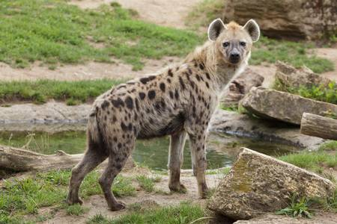
CHEETACH | GHEPARDO
CHIMPAZEE  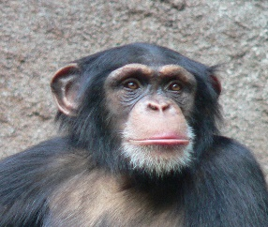 | SCIMPANZE
ELEPHANT | ELEFANTE
GORILLA | GORILLA
JAGUAR | GIAGUARO  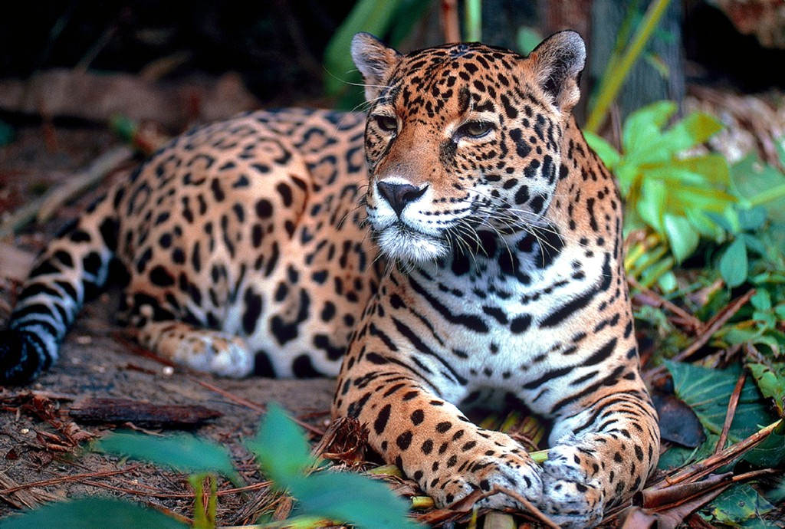
LEOPARD | LEOPARDO
LION | LEONE
ORANGUTANG  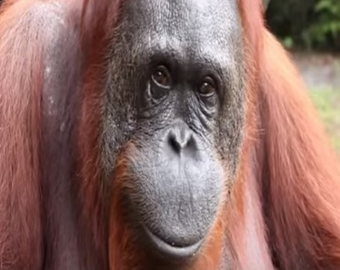 | ORANGOTANGO
PANDA | PANDA
PANGLIN | PANGOLINO  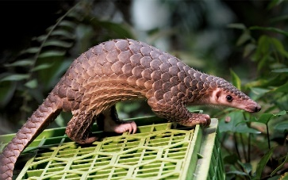
PARROT | PAPPAGALLO
RHINOCEROS | RINOCERONTE
SNAKE  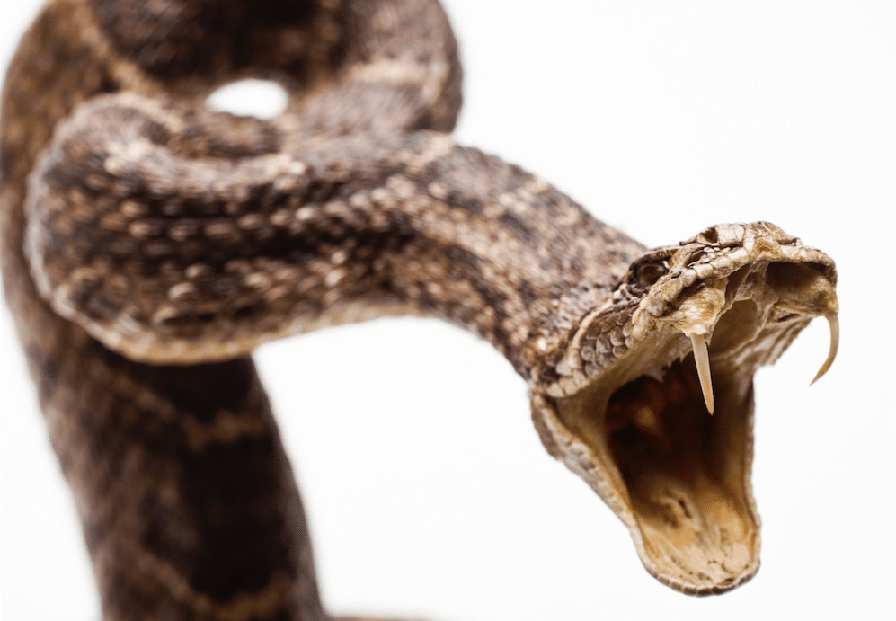 | SERPENTE
TIGER | TIGRE
ZEBRA | ZEBRA

