Pottery
In Hungary pottery has a big tradition. It’s an old profession but there are still many people who make potteries today. There are some famous manufactures such as the Zsolnay Porcelain Manufacture or the Herend Porcelain Manufactory. These factories make beautiful, high-quality products and that’s why they have been world-famous for many years.
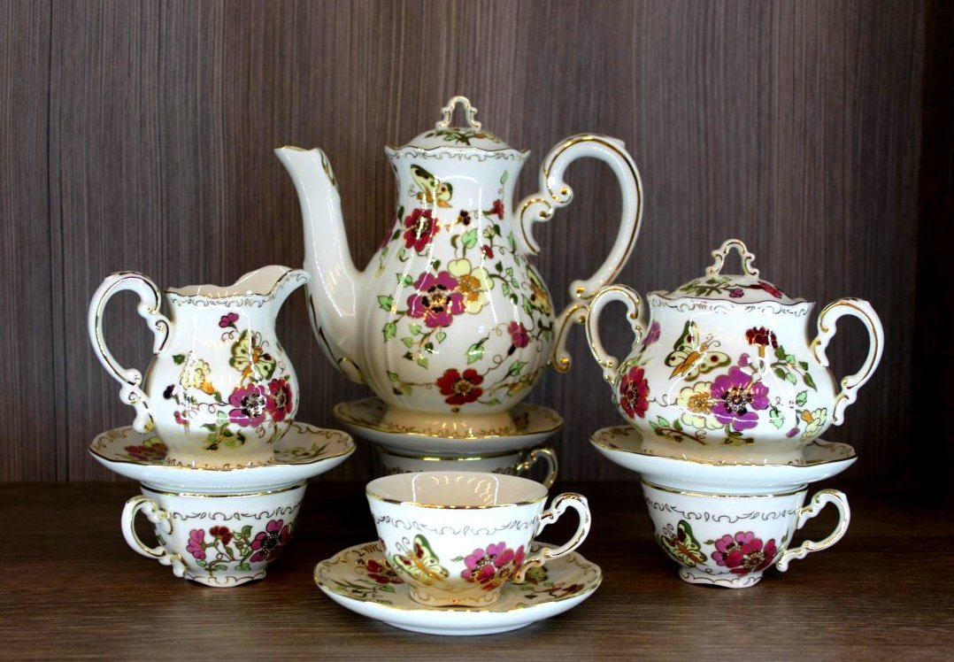
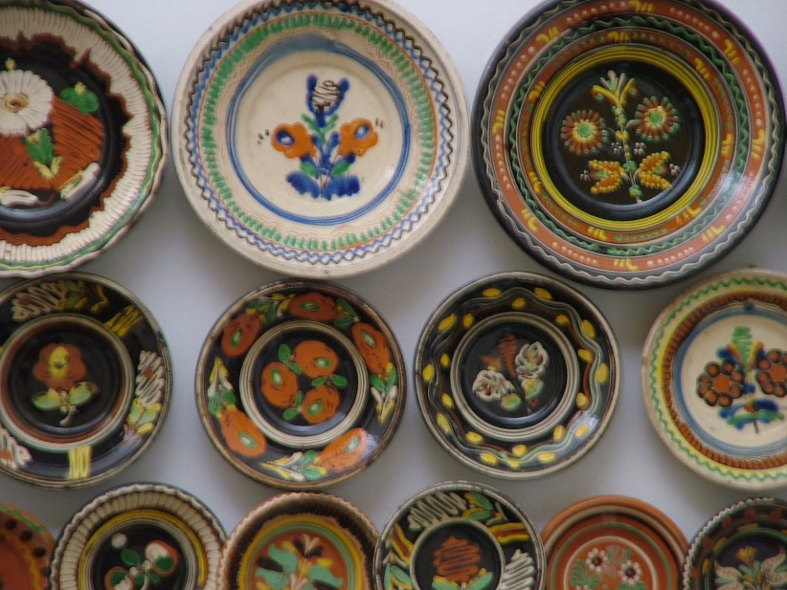

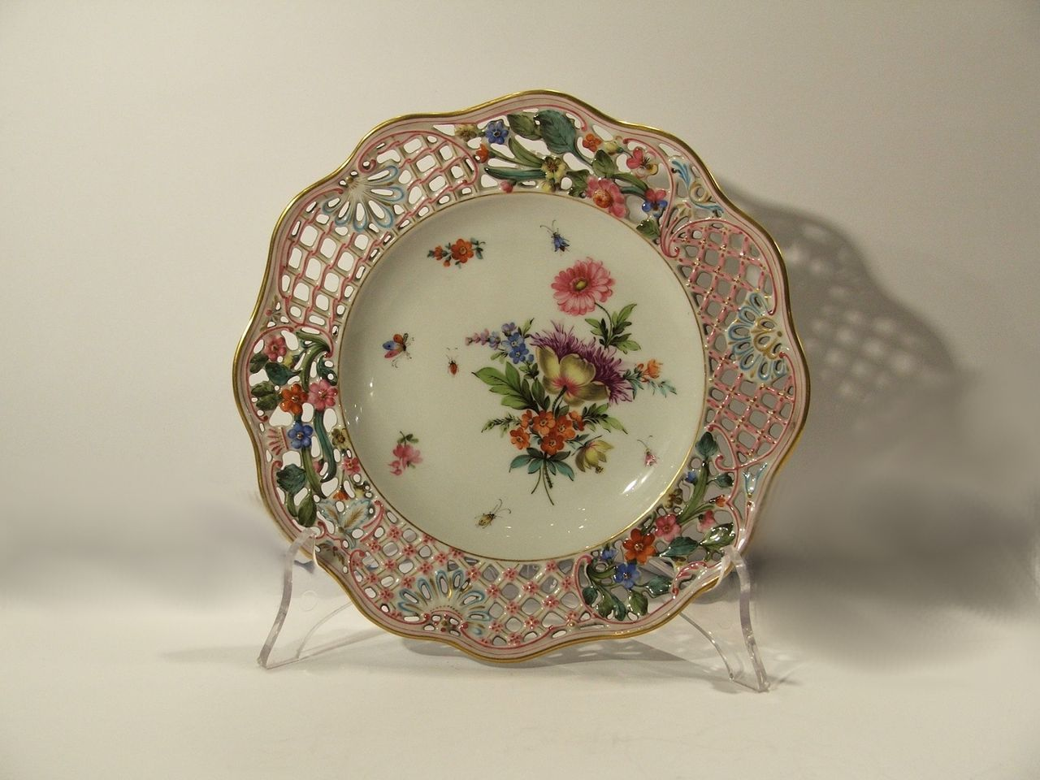
Wood carving
In the past they used to carve wood to decorate furniture, doors, gates, buildings or just to create statues. It’s a traditional profession. Wood carvers were real artists even though for most of the cases they were self-taught people, they did all their work alone without any professional prior learning. Nowadays wood carving is getting more and more popular again. There are a lot of carved statues and other things in public places too.
