Blacksmith
Blacksmiths work by heating pieces of wrought iron or steel until the metal becomes soft enough for shaping with hand tools, such as a hammer. There are 3 different kinds of this job. The horse smith, who makes horseshoes, the arms smith, who makes armours, guns, and the tool maker blacksmith. It has been a traditional job in our country since the Hungarians occupied the Carpathian Basin.
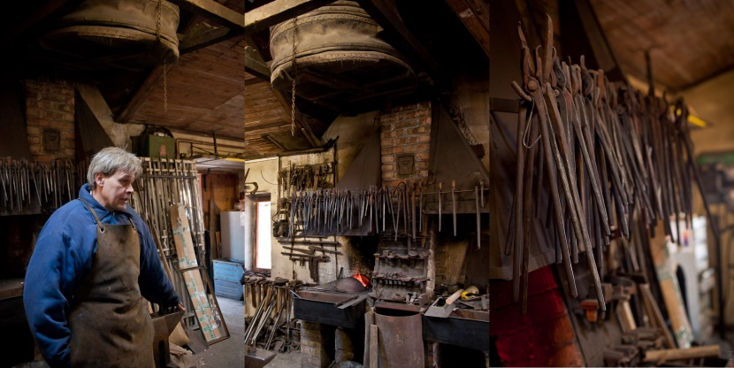
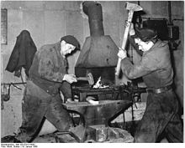

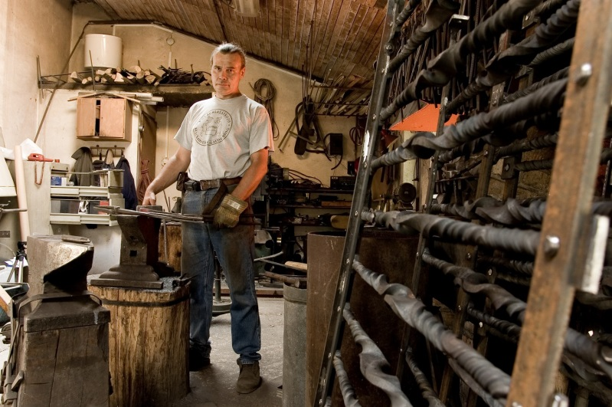
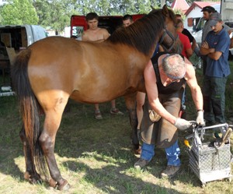
Csikós
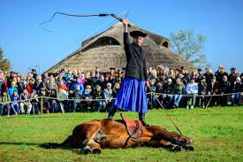
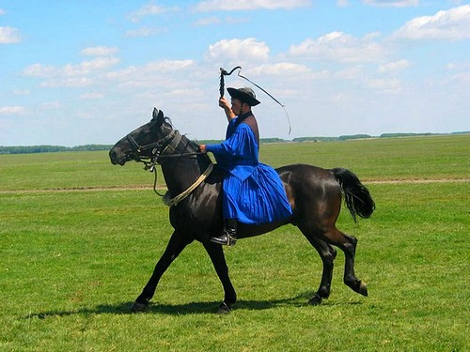
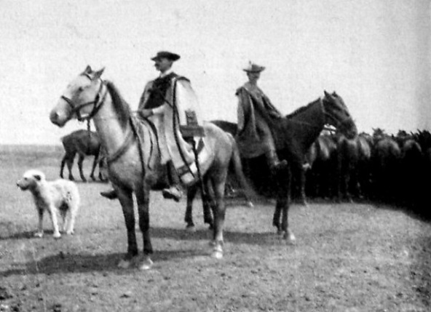
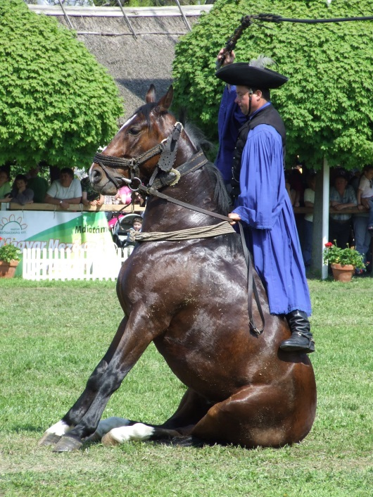
The csikós is the mounted horse-herdsman in Hungary. The csikós tradition is closely associated with the Hungarian puszta. It is also closely linked to the Nonius breed of horse. The csikós looks after and takes care of the herd. They wear a blue shirt, blue trousers and a black hat, this is the traditional clothes. They can teach the horse like a dog pet. They have a special whip.

