Csizmadia (Shoe-Maker)

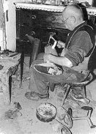
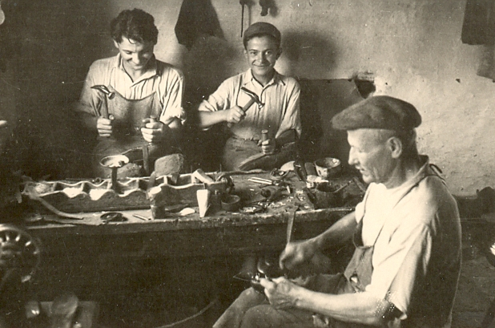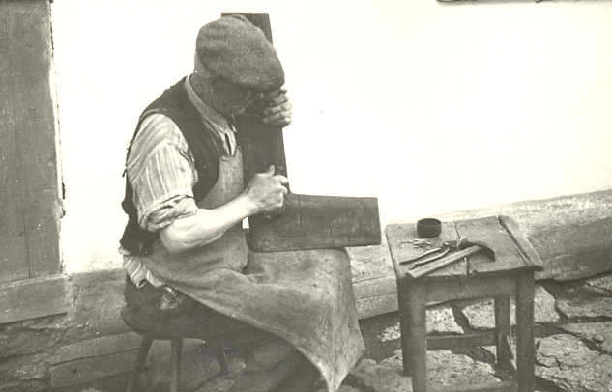

Csizmadia is an old Hungarian job that has become extinct. Csizmadia made boots and leather shoes. Different social class wore contrasting shoes. The poor people’s shoos were made by sewing. The rich people’s shoos were made by „modern” and expensive furnishing. Their classic products were riding-boots, shooting-boots and peasant boots. They worked up the ready leather and made the boots of overleather and boot-sole.

Pásztor (Herdsman)
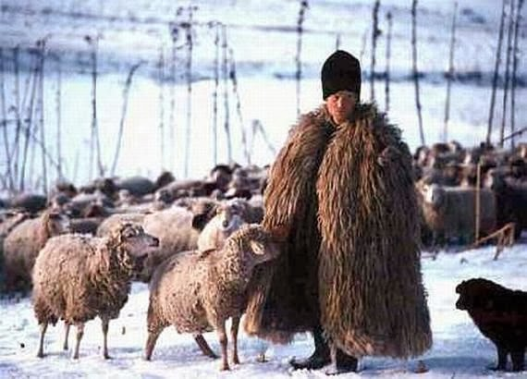
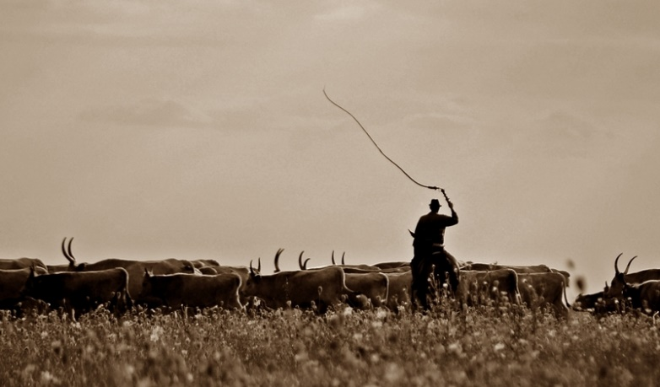
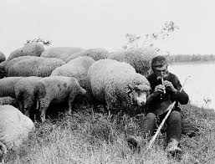

Herder is a very ancient occupation and this is a lifestyle. The herders lived in the wild and shepherded the animals when they wandered pasture lands. Their work was necessarily mostly outdoors, when they moved around from place to place. This job was very hard, because had to do it every day. Usually when the person is a minor, he is called a herdboy, a male herder is also called a herdsman and a female herder by contrast is also called a herdswoman. Generally the herders made this job from an early childhood. This job was close to nature, so the herders were not stressful. They had got a lot of free time, so they learned carving wood and playing the flute. The herders were poor but happy.

