Pálinka Distillation
A lot of families in Hungary distil pálinka (traditional strong fruit brandy).
The first step in the production process is the preparation of the fruit mash. They put the ripe fruits (such as apricots, apples, plums, peaches, cherries, or grapes) into a barrel, but before that they remove the stony seed from the fruits that have such (e.g., cherry, apricot, plum). Some fruits (e.g., apple, pear) are ground in order to make the mash soft.
The second step in the production process is the fermentation. The ideal temperature for the fermentation process is between 14–16°C, and the process takes between 10 and 15 days.
The third step in the production process is the distillation.
And the final result is a strong drink, Pálinka.
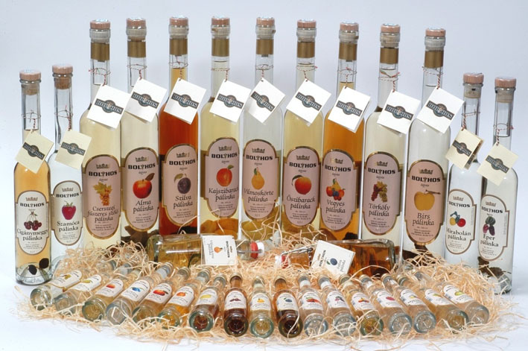
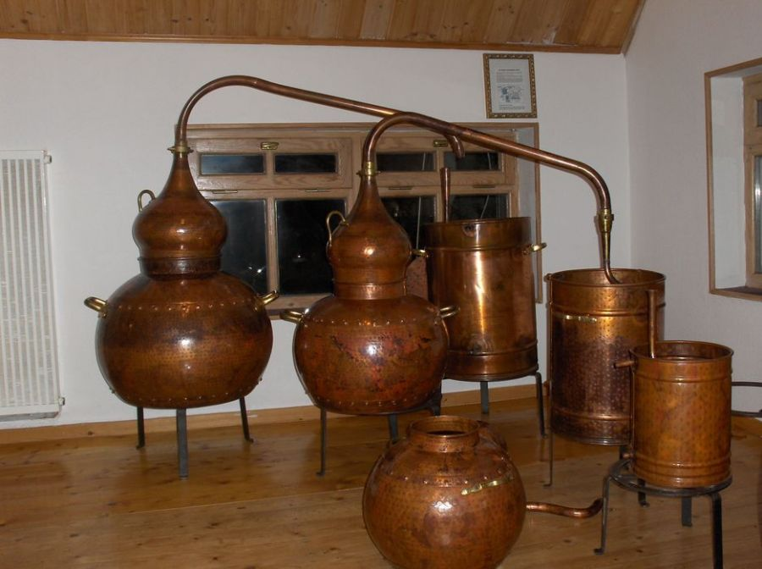

Hungarian Grey Cattle Breeding
These cattle were bred in Hungary.
In the Middle Ages the breed was used as a draught animal but from 1861 has been bred for beef quality.
Nowadays Hungarian Grey cattle are kept mainly as tourist attractions in many Hungarian national parks.

