Pan fried pork
TOCHITURA
Pan fried pork is one the most appreciated Romanian dishes and at the top of the list of traditional specialities in all the restaurants.
Preparation: 90 min.
Ingredients:
- 500 g pork, 3-4 smoked sausages
- 4-5 cloves of garlic, salt, pepper, parsley, 1 hot pepper
- 2-3 tablespoons of tomato sauce
- 100 ml red or white wine
- 2 eggs
- 500 g polenta
- 20 ml oil
- 50 g cheese

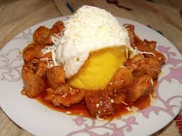

Preparation:
The pork and the sausages are cut into small pieces .
In a pan put the oil , then add the meat and mix them a little.After that, pour the wine and water, just enough to cover the meat. Let it simmer for a while and then add the sausages.
Continue mixing them.Then add the garlic, the chopped hot pepper, salt, pepper and the tomato sauce.It simmers for a few more minutes and then add the cut parsley.
The pan fried pork is served with polenta, over easy eggs and some scraped cheese.

Enjoy your meal!

