Lamb haggis

Lamb haggis is one of the traditional dishes that it is always present at the Easter meal.

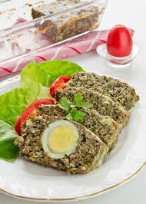- salt and pepper
Time of preparation: 60 min.
Ingredients:
- 1,5 kg of lamb organs (kidneys, spleen, liver, lungs, heart)
- 3 bunches of green garlic
- 3 bunches of green onion
- 3 bunches of dill
- 3 bunches of parsley
- 5 raw eggs
- 5 boiled eggs
- 150g butter
- Caul( membrane holding the intestines together)
- salt

- sare și piper după gust.

Preparation:

The lamb’s organs are cleaned, they are washed well and they are boiled with a pinch of salt. They boil for approximately 30 minutes, removing the foam from time to time. 5 eggs are boiled, as well.
While the organs boil, the garlic,onion,dill and parsley are chopped very well.After the meat is boiled it is cut into pieces . Then the organs are minced in the mincing machine. In a big bowl, mix the organs with the chopped greenery, the raw eggs, butter and spices.
The caul is washed very well with cold water and layed in an oiled pan,making sure it covers the margins.Half of the contents earlier prepared are layed in the pan, then the boiled eggs are put.After that, add the remainder of the mix. Turn the margins of the caul over it .Oil the haggis and put the pan in the hot oven.It is baked for about 60 min until it reddens.

Enjoy your meal!

