Menu 3

**Starter:**

Garlic cream soup

Ingredients: 1 onion, 2 tablespoon of butter, 2 tablespoon flour, 12 cloves of garlic, 7.5 dl of stock, 2.5 dl of double cream, a pinch of salt, a pinch of pepper, a pinch of nutmeg, a teaspoonful of sage, a tablespoon of lemon juice, 100 g of grated smoked cheese, some chive

Preparation: Chop the onion and put it in the melted butter and fry it until it is glassy. Cut the garlic cloves into four, and add them to the onion and steam them together. After that add the flour, braise them for a short while, then add the stock and the double cream, and boil them for about 20 minutes. When it is done, mix the soup and season it with the spices. Serve it with toast with the grated cheese sprinkled on the top.

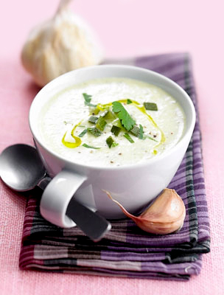

**Main course:**

Cabbage pottage with tomato

Ingredients: 1 kg white cabbage, 1 onion, 2 tbsp. oil, 2 dkg whole meal flour, 5 dl homemade tomato sauce, 1 tsp brown sugar

Preparation: Warm the oil in a large pot over medium-high heat. Chop the onion and the cabbage to medium stripes. Stew the onion and the cabbage in the oil, until they will be translucent, 5 to 7 minutes. Add the tomato sauce some salt, pepper and the sugar then mix it. Bring the mixture to a boil, cook at a boil until the cabbage are tender. Thick the pottage with the flour with stable mixing. Boil it again and it is done. Enjoy your meal!

You can serve the pottage with various types of roast meat.

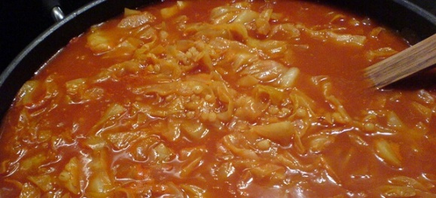

**Dessert:**

Cottage-cheese [soufflé](http://szotar.sztaki.hu/search?searchWord=souffl%C3%A9&fromlang=eng&tolang=hun&outLanguage=hun) with sour cherry

Ingredients: 0,5 kg sour cherry, 3 eggs, 0,5 kg cottage-cheese, sugar, a pinch of salt, juice of half lemon, lemon zest, a little butter.

Preparation: Cut the sour cherry into little pieces and add some breadcrumbs to it. Whip the egg yolk with the sugar until it becomes white and finally add the juice and the zest of the lemon, then the cottage-cheese and the sour cherry. Whip the egg white with the salt and gently mix it with the other ingredients. Put the mixture into a greased and floured pan, and bake it.

