Menu 5

Starter:
Smoked fleshy scone
Ingredients: 50 dkg of flour, 25 dkg of margarine, 1 spoonful of salt, 2 dl of warm milk, 1 teaspoonful of sugar, 2,5 dkg of yeast, 1 egg, 15 dkg of grated cheese, 15 dkg smoked meat
Preparation:
Make the yeast increase in the sugary milk. Knead the flour, the margarine, the salt, the egg, and the increased yeast. Put the dough into a mixing bowl. Cover it. Put it in a cold place for some hours.
After some hours knead the dough thoroughly. Roll the pasta 2-finger thick and tip the scones.
Put them on a baking plate, grease them with egg. Put the graded cheese and sliced meat on top. Bake the scones for 20-25 minutes.
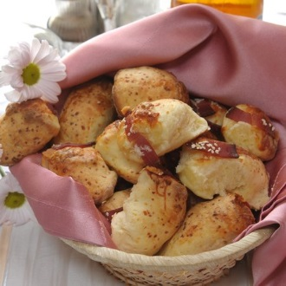

Main course:
Hungarian Lecsó
Ingredients: potato 1,5 kg, tomato 1 kg, red pepper 1 kg, green pepper 0,5 kg, onion 1,5 kg, red paprika ground, sweet, salt
Preparation: Peel the potatoes, tomatoes, onions, then cut them into pieces. Simmer the onion until it gets light brown. Then add all the other ingredients, 1 teaspoonful of salt and 1 teaspoonful of red paprika. Cover it and simmer the mixture until the potatoes are soft. Make sure to add some water if necessary for simmering. For the last ten minutes or so of cooking time, remove the lid and let it reduce a little bit. Serve with crusty white bread.

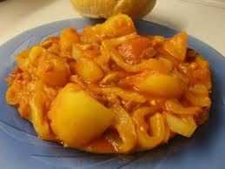
Dessert:
Orange-pumpkin-vanilla cream
Ingredients: 1 pumpkin, 2 apples, 1 orange, a packet of vanilla custard powder, 400 ml of milk
Preparation: For the pumpkin mash: first slice the apples. Peel the pumpkin, then dice it and cook it. When the pumpkin is cooked add the two sliced apples and cook them together for a couple of minutes until they are soft. After that mix them with a blender.
For the vanilla cream: cook a packet of vanilla custard powder in 400 ml of milk (milk can be replaced with coconut milk or sugar-free almond milk).
Add the juice of the squeezed orange to the vanilla custard. After that blend the apple-pumpkin mash and the orange-vanilla cream together. You can add some ginger, vanilla and cinnamon as well. Put the cream in glasses. You can decorate them with sliced almond, pumpkin seeds, walnut or oat flakes. Serve them cold. This cream is delicious in itself, but you can use it in cakes as well.

