Menu 4

Starter:
Green pepper filled with cottage cheese
Ingredients: 3 pieces of green pepper, 50 dkg cottage cheese, 2 tablespoon sour cream, 10 dkg butter, 1 little onion (red), 1 teaspoon salt, 1 teaspoon ground sweet paprika, 1 teaspoon ground cumin
Preparation: Wash the green peppers and slice them in the middle. We don’t need the pits. Then put the peppers in a bowl. Put the butter, the sour cream, and the cottage cheese into another bowl and mix them until they are soft and creamy. Slice the onions to small pieces. Add the onion, the salt, the sweet paprika and the cumin to the cream and mix them. Then fill the sliced peppers with the cream. We can decorate them with celery leaves or tomatoes.
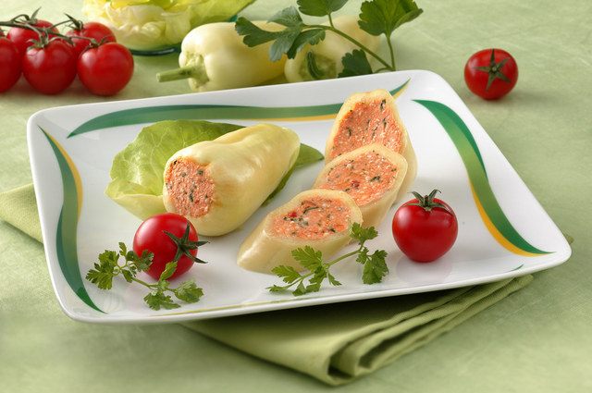

Main course:
Wild boar with mushroom
Ingredients: 60 dkg wild boar back, 2 red onions, 3 carrots, salt, 3 bay leaves, savory, 20 dkg mushrooms, 7 tablespoons of oil, 2 dl dry red wine, 5 dkg smoked bacon, 2 dkg flour, 1 celery, 5 dkg tomato juice, 2 cloves of garlic
Preparation: Dice the wild boar meat, the bacon and the mushrooms into small cubes. Chop the onions, the garlic and the celery. Fry the bacon cubes a bit. When the bacon is ready add the diced wild boar chops, the chopped onions, the garlic and the celery. Continue frying it and then add the tomato juice. Sprinkle the spices and pour the red wine over it. Stew it until it is ready. After frying the mushroom cubes, add them to the meat. As a side dish we recommend boiled potatoes or potato croquettes with almonds. You can decorate it with boiled carrot balls as well.
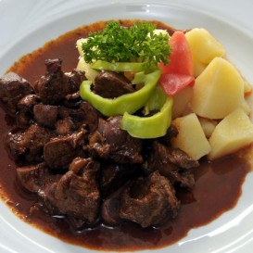

Dessert:
Hungarian floating islands
Ingredients: 5 egg whites, 1 tablespoon sugar, 5 egg yolks, 1/4 cup sugar, 1 tablespoon flour, 2 cups whole milk, 1/2 vanilla bean, cut lengthwise Instead of the vanilla bean you can use 2 tablespoon of real vanilla sugar or 2 tablespoon of pure vanilla extract
Preparation:
In a large saucepan, bring water to boil. Turn the heat down to slow simmer. Beat the egg whites until stiff peaks form. Beat in 1 tablespoon of sugar. With a wooden spoon drop 2-3 spoonful of beaten egg whites into the simmering water. In a few seconds the meringues will puff up, gently turn them over with the wooden spoon. Cook the meringues for a few seconds longer and then transfer them with a slotted spoon to a serving bowl. Beat the egg yolks and sugar for 3-4 minutes until very thick and creamy. Add 1 tablespoon of flour and whisk to combine. This step is optional. Add the milk and whisk to combine. Transfer yolk-milk mixture to a saucepan. Split the vanilla bean and add to the saucepan. Slowly heat the mixture and keep stirring with a wooden spoon. You must not let the milk boil or the yolks will curdle. Let it come no higher than 175F or 80C. Dip the wooden spoon into the custard and run your finger along the back of the spoon. If the streak remains without the cream running down through the streak, it is ready. If you use vanilla extract or vanilla sugar, now is the time to add to the hot custard. Strain the hot custard through a fine sieve into a bowl. If you used vanilla bean scrape the seeds into the hot custard and stir. Pour the custard over the meringues. Serve hot or chilled.
