Menu 2

**Starter:**

Fish Soup

Ingredients: a big carp (1,5 kilos), some different types of small fish (500 gram freshwater fish), 2 litres of water, 1 big peeled tomato, 2 large chopped onions, 2 tbs Hungarian paprika powder, salt to taste, 1 green pepper, 1 dl red wine

Preparation:

Clean the fish and remove its teeth, tail, fins and scales with a sharp knife. Cut out the eyes from the head. Wash the cleaned fish with cold water. Open up the carp at its belly and remove the chitterlings. Slice it up for 2 cm thick slices and salt the fish fillets.

Make a fish stock. Cook the head of carp and the small fish in water until tender, strain and pour it through a sieve. Cook the chopped onion in water until it is soft, sieve and put it into the fish stock. Place the salted carp slices into the fish stock. Add slices of green pepper and the peeled sliced tomato, some salt if necessary and bring it to the boil. If you find it necessary, add some water. Add the Hungarian red paprika powder and the wine and cook until the carp is tender. Serve by carefully removing the fish fillets with a skimmer and placing them in the plates, then use a ladle to scoop some soup until it is covered.

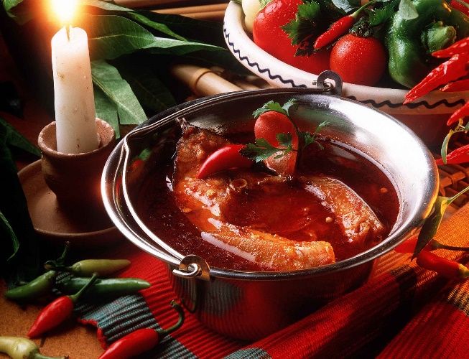

**Main course:**

Rabbit in mustard

Ingredients: 1 rabbit, salt, mustard, parsley, flour, 1 tub of sour cream

Preparation: Cut the meat into bigger pieces. Put the salt and spread the mustard on the meat and leave it in the fridge for one day. After that sauté it in hot oil, then steam it with chopped parsley until it is soft. Then put the soft meat into a casserole. Mix the meat juice with the flour and the smooth sour cream then pour it on the meat in the casserole. Then put the meat into the oven and fry it until the top is nicely fried. Serve it with potato croquettes.

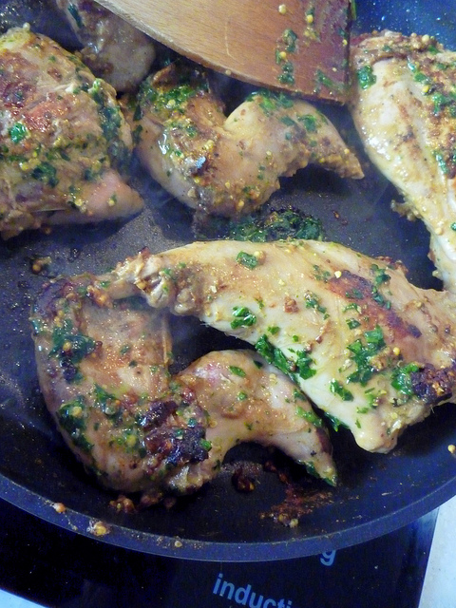

**Dessert:**

Sponge Cake a’la Somló

Ingredients**:**

3 1/2 ounce raisins soaked in rum, 3 1/2 ounce [ground walnuts](http://www.amazon.com/s/?ie=UTF8&tag=hungarbooks0f-20&link_code=btl&camp=213689&creative=392969&search-alias=aps&field-keywords=ground%20walnuts), whipped cream made from 1 cup heavy cream

Sponge Cake***:*** 6 eggs, 6 tablespoon [powdered sugar](http://www.amazon.com/s/?ie=UTF8&tag=hungarbooks0f-20&link_code=btl&camp=213689&creative=392969&search-alias=aps&field-keywords=powdered%20sugar), 3 1/2 ounce walnut, 1 heaping tablespoon [cocoa](http://www.amazon.com/s/?ie=UTF8&tag=hungarbooks0f-20&link_code=btl&camp=213689&creative=392969&search-alias=aps&field-keywords=cocoa)



Rum Sauce: 1 1/2 cups milk, 5 ounce sugar, 1 teaspoon ground lemon peel, 1 teaspoon ground orange peel, 2 tablespoon rum

Vanilla Cream:1 1/2 cups milk, 1 whole vanilla stick, 2 egg yolks, 2 ounce powdered sugar, 1 teaspoon corn, starch

Chocolate Syrup: 7 ounce [bitter dark chocolate](http://www.amazon.com/s/?ie=UTF8&tag=hungarbooks0f-20&link_code=btl&camp=213689&creative=392969&search-alias=gourmet&field-keywords=bitter%20dark%20chocolate), 2 tablespoon rum



Preparation:To prepare the sponge cake, beat the egg yolks and sugar until stiff, add the flour, then the stiffly beaten egg whites. Combine. Divide the mixture in two. Mix the ground walnuts into one half and the cocoa into the other. Pour the mixes separately into a high baking sheet lined with baking paper and bake in a medium hot oven until ready. (The sponge cake should be done in about 12 minutes. To prevent the cake from collapsing, do not open the oven door.)

Boil the milk and the vanilla stick for 5 minutes, remove, add egg yolks, sugar, and the corn starch.

To prepare the rum syrup, cook the sugar in 1 cup milk, the lemon and orange peel for 15 minutes, then add rum.

Break the sponge cake into smaller pieces and combine. Place one layer of sponge cake in the bottom of a large glass or on a plate, sprinkle with the rum syrup, the ground walnuts, raisins, smooth some of the vanilla cream on top, then repeat the layers again. Make sure the top layer is sponge cake. Sprinkle the top with cocoa, add whipped cream made from 1 cup heavy cream, and 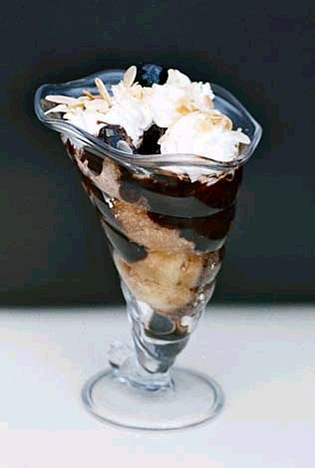pour the chocolate syrup on top.