Menu 1

Starter:
Filled aubergines

Ingredients: 2 aubergines, 2 dl sour cream, 10 dkg mushroom, 1 dl boiled rice, 1 egg, 2 tablespoon grated cheese, 2 tablespoon oil, 1 red onion, parsley, salt and pepper

Preparation: Slice the aubergines along, then put them into the oven. While baking, make the filling. Make a stew from the mushroom and mix it with the rice, the cheese and the parsley. When it cools down a bit you can add the egg. Remove the inside of the aubergines, slice them into small pieces and add them to the cream. When the cream is done we can fill the aubergines. Then you can put the sour cream and the cheese on the top. Bake them until they are red.

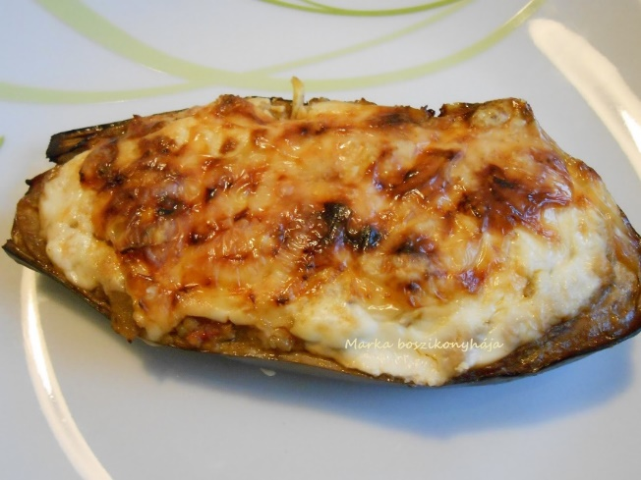

Main course:
Goulash soup

Ingredients: 600 g beef shank or chuck 30 mm cubed, 2-3 onion minced, 1 spoonful oil, 1 spoonful pepper powder, 1 clove of garlic, 1 teaspoon of caraway seed and black pepper, salt, 1-3 bay leaf, 1-2 carrot diced, 1 Hungarian green pepper chopped, 2 tomatoes chopped, celery leaf, parsley chopped, 1 parsnip diced, 2 potatoes cubed
Preparation: Cut the onion into small pieces and brown it in hot oil. Add the chopped meat and stir until well browned, powder it with paprika powder and stir well. Add a little water and keep stirring. Add salt, the clove of garlic, the caraway seeds, black pepper, bay leaf and tomatoes, a little water and let it simmer for about 30 minutes. Add enough water to cover the meat. Add carrot, parsnip, green pepper, celery leaf, parsley and bring it to a boil. Turn to low heat and simmer it for 10 minutes. Add potatoes and more water to soup consistency. Salt to taste. Simmer until potatoes and meat are well cooked.
I like it with hot chili pepper in soup (dried or sauce).

Dessert:
Classic Apple Pie
Ingredients: 45 dkg flour, 1 tablespoon baking-powder, 1 pinch of salt, 20-25 dkg sugar, 15 dkg butter, 0,5 litre of milk, 2 eggs, grated zest of a lemon
For the filling: 1,5-2 kg of apple, juice of a lemon, 3-4 tablespoons of breadcrumbs, sugar, cinnamon

Preparation: First make the filling. Grate the apples and add some cinnamon and sugar to it. Then mix the flour with the baking-powder and the salt, then mix them with the eggs, the butter, the sugar, the milk and the lemon zest. Then take half of the dough, roll it out and put it into a cake pan (about 40 x 26 cm). After that squeeze the filling (the grated apple and cinnamon) and put it on the noodle, pour lemon juice on it and sprinkle it with breadcrumbs. Roll out the other half of the dough too, and cover the filling with it and then bake it until it gets light brown.

