Hello!
Nice to meet you all! My name is Nini Giorgadze. I’m 10 yars old. I have two sisters and one brother. My favorite school subject is science. In my spere time I dancing and singig. I’m glad to work with you in this project. Best Regards, Nini
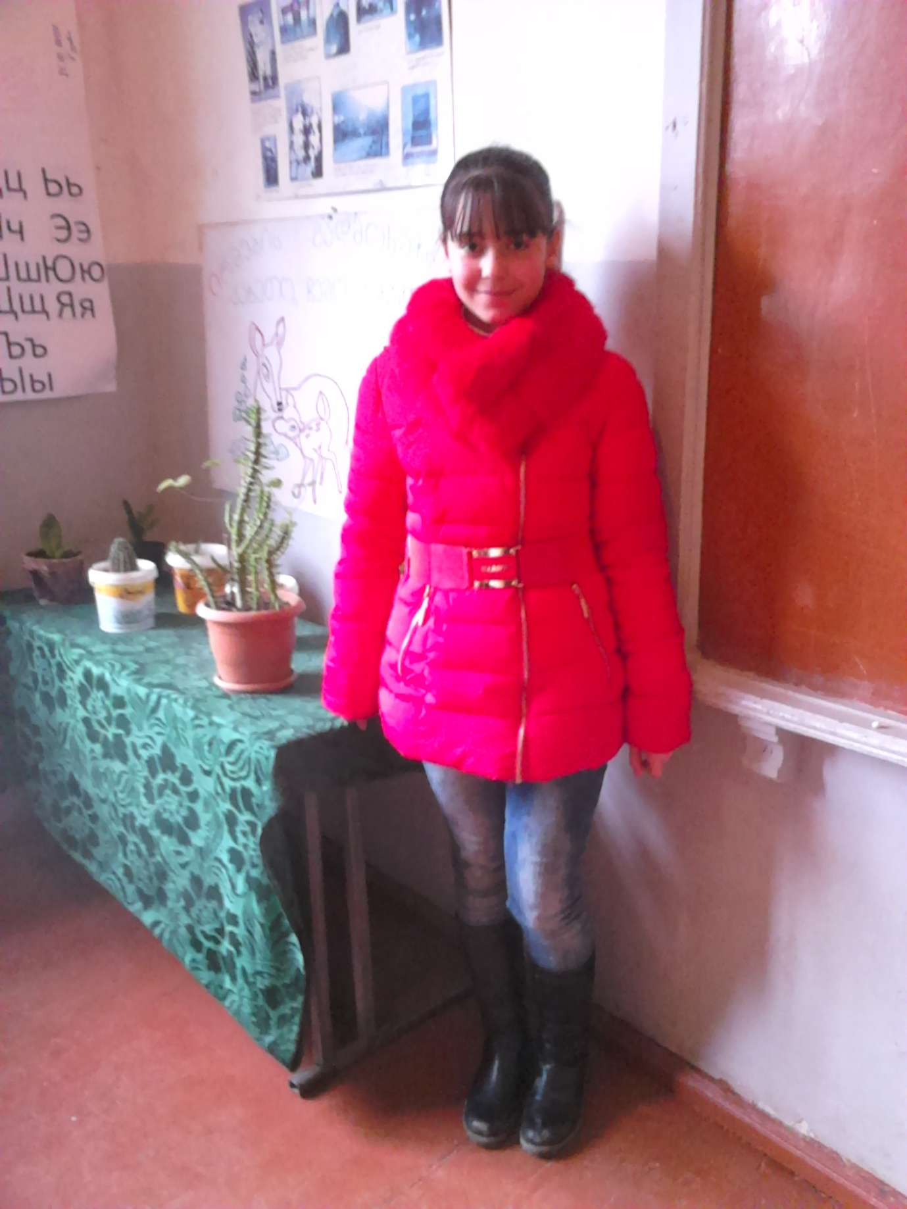

Hello!
My name is Luka Giorgadze. I’m 10 yars old. I have two brothers. My favorite school subject IST. In my spere time I playng the football.
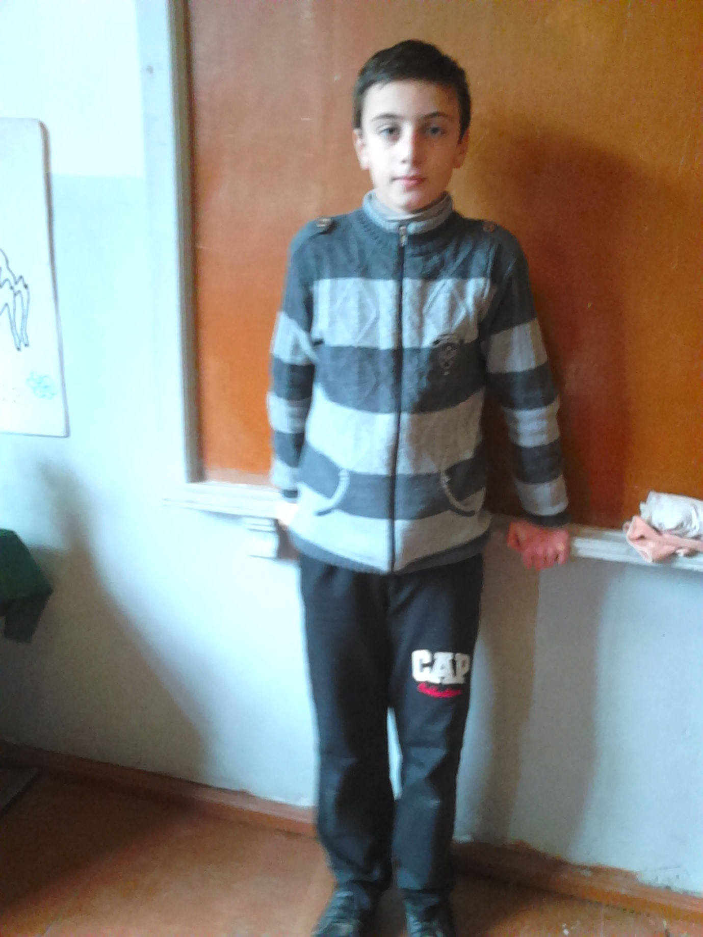

Hello!
My name is Elene Kakhelashvili . I’m 10 yars old. I have one brother. My favorite school subject is English languige. In my spere time I redding the book.
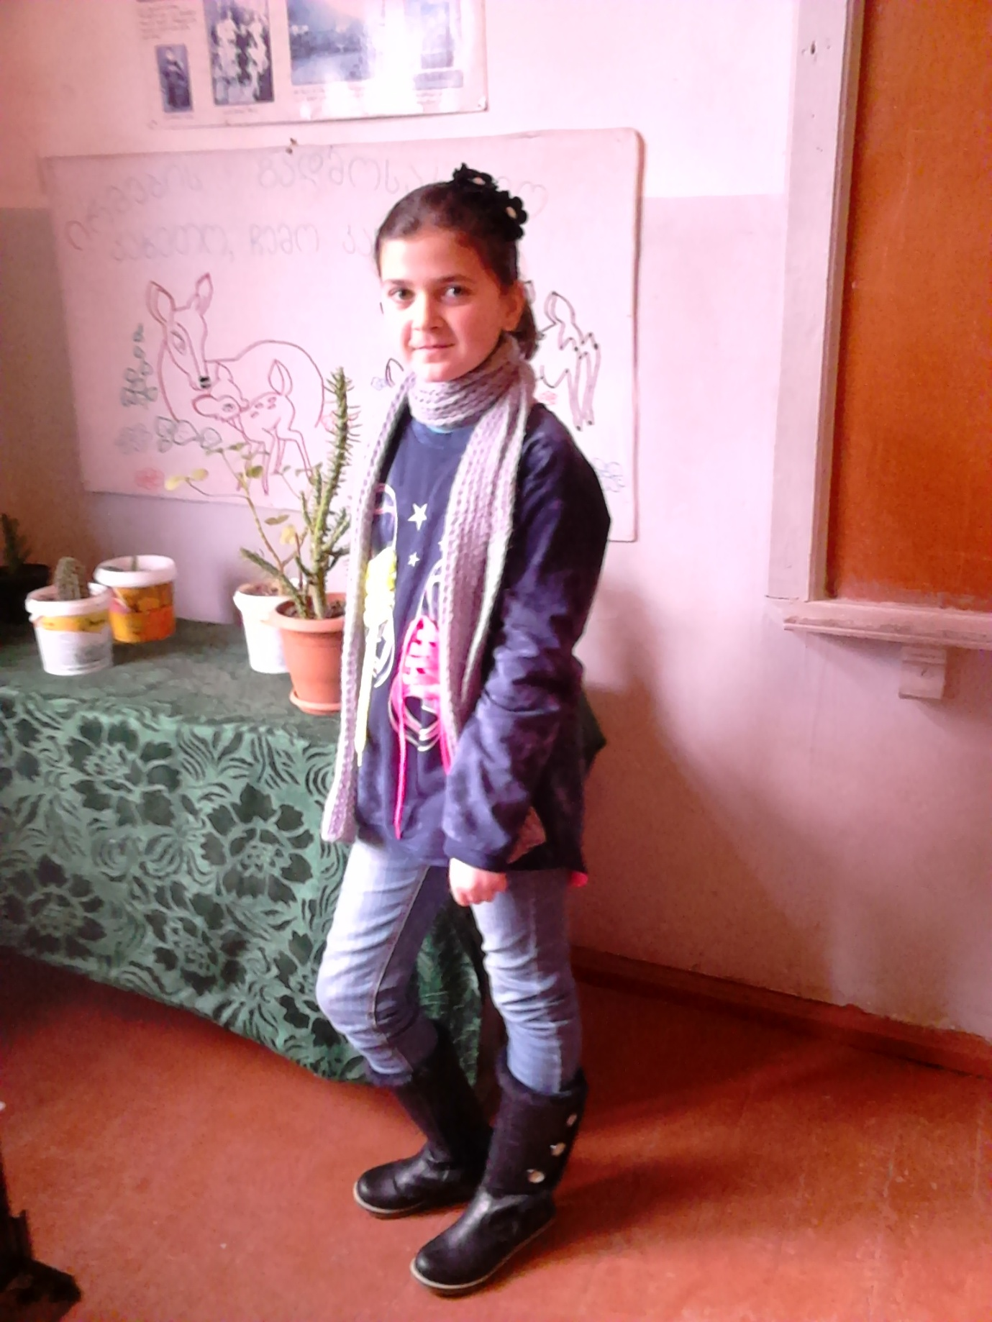

Hello!
Nice to meet you all! My name is Qristine Thoriashvili . I’m 11 yars old. I have one sister. My favorite school subjects is English language, math and nature. In my spere time I reading books.
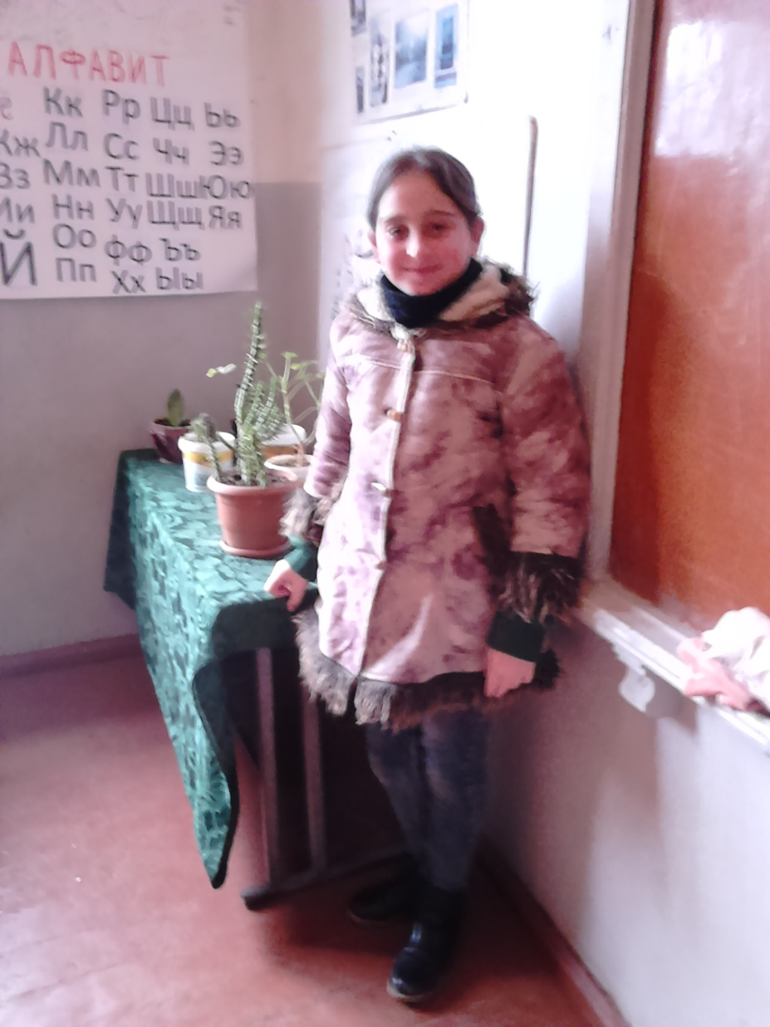
Hello! My name is Gvanca Boshishvili . I’m 11 yars old. I have one brother and one sister . My favorite school subjects are English language, nature, math and IST. In my spere time I redding the book, dancing and traveling.
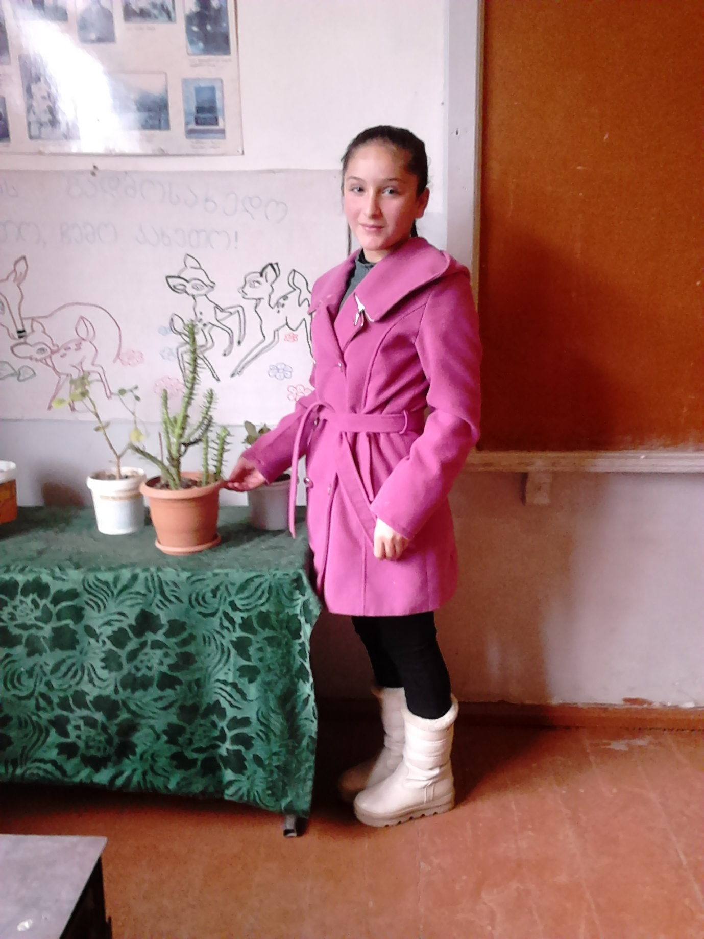
Hello!
I’M Giorgi . I’m 11 yars old. I have two sisters. My favorite school subject is sport and nature. In my spere time I playng football. With love, Giorgi
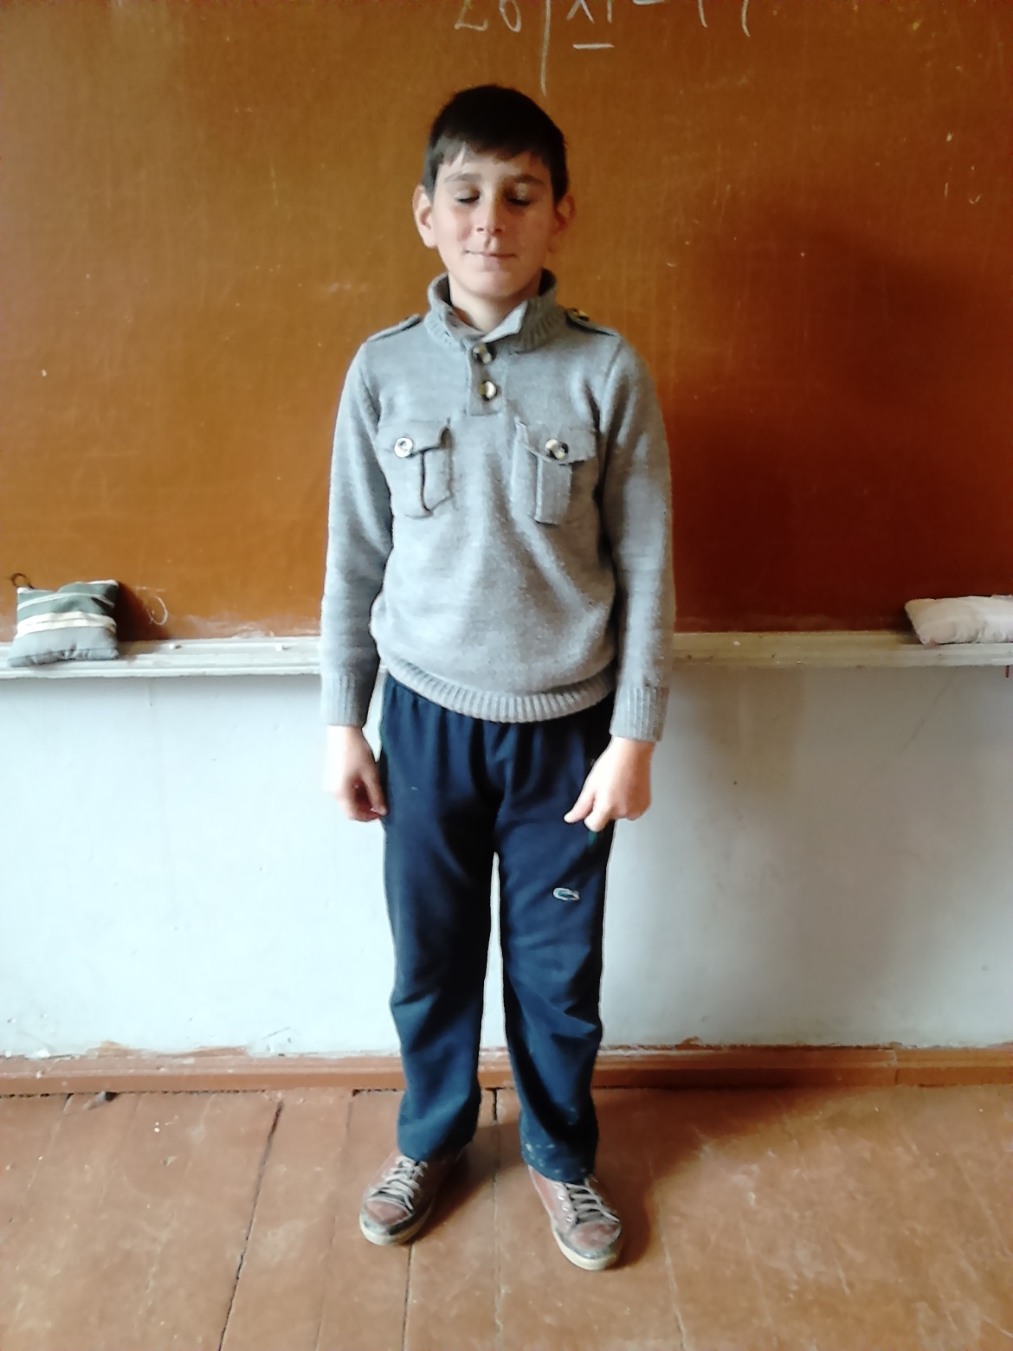

Hello!
My name is Nikoloz Qobuladze . I’m 10 yars old. I have parents and one brother. My favorite school subject is ICT and Sport . In my spere time I redding the book and playng the football.
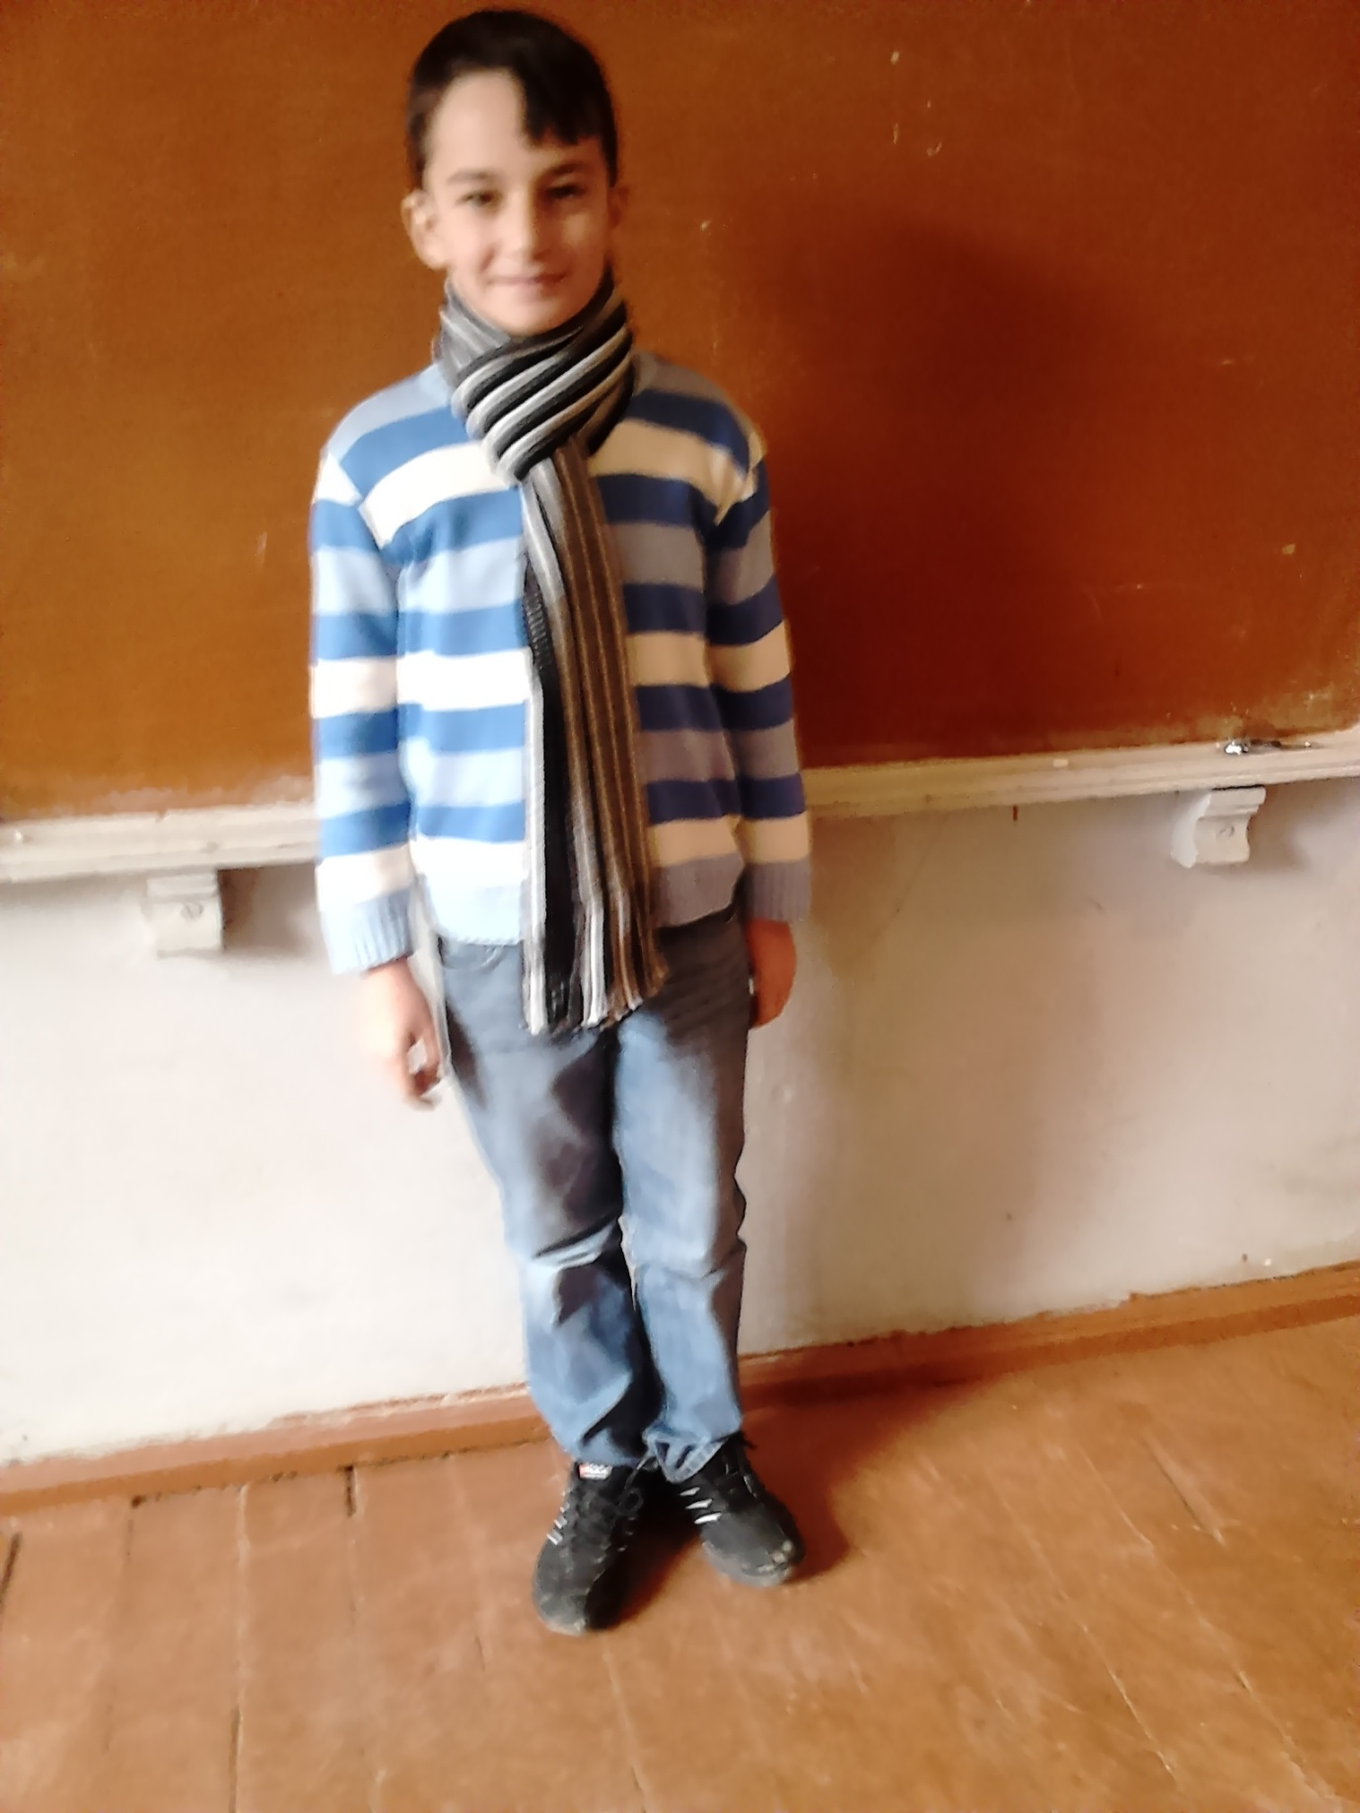

Hello!
My name is Beso . I’m 11 yars old. I have one brother and parents. My favorite school subject is Nature. In my spere time I playng the football and dancing.
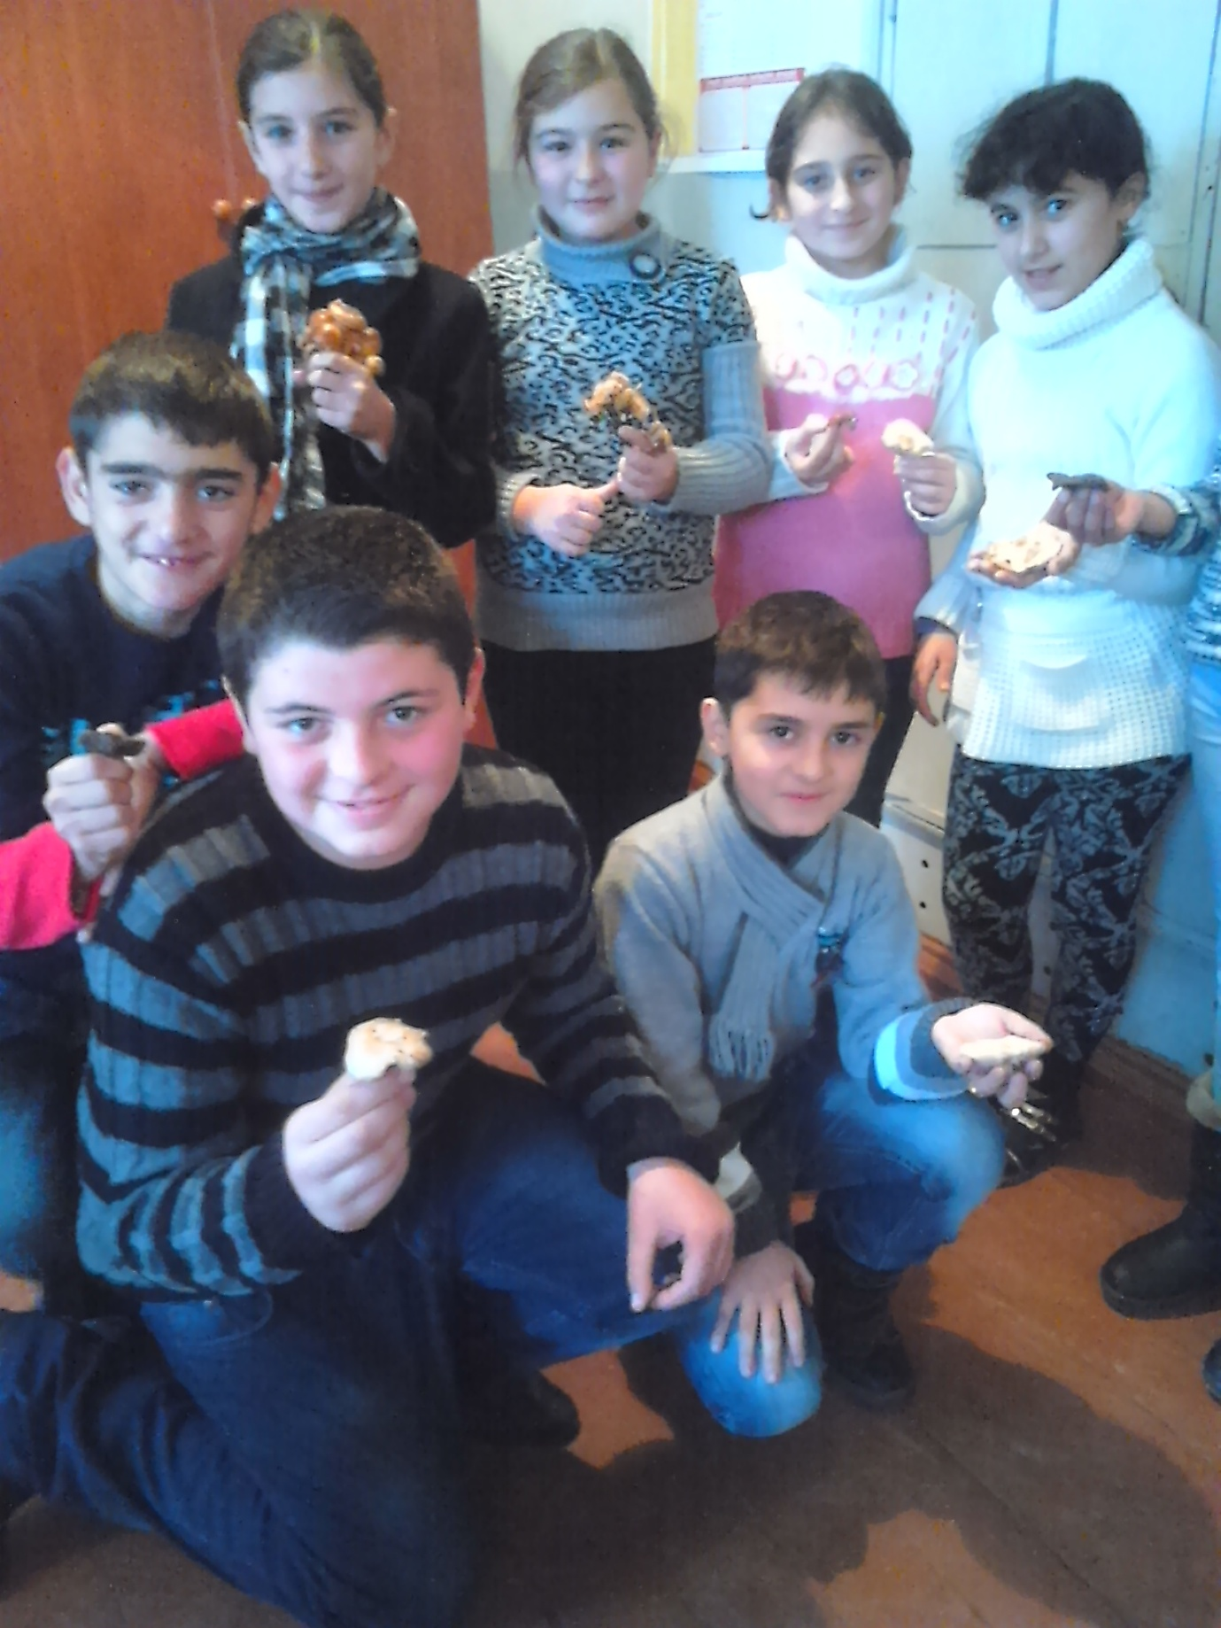
Hello!
My name is Ela Varteresova . I’m 10 yars old. I have one sister. My favorite school subject is math. In my spere time I redding the book and singing. With love, Ela!
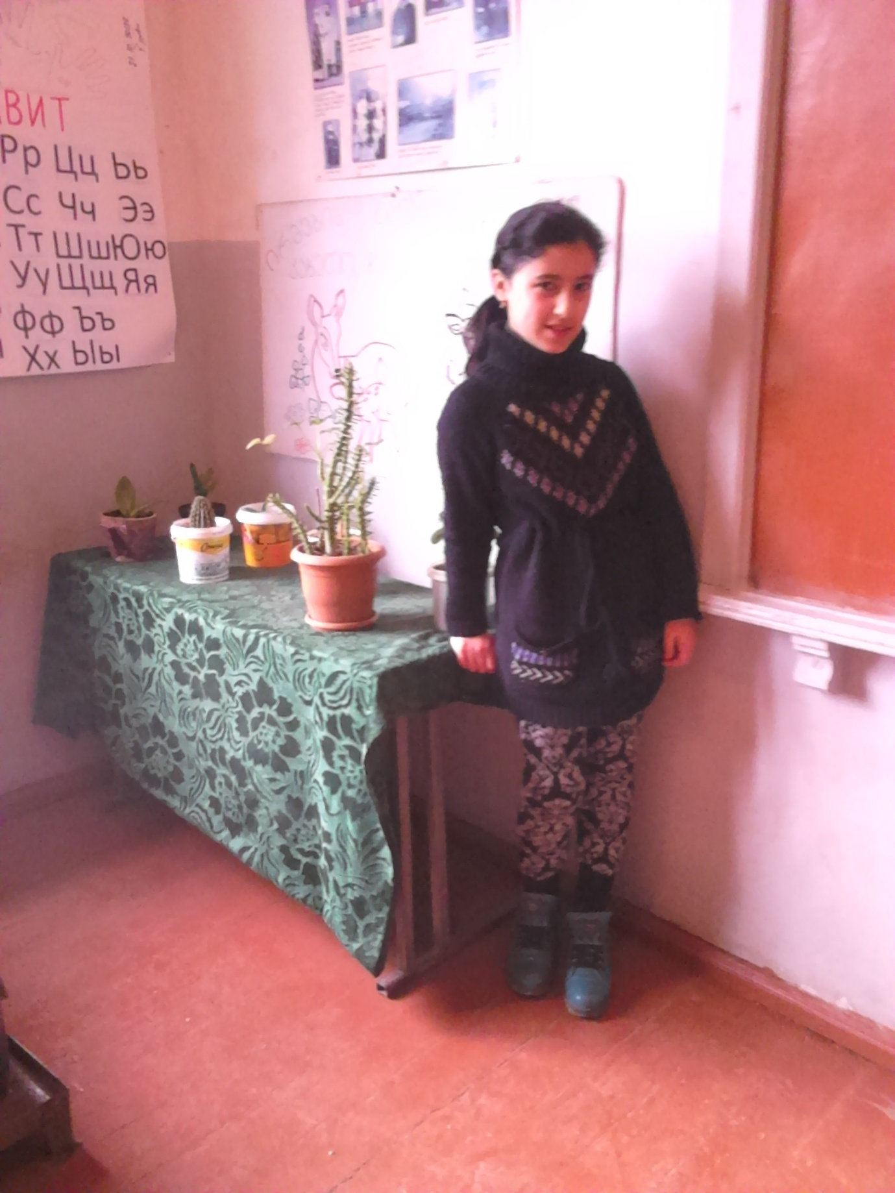

Hello!
My name is Mariam Dedalamazishvili . I’m 10 yars old. I have mother one sister. My favorite school subject is English languige. In my spere time I singing and playng with my friends.
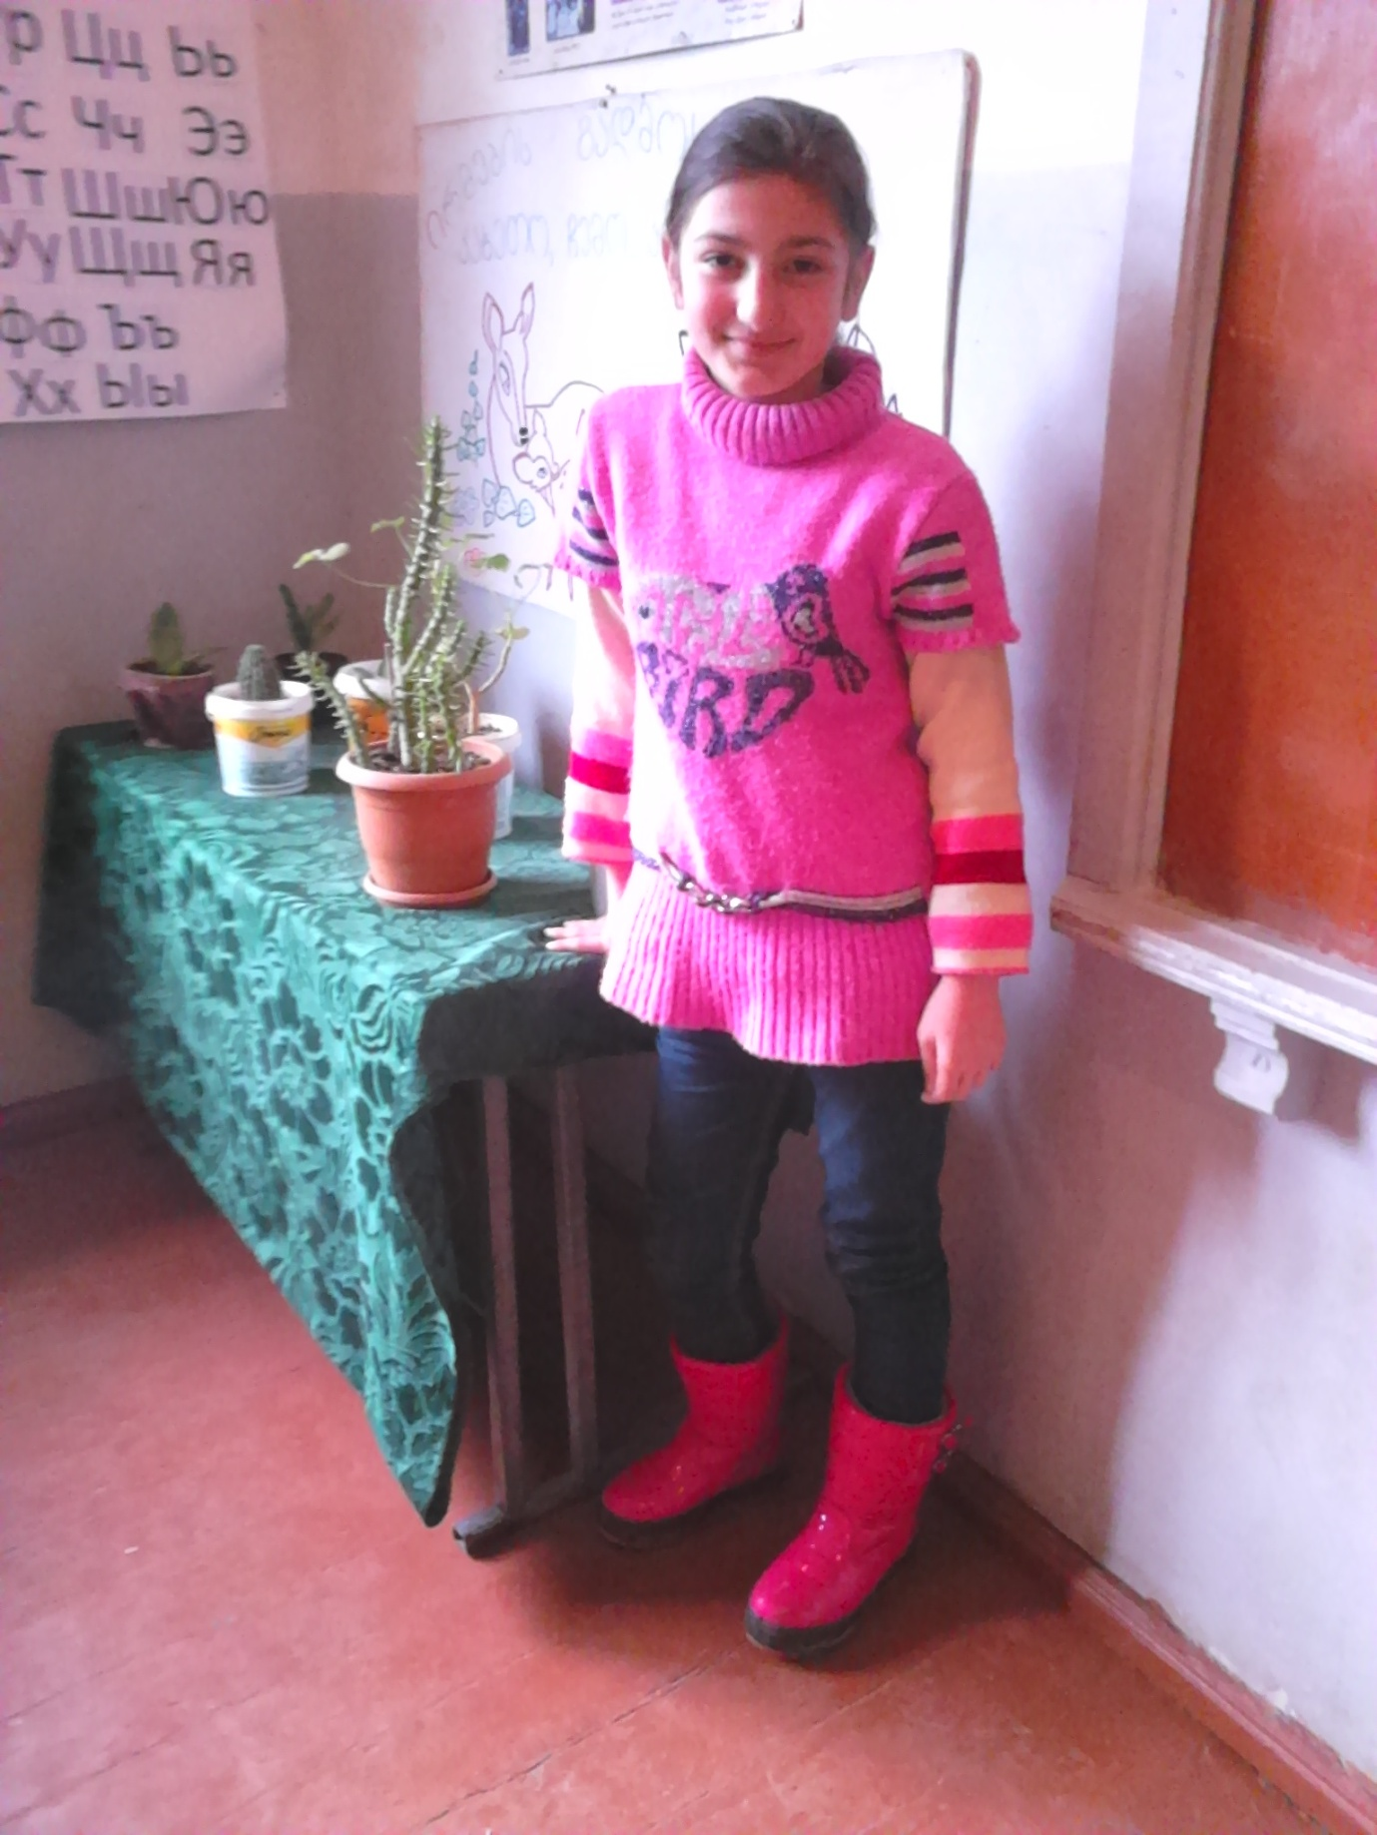

Hello!
My name is Lana Kharatishvili . I’m 10 yars old. I have two brothers. My favorite school subject is math, Ist, history and nature. In my spere time I redding the book.
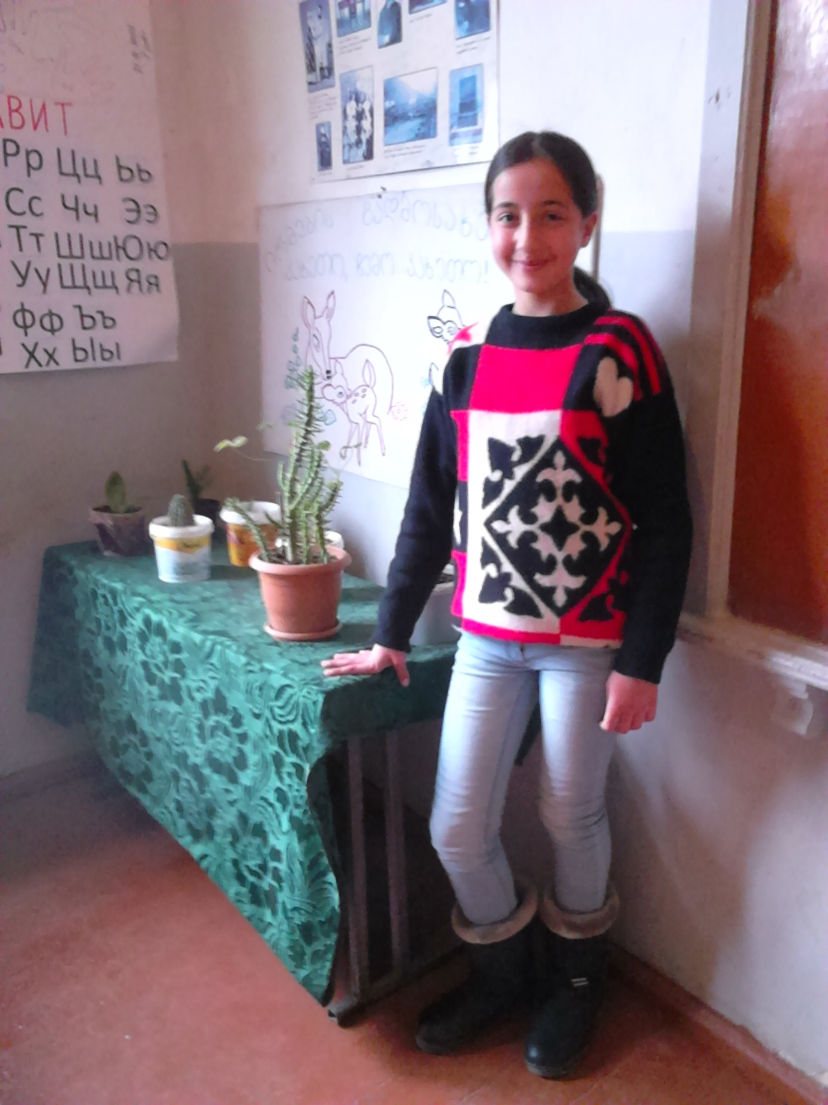

Hello!
I’m Tamar Lortkiphanidze, I’m 10 yars old. I have two brothers and two sisters. My favorite school subject is history and sport. In my free time I playng with my friends. I love my friends.
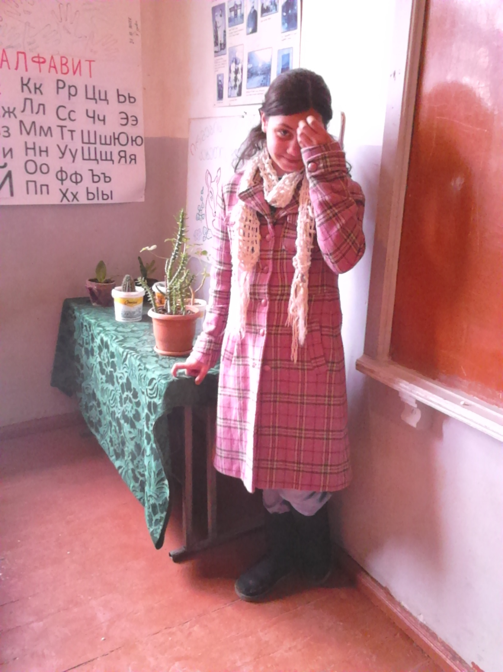

Hello!
My name is Beso Mdivnishvili . I’m 11 yars old. I have one sister. My favorite school subject is sport and nature. In my free time I playng the football.
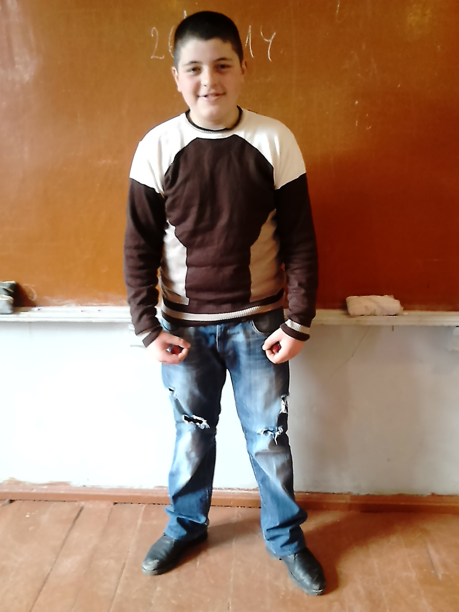
Hi! I’M Ani Altunashvili. I’m 10 yars old. I have mother. We live in the nice village Kumisi. I very like my village. In my spere time I playng with my friends. My favorite school subject is nature and art. I’m glead to participate in this project with you. Best Regards , Ani Altunashvili .

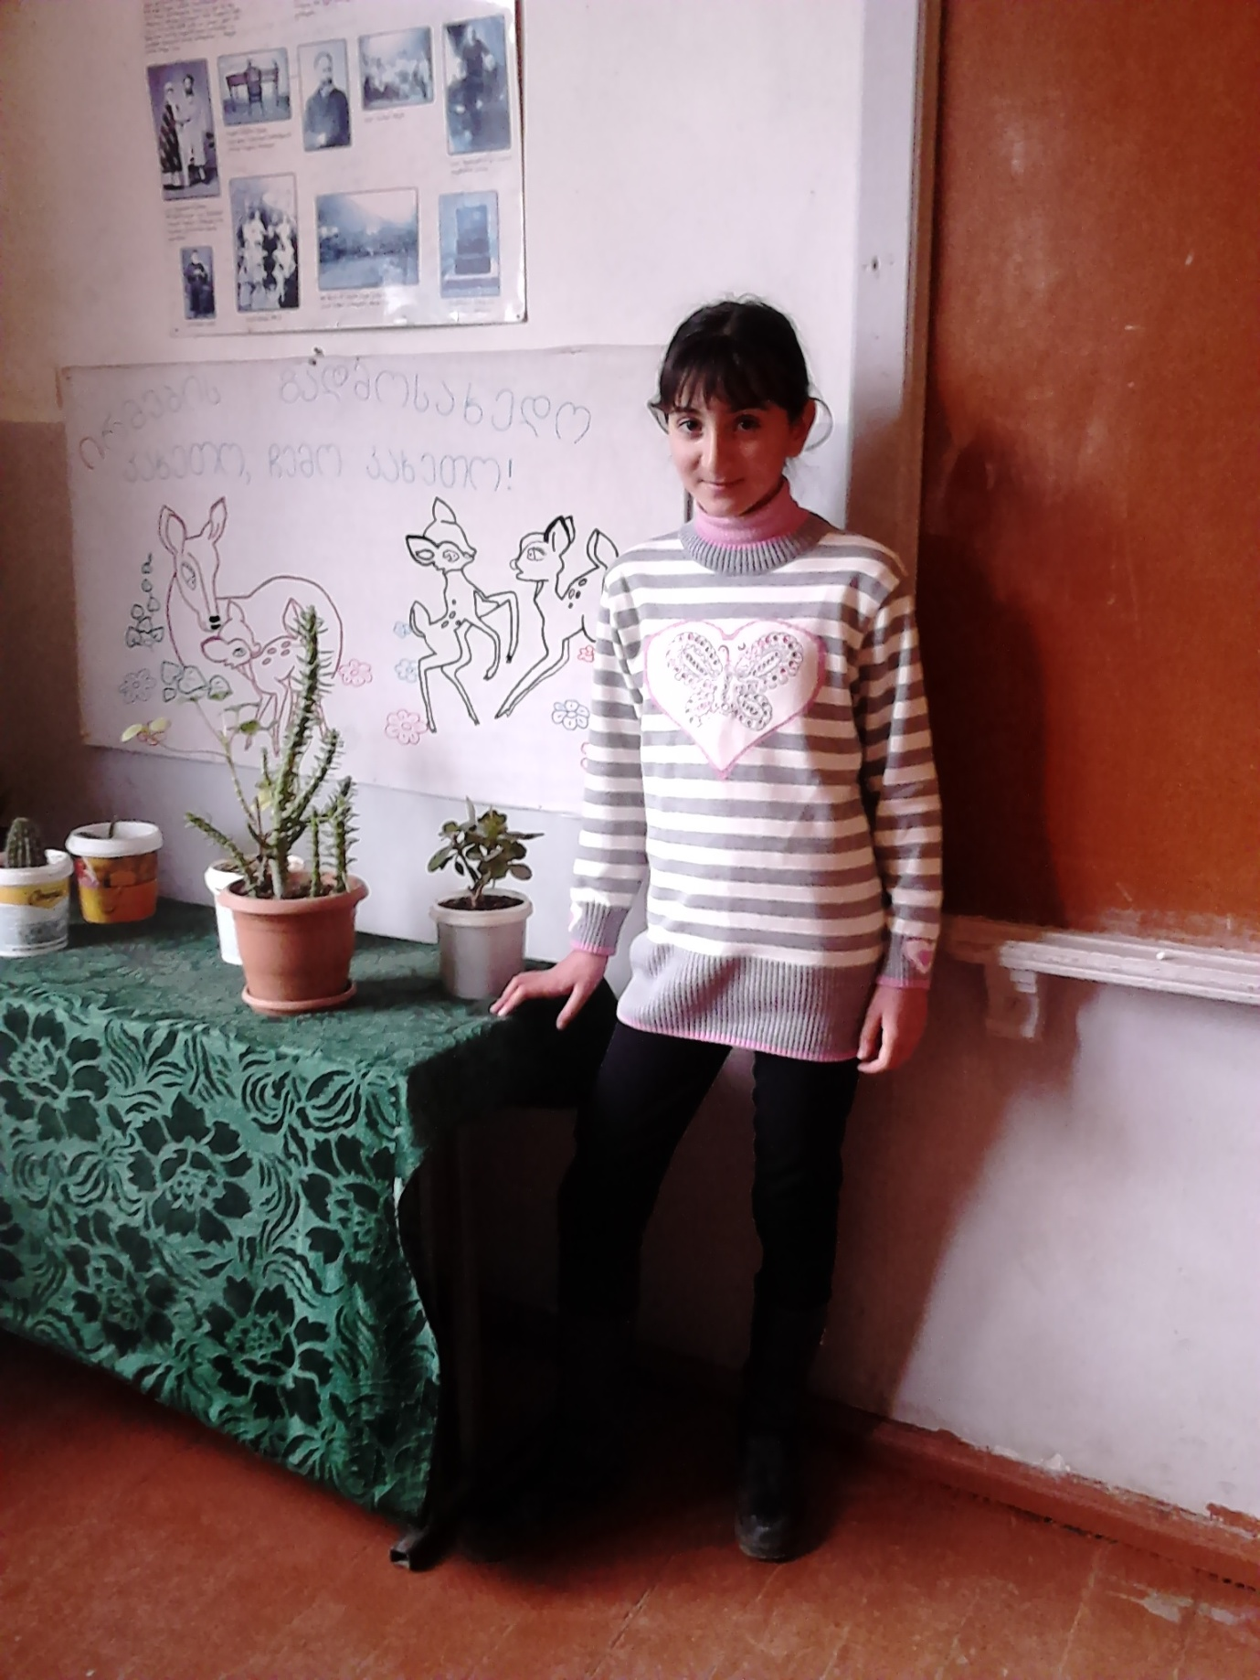
Hello!
I’m Sergo Tatuashvili, I’m 10 yars old. I have two sisters. My favorite school subject is history and sport. In my free time I playng with my friends the football and basketball.
Kind Regards, Sergo.
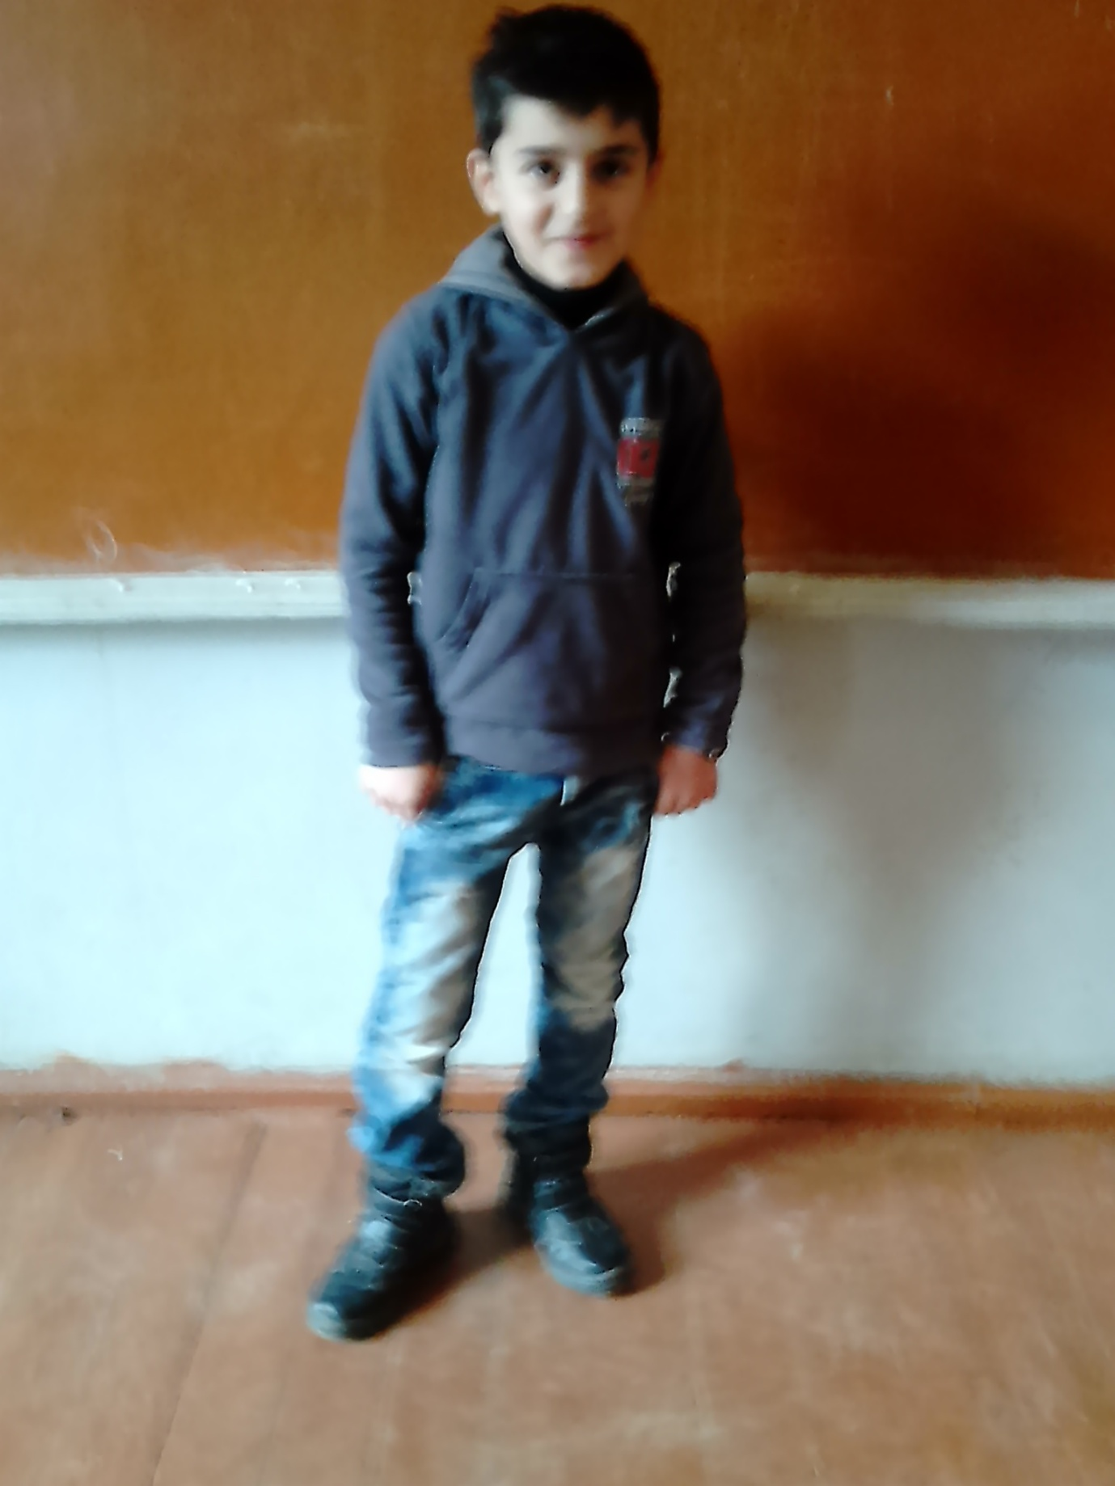
Hello!
I’m Leluka Palavandishvili, I’m 11 yars old. I have two brothers. My favorite school subject is history and English Languige. In my free time I playng with my friends and dancing. I’m glad to work with you in this project . Kind Regards, Leluka.
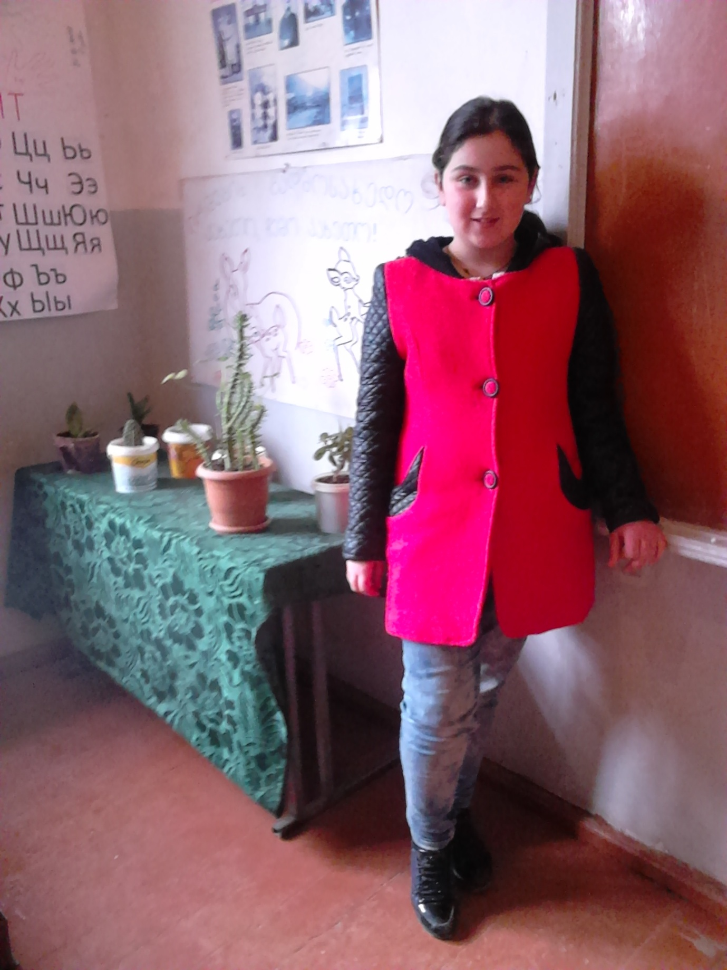
Hi!
I’m Lika Avalishvili, I’m 10 yars old. I have one brother. My favorite school subject is nature, Georgian history and English Languige. In my free time I playng and reading the book. I’m glad to work with you in this project . Best Regards, Lika.
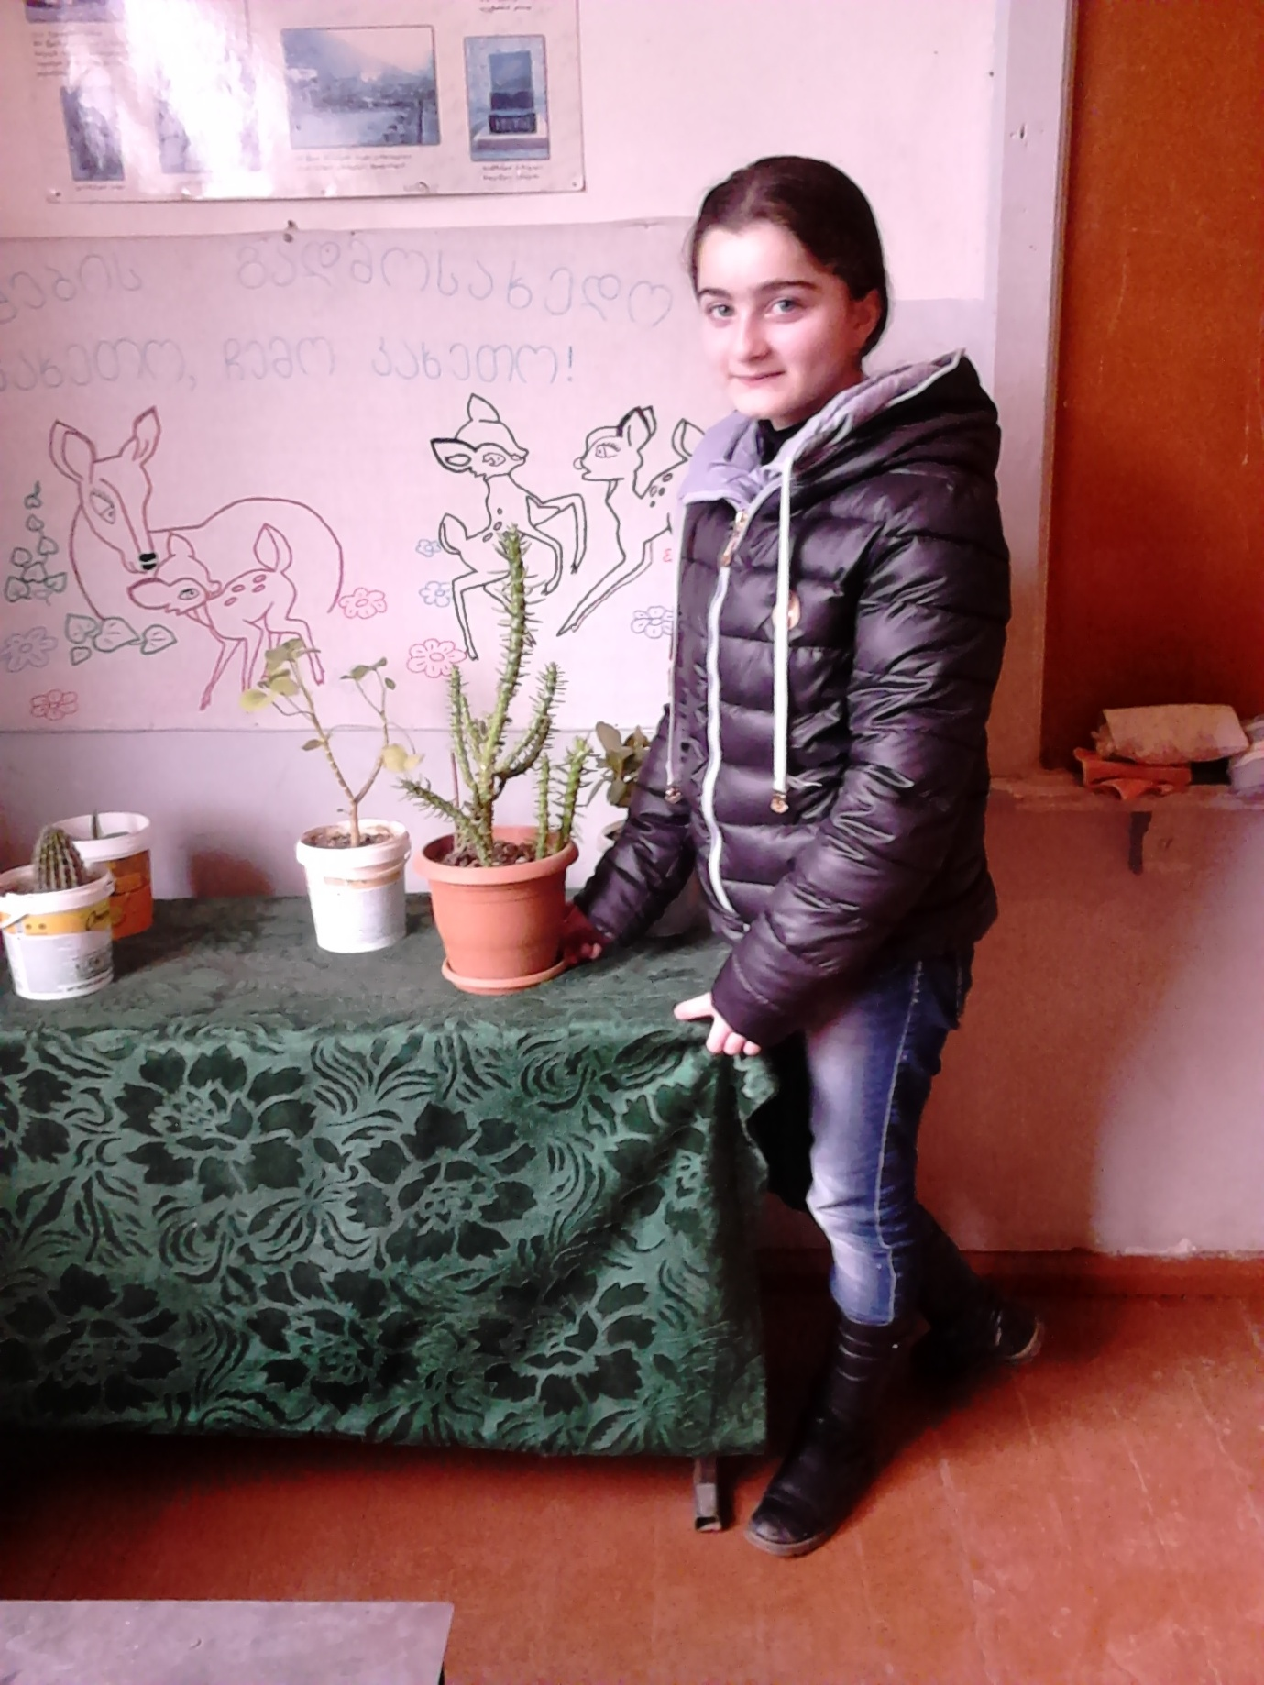
Hello! Nice to meet you all! I’m glad to work with you in this project . I’m Mariam Gabashvili, I’m 10 yars old. I have two brothers. My favorite school subject is nature, Georgian history and sport. In my free time I dancing and reading the book. I’m glad to work with you in this project . Best Regards, Mariam.
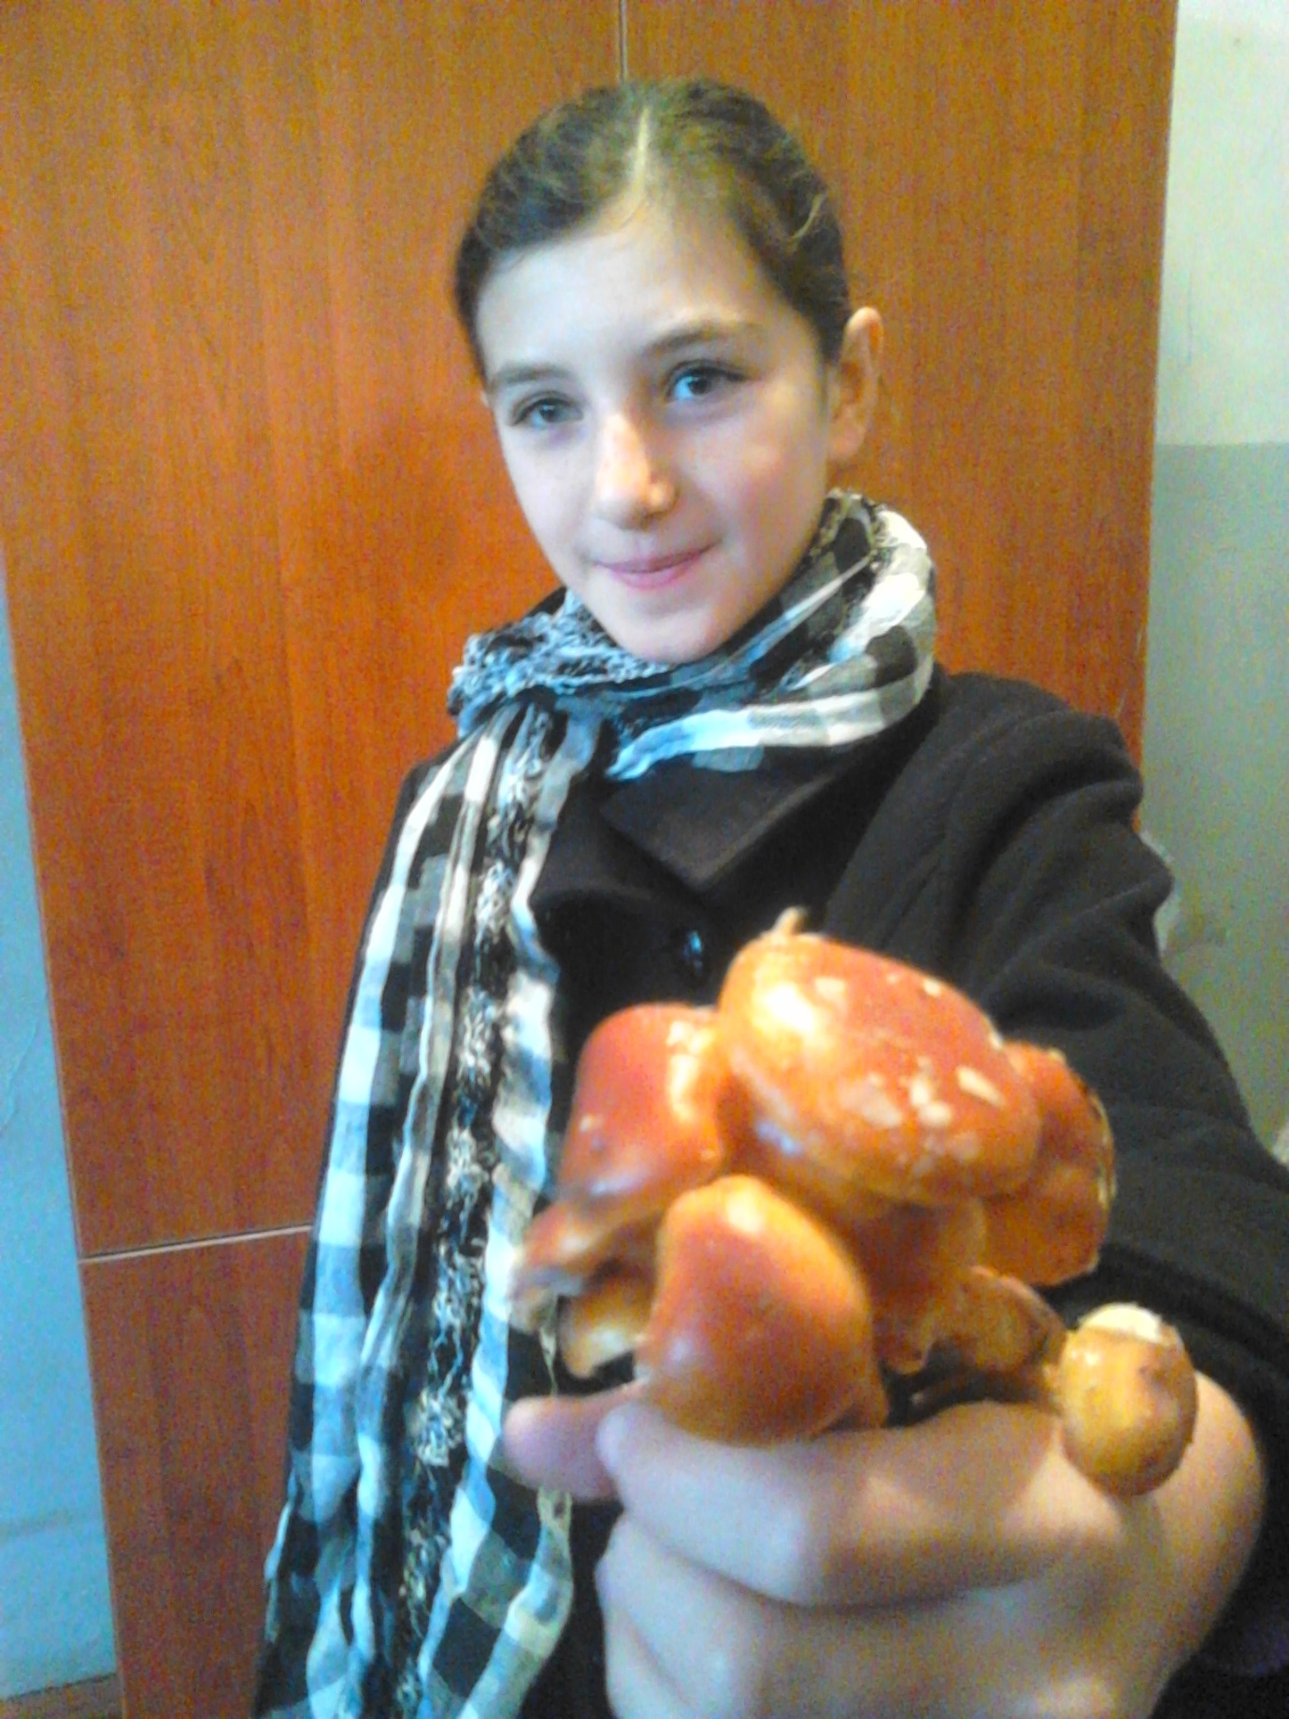
Hello! Nice to meet you all! I’m Tamuna Laghidze, I’m 10 yars old. I have one brother. My favorite school subject is math, Georgian languige and sport. In my free time I dancing with my classmates and reading the book. I’m glad to work with you in this project . With love, Tamuna.
