Europeana Learning Scenario

Title
Greetings from the Past
Author(s)
Anita Lasić
Summary

Table of summary
Subject | English, History, Geography, ICT.
Topic | Historic Landmarks of Croatia as Shown in the Vintage Postcards
Age of students | 14
Preparation time | 10
Teaching time | 45 minutes in the classroom
Online teaching material | List here all the links of online tools, applications and support documents that you will use during the lesson, such as: Padlet, Kahoot, Historiana, etc.  Google sites: https://bit.ly/2VhGReE  Kahoot:  Wikipedia: https://bit.ly/1IJQQeM  Wikipedia: https://bit.ly/2TB2QM7  Wikipedia: https://bit.ly/2AD6EFv  Google questionnaire: https://bit.ly/2THqNRV
Offline teaching material | List here all the offline tools, such as:  paper, glue, markers, worksheets, poster.
Europeana resources used | List here links ALL of the Europeana resources used for this learning scenario.  Four Europeana vintage postcards: https://bit.ly/2Fc6vNh

Licenses
Please indicate below which license you attribute your work with by picking one of the options below. We do NOT recommend the last option – in case you pick that one, your work will not be translatable or editable. If you include images in the learning scenario, please make sure to add the source and licenses under the pictures themselves.
- Attribution CC BY. This license lets others distribute, remix, tweak, and build upon your work, even commercially, as long as they credit you for the original creation. This is the most accommodating of licenses offered. Recommended for maximum dissemination and use of licensed materials.
- Attribution ShareAlike CC BY-SA. This license lets others remix, tweak, and build upon your work even for commercial purposes, as long as they credit you and license their new creations under the identical terms. This is the license used by Wikipedia, and is recommended for materials that would benefit from incorporating content from Wikipedia and similarly licensed projects.
- Attribution-NoDerivs CC BY-ND. This license allows for redistribution, commercial and non-commercial, as long as it is passed along unchanged and in whole, with credit to you.
- Attribution-NonCommercial CC BY-NC. This license lets others remix, tweak, and build upon your work non-commercially, and although their new works must also acknowledge you and be non-commercial, they don’t have to license their derivative works on the same terms.
- Attribution-NonCommercial-ShareAlike CC BY-NC-SA. This license lets others remix, tweak, and build upon your work non-commercially, as long as they credit you and license their new creations under the identical terms.
- Attribution-NonCommercial-NoDerivs CC BY-NC-ND. This license is the most restrictive of the six main licenses, only allowing others to download your works and share them with others as long as they credit you, but they can’t change them in any way or use them commercially.
Integration into the curriculum
Detail in a few sentences how the topic of the learning scenario will fit into your national curriculum.
Croatian National Curriculum has accepted the eight key competences as the basis of the learning process. This project is competence-oriented. It will help our students improve their linguistic competence. They will do the research work in Croatian and English and create material in English. Furthermore, students will improve their ICT competence by using and creating digitized learning material. In addition, they will improve their cultural awareness by getting to know Croatian cultural heritage and using it for educational aims. They will also learn how to learn by doing part of the job individually and in teams. They will improve own autonomy by being responsible for the research parts of the project activities. They will learn how to collaborate with other students by working together on the presentation. They will give a presentation to the class thus improving own presentation skills.
Aim of the lesson
Describe in 1-2 sentences what you would like to achieve with your students by the end of the lesson.
The students will be able to navigate Europeana collections and get the key information about the items they work on. They will work in teams thus improving their team work and collaboration skills.. They will also conduct online research to get other information about the landmark. They will be able to present their findings about the postcard they have researched. They will improve their ICT competence by searching, summarizing, categorizing and presenting information in the digital form. They will be able to name some of the most important historical landmarks in Croatia.

Trends
List the relevant trends that the lesson incorporates: http://www.allourideas.org/trendiez/results
Project-Based Learning: students get fact-based tasks, problems to solve and they work in groups. This kind of learning usually transcends traditional subjects.
Collaborative learning: a strong focus on team work.
Mobile Learning: we get access to knowledge through smartphones and tablets. It is learning anytime, anywhere.
Learning materials: shift from textbooks to web resources and open source books.
21st century skills
Add here how the learning scenario corresponds to 21st century skills. To find out more: http://www.p21.org/our-work/p21-framework .
By working on this project, students will learn how to obtain information from the Internet, how to interpret and analyze it. They will work in teams thus improving their cooperation and collaboration skills. By having to find facts in a text, they will improve their critical thinking. Once they deliver an oral presentation in fron of the class, they will improve their presentation skills. The whole task contributes to the improvement of their literacy, ICT literacy as well as cultural and civic literacy.
Activities
Describe here in detail all the activities during the lesson and the time they require. Remember, that your learning scenario needs to use Europeana resources.

Name of activity | Procedure | Time
Introduction | Teacher explains Europeana concept, its history and how to use it | 10
Implementation | Students are divided into four teams. Each team gets a worksheet with the necessary information and instructions on what to look for on Europeana and the Internet . | 15
Presentation | Students present their work to the rest of the class | 10
Assessment | Students solve the quiz (Kahoot) prepared by the teacher | 5
Conclusion | Students create a class poster by attaching worksheet on a piece of paper | 5

Assessment
Describe here the assessment method of the lesson, if any. For example, if you plan on assessing your students with a quiz, include here questions and answer options with color-coding the correct answers.

Teacher will prepare a Kahoot quiz with questions about Europeana and items dealt with during the lesson:
- What is Europeana?
- A digital platform for cultural heritage
- The portal to the past archives
- A game based platform
- An application to create online bulletin board
- Europeana provides access to …
- over 10 million digitised items
- over 27 million digitised items
- over 46 million digitised items
- over 53 million digitised items
- How many institutions across Europe have contributed to Europeana?
- more than 1,000
- more than 2,000
- more than 3,000
- more than 4,000
- When was the prototype of Europeana launched?
- In 2005
- In 2006
- In 2008
- In 2010
- Who was the publisher of the Dubrovnik postcard?
- Tošović
- Jos. Einerl
- M. Schulz
- Papirnica Vjekoslav Cvitanić
- Where are the four postcards stored / exhibited?
- At National and University Library
- At Mimara Museum
- At Museum of Modern Arts
- At Museum of Postcards
- Which of the postcards is the oldest?
- Pula (Arena)
- Pula (butterfly)
- Dubrovnik
- Split
- When did UNESCO adopt a proposal that the historic city of Split built around the Palace gets included in the register of World Cultural Heritage?
- In November 1978.
- In November 1979.
- In November 1980.
- In November 1981.
- When was the Arena built?
- Between 27 BC and 68 AD.
- Between 57 BC and 65 AD.
- Between 29 BC and 100 AD.
- Between 68 BC and 98 AD.
- What kind of stone material was used to build the Walls of Dubrovnik?
- Marble.
- Granite.
- Limestone.
- Slate.
******************************* AFTER IMPLEMENTATION ********************************

Student feedback
Add here the method with which your students will be able to give you feedback and discuss the lesson.
Teacher will prepare a questionnaire (Google Forms) with questions concerning students’ attitude, feelings, knowledge and skills. The
https://bit.ly/2THqNRV

Teacher’s remarks
Add here your comments and evaluation AFTER the implementation of this lesson. You can always use a rubric for self-assessment.

About the Europeana DSI-4 project
Europeana is Europe’s digital platform for cultural heritage, providing free online access to over 53 million digitised items drawn from Europe’s museums, archives, libraries and galleries. The Europeana DSI-4 project continues the work of the previous three Europeana Digital Service Infrastructures (DSIs). It is the fourth iteration with a proven record of accomplishment in creating access, interoperability, visibility and use of European cultural heritage in the five target markets outlined: European Citizens, Education, Research, Creative Industries and Cultural Heritage Institutions.
European Schoolnet (EUN) is the network of 34 European Ministries of Education, based in Brussels. As a not-for-profit organisation, EUN aims to bring innovation in teaching and learning to its key stakeholders: Ministries of Education, schools, teachers, researchers, and industry partners. European Schoolnet’s task in the Europeana DSI-4 project is to continue and expand the Europeana Education Community.

Europeana DSI-4 project
Worksheet 1
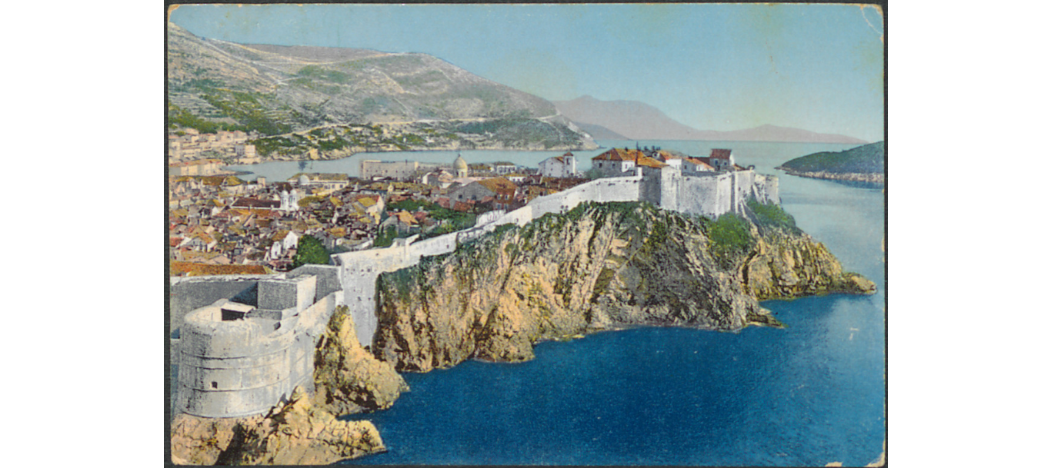
Dubrovnik – Ragusa; Tošović, 19__; Zbirka razglednica, Grafička
zbirka Nacionalne i sveučilišne knjižnice: Public Domain.

Task 1: Go to Europeana platform and find this postcard using this link or the QR code:
https://bit.ly/2sb6UXR

Task 2: Answer the questions.
- What town does this vintage postcard show? - ___________________________
- When was it sent? - ________________________________________________
- Where is it exhibited? - _____________________________________________
- What are the dimensions of the postcard? - _____________________________
- Who was the publisher? - ___________________________________________
- What historic landmark can you see? - ________________________________
________________________________________________________________
- Find the key info about the Walls of Dubrovnik on this site https://bit.ly/1IJQQeM and write a few sentences about them _________________________________
________________________________________________________________
Europeana DSI-4 project
Worksheet 2
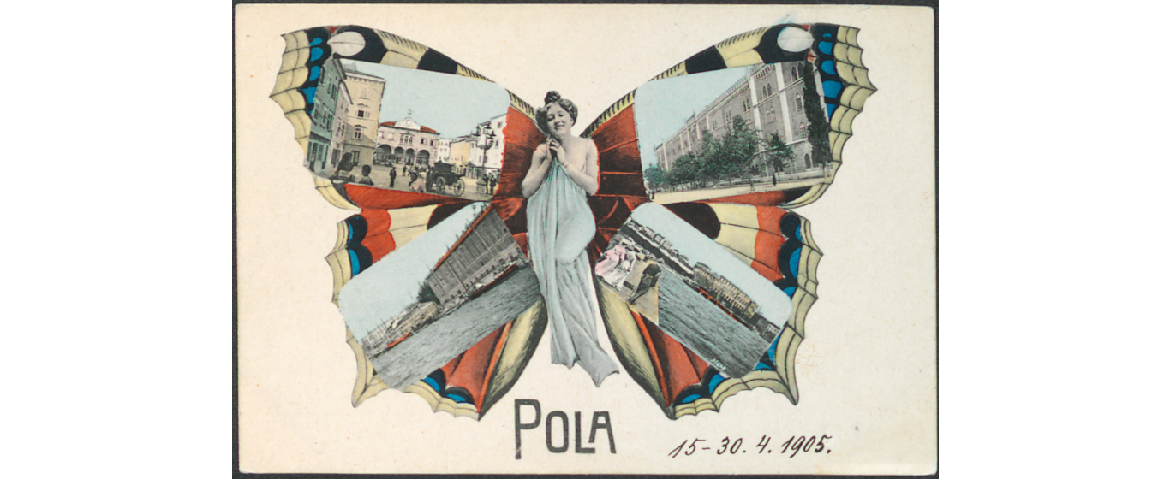
Pola; Jos. Einerl, 1905., Zbirka razglednica • Grafička zbirka
Nacionalne i sveučilišne knjižnice; Public Domain.

Task 1: Go to Europeana platform and find this postcard using this link or the QR code:

https://bit.ly/2C45umo | 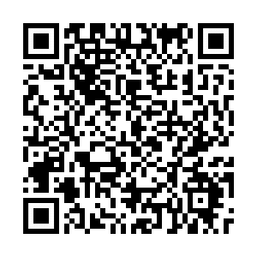
Task 2: Answer the questions.
- What town does this vintage postcard show? - ___________________________
- Where is it exhibited? - _____________________________________________
- What are the dimensions of the postcard? - _____________________________
- Who was the publisher? - ___________________________________________
- Was the postcard sent? - ____________________________________________
- Go to this site https://bit.ly/2TB2QM7 and get some key information about the Arena. __________________________________________________________
________________________________________________________________

Europeana DSI-4 project
Worksheet 3
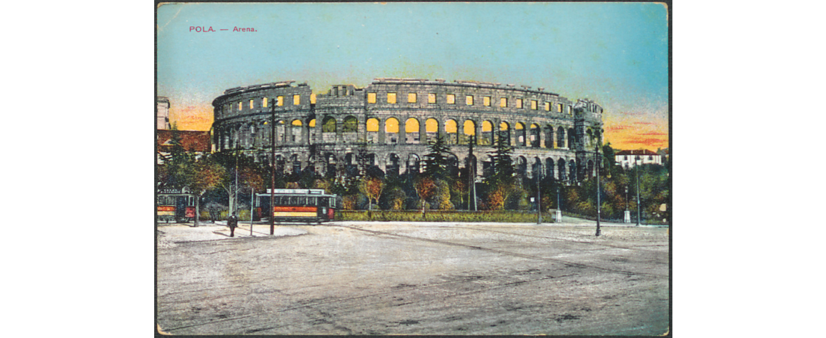
Pola: Arena; Prag: M. Schulz, 1915; Zbirka razglednica, Grafička zbirka
Nacionalne i sveučilišne knjižnice; Public Domain.

Task 1: Go to Europeana platform and find this postcard using this link or the QR code:
https://bit.ly/2seCjbS | 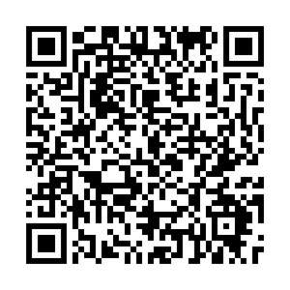

Task 2: Answer the questions.
- What town does this vintage postcard show? - ___________________________
- When was it sent? Was it sent? - _____________________________________
- Where is it exhibited? - _____________________________________________
- Who was the publisher? - ___________________________________________
- What historic landmarks can you see? – _______________________________
- Go to this site https://bit.ly/2TB2QM7 and get some key information about the Arena. __________________________________________________________
________________________________________________________________
Europeana DSI-4 project
Worksheet 4

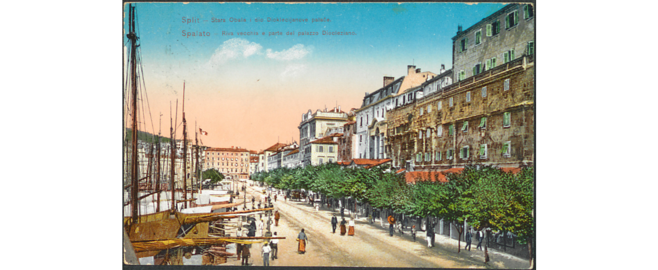
Split: stara obala i dio Dioklecijanove palače; Papirnica Vjekoslav
Cvitanić (godina 19--); Zbirka razglednica • Grafička zbirka NSK;
Public Domain.

Task 1: Go to Europeana platform and find this postcard using this link or the QR code:
https://bit.ly/2SF9hhb

Task 2: Answer the questions.
- What town does this vintage postcard show? - ___________________________
- Where is it exhibited? - _____________________________________________
- What are the dimensions of the postcard? - _____________________________
- Who was the publisher? - ___________________________________________
- What historic landmarks can you see?- _________________________________
- Go to this site https://bit.ly/2AD6EFv and get some key information about Diocletian's Palace. ________________________________________________
________________________________________________________________

