Project: “Present for the future” | Tasks for research | Group 1
Members: Adriana,Lena,Jessica,Jan-Justin (GER),Patrick,Alexandru (RUM),Dorota, Sara(POL),Benjamin,Karen(FR)

Explore the three nature reserves “Biesterberg“, nature park “Senne“ and “Bega“ more closely and do the following tasks:

1. Collect data and facts through surveys and observations during the excursions and during the subsequent project work phases.
2. Take a photo of interesting details.
3. Write down the results in the following table first and then in the respective file on the computer and upload your photos.

Assignment:

Describe the nature reserves in terms of their geographic location, size, geological features and the sort/nature of the area.

Biesterberg | Senne (Moosheide) | Bega
Geographic location:  -outskirts of Lemgo  -on a hill  -surrounded by settlements  Size:74.44 ha  Grassland approx. 20 ha  Scrubland approx. 20 ha and the rest is forest  Geological features:  -the ground is uneven, because of old tank tracks  -today the tractor replaces the tanks  Sort/nature of the area:  -central area is an open meadow  -large forest areas  -green area is expanding because there are no more tanks which destroy the ground.  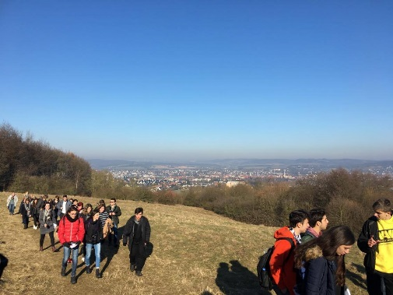  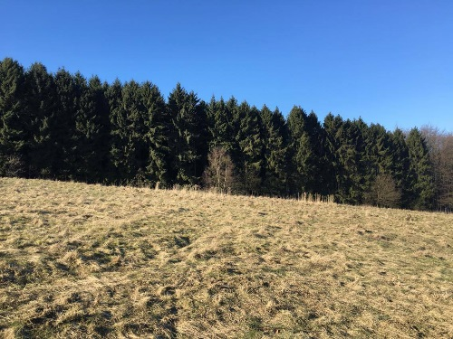  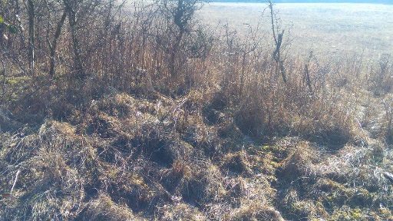  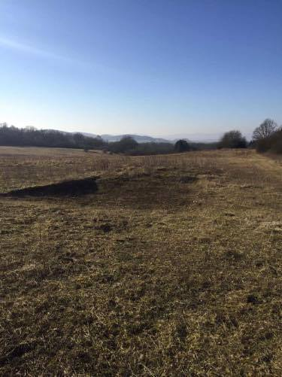 | Geographic location:  -located close to ‘Teutoburger forest and central Bielefeld  Size:  25,000 ha of which 11,600 ha are used by the military  Geological features:  -A part of the area is used as a group training place  -the Ems has its source there and flows towards Oerlinghausen  Sort/nature of the area:  - sandy area with heathlands  -surface with neglected grassland and inshore waters  -comprehensive nature  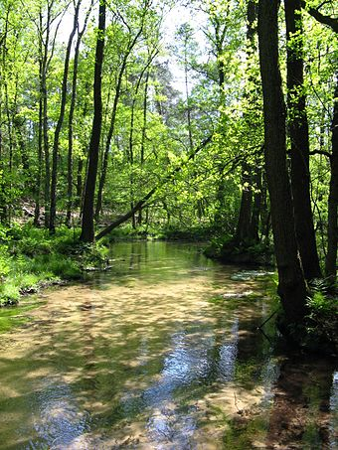  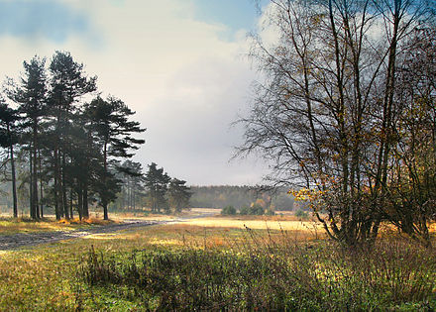 | Geographic location:  -flows east towards the river ‘Werre‘, a side stream of the river ‘Weser‘  -flows through the ‘Lipper‘ mountains  Size:  -43,9 km  -includes 37.670 ha  Geological features:  -The Bega tends to overflow a lot  Sort/nature of the area:  -is a flat river  