Project: “Present for the future” | Tasks for research | Group 5
Members: Margot Froin FR, Jackie Penner DE, Emilia Florczyk PL, Maria Wielgat PL, Mikolaj Suliga PL, Thiemo Utanc DE, Vincent Wussow DE, Denis Heidebrecht DE, Wolf Patrick Görner DE

Explore the three nature reserves “Biesterberg“, nature park “Senne“ and “Bega“ more closely and do the following tasks:

1. Collect data and facts through surveys and observations during the excursions and during the subsequent project work phases.
2. Take a photo of interesting details.
3. Write down the results in the following table first and then in the respective file on the computer and upload your photos.

Assignment:

Explain the importance of nature reserves for the regional development of tourism and the value of these areas as a local recreation area in the past, present and future.

Biesterberg | Senne (Moosheide) | Bega
-Visitors to the conservation area are able to do lots of different activities on these grounds which endanger the species living there (exercising, jogging, dog walking, etc.)  -People love walking their dogs there because they feel they can let them run around freely  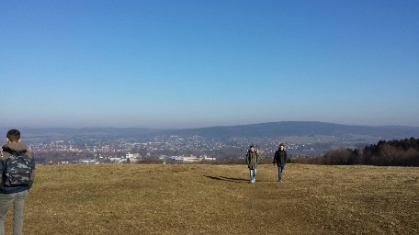  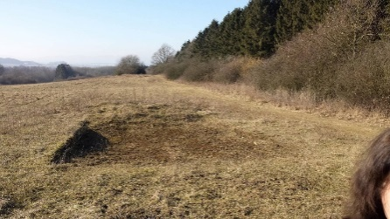  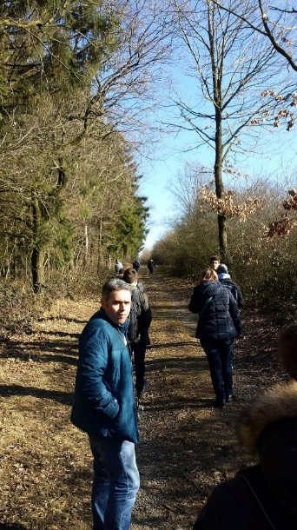  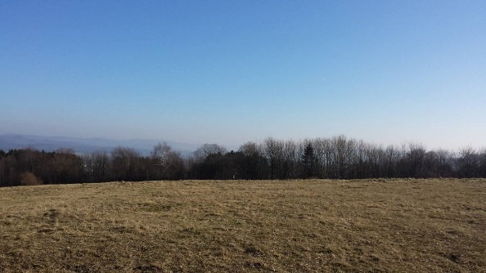  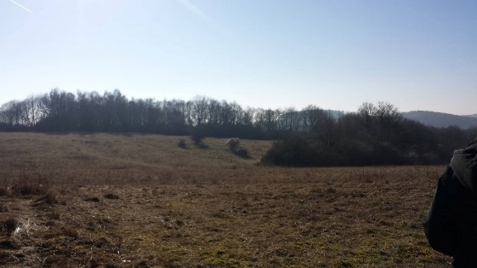 | - Two roads cross the Senne, which makes it very accessible, but endangers the area  - The beautiful landscape is a magnet for people who love nature  - Dogs destroy the nests of birds on the ground a problem  - There are information boards, where visitors to the site can read more about the area and the animals living there  - Horses can be seen in a natural environment  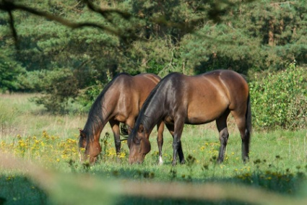  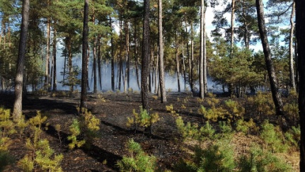  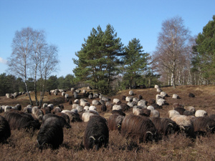  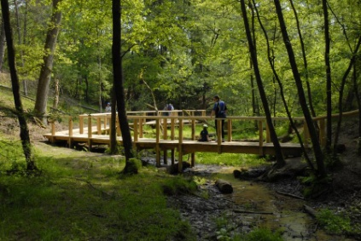 | - There are bike paths, trails tourists can use them and enjoy the natural view of the Bega  - A beautiful castle is located near the Bega  - People dump their rubbish around the Bega  - Several additions to the layout of the surroundings have made the area attractive for relaxation; particularly the "Langenbrücker Tor"  