–Project: “Present for the future” | Tasks for research | Group 4
Members: Alina, Raphael, Marvin, Helena, Maletz, Mete, Berke, Marine, Raouen
Explore the three nature reserves “Biesterberg“, nature park “Senne“ and “Bega“ more closely and do the following tasks:

1. Collect data and facts through surveys and observations during the excursions and during the subsequent project work phases.
2. Take a photo of interesting details.
3. Write down the results in the following table first and then in the respective file on the computer and upload your photos.

Assignment:

Explain the legal regulations for the establishment and conservation of nature reserves.
Juxtapose the aspects of financing, cultivtion and all related problems of these three nature reserves.

Biesterberg | Senne (Moosheide) | Bega
Challenges:  -People throw their litter into the woods although this is strictly forbidden by law  -Free walking dogs destroy the natural habitats of some birds  -Plants and species are endangered because security regulations are not strict enough.  Financing:  -1870: Lemgo bought the area it was forbidden for the villagers to use the area  -After the British army had left, the foundation “Staffstiftung” bought the area and since then has taken care for it  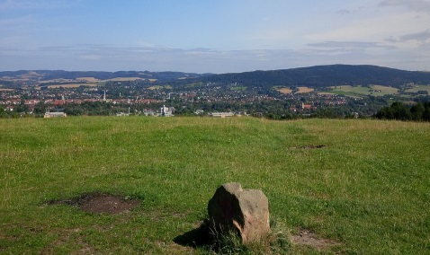 | Challenges:  -People want to spend more time in the conservation area. However, this chases away the animals  -If people ignore the designated walking areas, they destroy the plants and insects get crushed  -Visiting the site may be dangerous because there is still some ammunition left  -Visitors scare birds as a consequence they neglect their eggs  Financing:  -The biological station of Paderborn takes care of environmental matters  -Münster council supports nature protection in the area  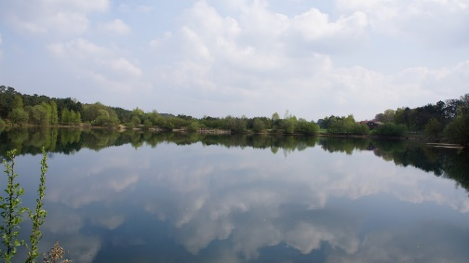  Would it not make sense to protect our environment rather than try to change it?? | Challenges:  -People throw away their litter  -Often high tides  -Houses can get flooded and it costs a lot of money to repair the buildings  Financing:  -Lemgo council pays for safety measurements  