

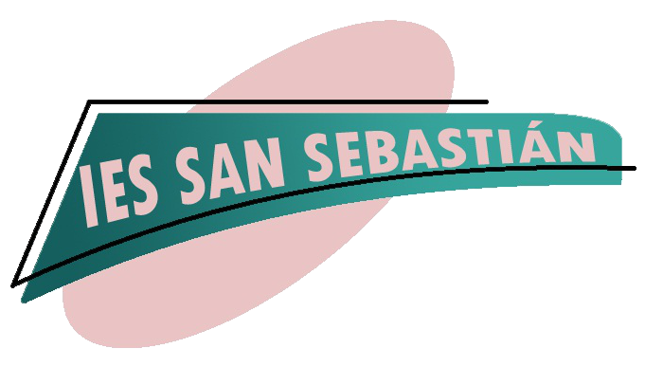

Huelva, 9th September 2021

Headmaster: **Mr Juan Antonio Cantisán**

IES San Sebastián

Ave Andalucía s/n

21006 HUELVA (SPAIN)

**Formal invitation to ……. and ….**

We are pleased to inform you that our highschool **IES San Sebastián** in Huelva, Spain, is formally inviting you to visit our institution within the **ERAMUS PLUS KA226 We are Ready for Digital World** from **4th to 5th October 2021,** with the following purpose:

* Presentation of the school Board
* Meeting the Erasmus working team
* Meeting IT students involved in the project
* Learning about our methodology and how the different departments work.
* To plan the **chronogram** of activities to be carried out in the two-year project
* Getting to know about **cultural and educational activities** carried out, both addressed to students and teachers
* To set up **e- Twinning** platform as well as the **web page** to disseminate the project

Yours faithfully

**Mr. Juan Antonio Cantisán**

Headmaster at IES San Sebastián (Huelva)

**PS:** We are also available at

Sending organisation: IES San Sebastián

Address: Ave Andalucía s/n

ID: KA226-3E2ABCD7

Telephone: +34959524177

E-mail: 21700010.edu@juntadeandalucia.es

Contact person: **Carmen Fernández Nevado**

E-mail: mfernev694@g.educaand.es

Telephone: 619851270