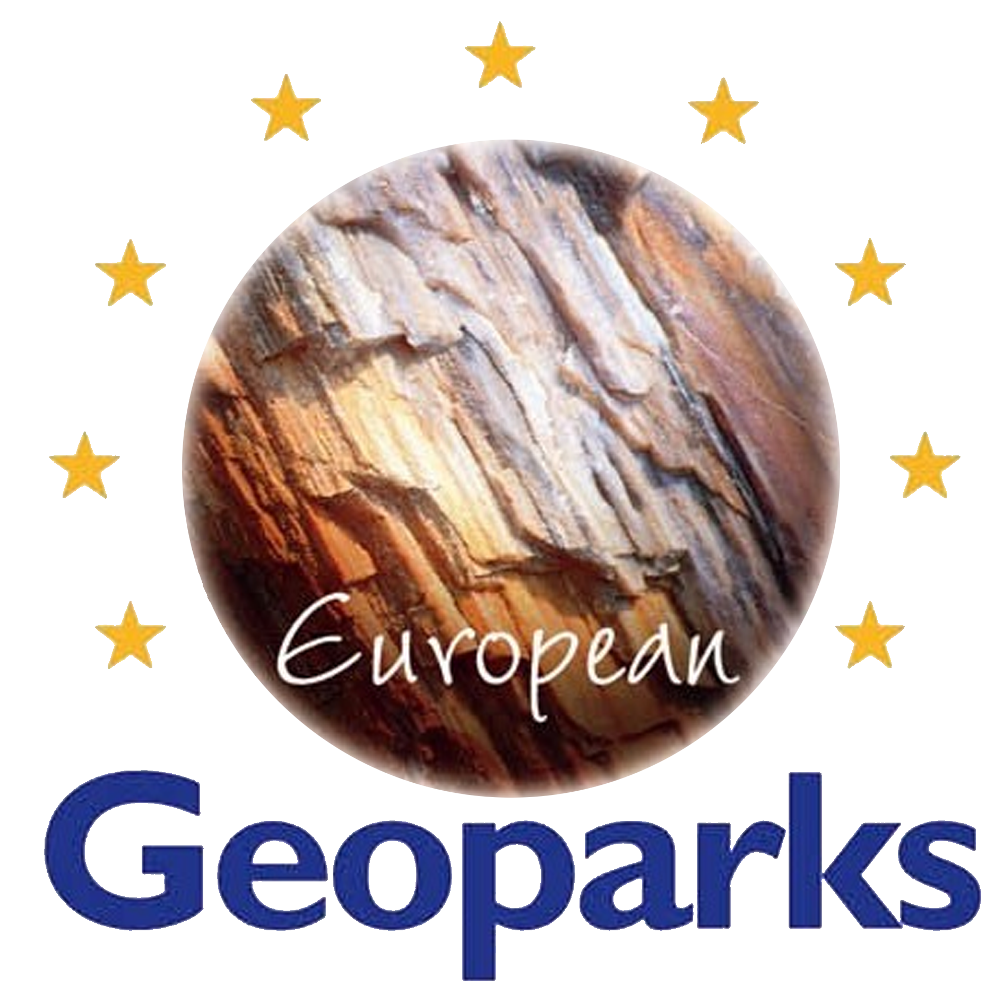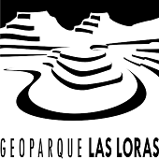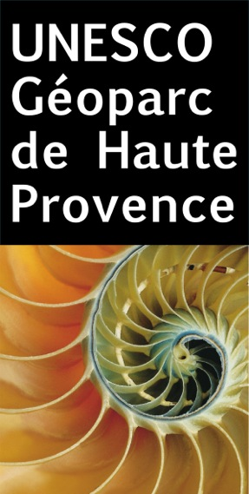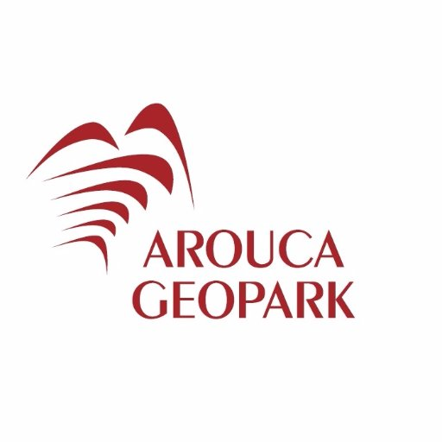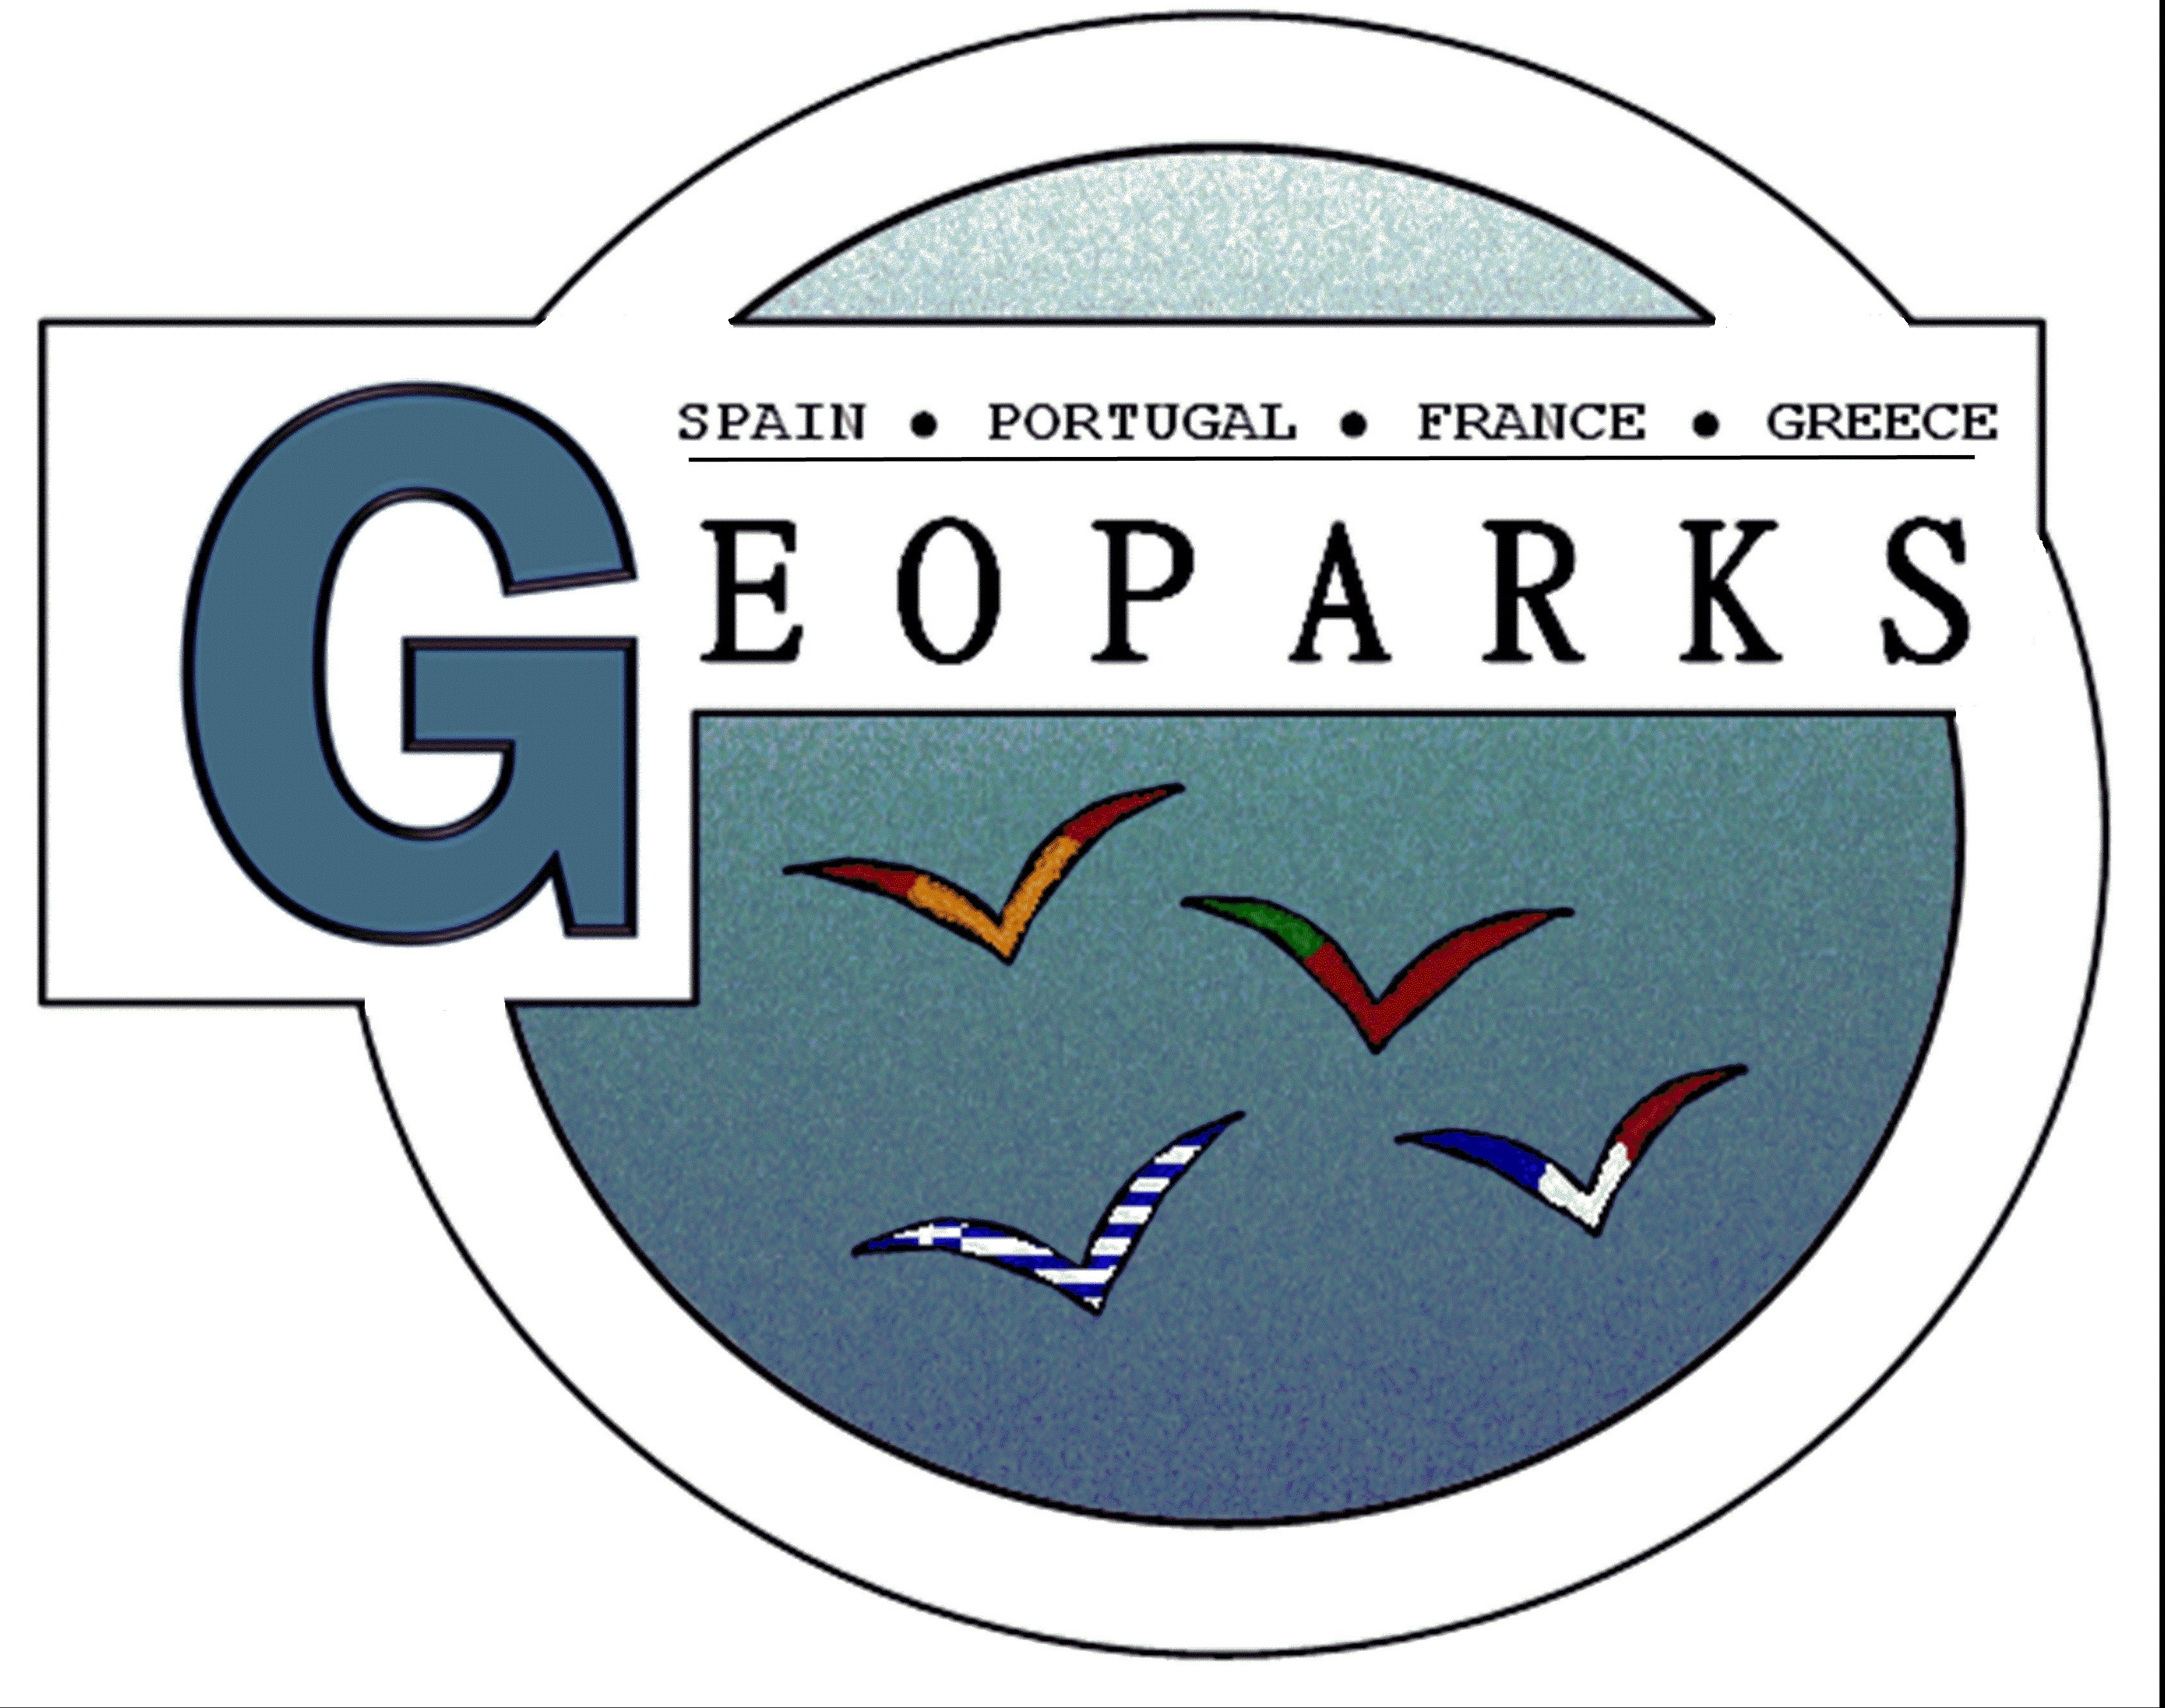

COMPARATIVE ANALYSIS FLORA and FAUNA

Geopark | Flora |  |  | Fauna
Geopark | Herbaceous | Bushes | Trees | Fish | Insects | Amphibians | Reptiles | Birds | Mammals
HAUTE PROVENCE  (France) | Edelweiss  Orchid (Sabot de Venus, Nigritelle, Limodore)  Lilium martagon  Orange lily  Lilium pomponium  Paeonia peregrina  Dracocephalum  Primrose marginata  Laîche des tourbières Carex limosa  Trichophorum alpinum  Minuartia rupestris | Genet radié | Juniperus oxycedrus  Juniperus communis  Juniperus phoenicea  Juniperus thurifera | Apron du Rhône  Salmon trutta | Rosalie des Alpes  Isabelle de France  Proserpine | Bombina variagata  Salamender  Triturus alpestris | Orsini’s viper  Ocelleted lezard | Tetras Lyre  European bee-eater  Griffon vulture  Cinereous vulture  Royal eagle  Tetrax tetrax | Beaver  Ibex  Chamois  Wolf
LESBOS  (Greece) | Paeonia,  Alyssum, lesbiacum,  Alyssum umbellatum,  Fritillaria theophrasti,  Stachys cretica lesbiaca,  Asperula nitida mytilinica,  Haplophyllym megalanthum,  Lavander,  Crocus,  Tulipas,  Violas,  Orchids,  Camomile,  Rosemary,  Sage,  Oregano,  Dittany,  Thyme,  Anemone,  Poppy,  Yellow rhododendron, Alyssum, lesbiacum, Alyssum umbellatum, Fritillaria theophrasti, Stachys cretica lesbiaca, Asperula nitida mytilinica, Haplophyllym megalanthum, Comptoglossum agiasense , Himantoglossum, Compreria comperiana, Ophrys lesbis, pears of Lesvos, local species of mountain tea, sand flowers | Yellow rhododendron,  Myrtle,  Styrax,  Spartum,  Oleander bush,  Berries,  Chinese dates,  Apollo’s laurel, | Olive trees ,  Chestnut tree,  Platanus,  Pinus brutia,  Pinus nigra,  Pinus pinea,  Oak tree,  Elm trees,  Samboukos,  Tamarix,  Almond tree,  Walnut tree,  Cherry tree,  Plum tree,  Figs, | Sardine,  Mackerel,  Cod fish,  Short fish,  Red snapper,  Kotsomoura,  Octopus,  Squid,  Kalamari,  Ursine,  Massels,  Etc... | dragonflies ( 45 species),  bees ( 430 species ),  butterflies | Frogs ( 4 species),  Turtles ( 4 species), | Lizards (6 species),  Snakes ( 11 species)  ottaman viper | (325 species): Seagull,  Tourkotsompanakos,  Geese,  Smirnotsichlono,  Stork,  Hawk,  Ardeidae family (14 species),  Birds of the olive groves(22 species),  Swallows,  Flamingo,  black stork, seagull (larus auduini), hawks (falco elenorae, falcon naumanni)  , sitta krueperi, asian geese, emberiza cineracea | Asian squirrel,  Fox,  Ferret,  Cat,  Rabbit,  Porcupine,  Lizard,  Otter,  Weasel,  Roe,  Boar,  Dolphin,  Asian squirrel
AROUCA  (Portugal) | Mosses  (Andreaea frigida;  Sicrano scoparium; Sphagnum spp)  Fern  (Dryopteris filix-mas; Osmunda regalis)  Sundew  (Drosera intermedia)  Rushes  (Juncus spp)  Golden bells  (Narcissus bulbocodium)  Opened Capsule  (Merendera pyrenaica)  Anarrhinum longipedicellatum;  Narcissus cyclamineus;  Fritillaria pyrenaica  Gentian (Gentiana pneumonanthe) | Rhododendron  (Rhododendron ponticum)  Strawberry tree  (Arbutus unedo)  Heather  (Erica spp)  Gorse  (Pterospartum tridentatum ) | Alder tree  (Alnus glutinosa)  Willow tee  (Salix spp  )  Bay tree  (Laurus nobilis)  Chestnut tree  (Castanea sativa)  Oak tree  (Quercus pyrenaica)  Holly  (Ilex aquifolium)  Pine tree  (Pinus sylvestris ; Pinus pinaster) | Trout  Salmo trutta  Barbel  (Luciobarbus bocagei)  Bordalo (Squalius alburnoids) | Dragonflies (Calopterix virgo ; Macromia splendens ; Oxygastra curtisi ; Pyrrhosoma nymphula)  Butterflies (Nymphalis antipoda; Argynnis paphia ; Charaxes jasius; Apatura ilia; Phengaris alcon; Iphiclides podalirius)  Grosshopper (Oedaleus decorus) | Salamander (Chioglossa lusitanica)  Newt  (Lissotriton boscai)  Frog  (Rana perezi ; Rana iberica)  Toad  (Bufo spinosus) | Snake  (Natrix natrix ; Malpolon monspessulanus)  Viper  (Vipera latastei)  Lizard  (Lacerta schreiberi)  Three toed skink (Chalcides striatus) | Kingfisher  (Alcedo atthis)  Dipper  (Cinclus cinclus)  Jay  (Garrulus glandarius)  Rock Thrush (Monticula saxatilis)  Eagles (Circaetus gallicus; Buteo buteo; Falco tinnunculus) | Otter (Lutra lutra)  Shrew mouse  (Crocidura russsula)  Hedgehog (Erinaceus europaeus)  Squirrel  (Sciurus vulgaris)  Boar  (Sus scrofa)  Genet  (Genetta genetta)  Wolf  (Canis lupus)  Wild rabbit (Oryctolagus cuniculus)
LAS LORAS  (Spain) | Evergreen plants  -Rock tea  -Bearberry  -Grass  -Legouminous  -Graminae  -Yellow flags  -Mentha  -Watercress  -Water Veronica | Willows  -Blackthorn  -Dog Rose  -Blackberry  -Gorse  -Maple  -Ash  -Poplar | Oak  -Beech  -Old man’s beard  -Aspen  -Yew | -Iberian nase  -Trout | -Apollo butterfly  -Golden ringed dragonfly  - Damselfies  -Spiders  -Iberian marble white | -Fire salamander  -Common frog  -Common toad | -Water snake  -Lizard  -Vipers | -Wild duck  -Griffon vulture  -Egypitian vulture  -Eurasian eagle-owl  -Common kingfisher  -Dipper  -Grey heron  -White wagtail  -Common nightingale | -Wolf  -Foxes  -Wild boar  -Roe deer  -Mole  -Otter  -Badger

Endangered
Endemism (local)

