Erasmus. Copenhagen, the 30. of November 2017
Carsten Hjorth Pedersen, Associate professor in pedagogy, general manager of Christian Pedagogical Institute

What values ​​and ideologies characterizes school and teaching?
How do we convey these values ​​and ideologies in respect of the students?

PART 1:
What values ​​and ideologies characterizes school and teaching?
A ”norm” means finding the vertical. Norm, normal, normality, normative
We see our own norms breefly when we meet other people, fx teachers from other countries.

Norms in the public school in Denmark:
• familiar with Danish culture and history
• understanding of other countries and cultures
• understanding of human interaction with nature
• participation, co-responsibility, rights and duties in a society of freedom and democracy
• spiritual freedom, equality and democracy.

Education and/or formation.
Danish Teachers' Association since 1920: "We learn for life, not for school."
Without a conscious mind, a school can convey norms like hedonism (feelgood as the highest good), materialism or "everyone makes his own happyness".

Wee cannot live without norms
Children and youth develop their own norms/standards if they meet standards from the environment they live in. In addition, therefore, the school must be normative. Not so that students unreflected takes over - or should take over - the norms they are affected by, but so that they can only develop their own norms if they meet norms. The norms are pointers without which we cannot find way through existence, whether the mark is "you must act against others as you want them to act against you" or "liberalism is the best model of society" or "Allah is great."

- “We cannot wipe ourselves out as civilians; we cannot take a dead or neutral position. It is indeed a triviality, but at the same time, it is the primary and most serious pedagogical case. Education is above all surrender, announcing what is important to ourselves. There cannot be any educational action where the adult does not communicate anything about himself and his way of life, intentionally or unwillingly.” (Mollenhauer 1996)
- ”So important it is to be able to interact with each other in a pluralist society, so important is not to get rid of pluralism, but do whatever you can to penetrate it into the context we try to convince each other about. If we abandon it and accept pluralism, we accept cohesion. If we accept cohesion, we accept communicationlessness. To abide by pluralism is spiritual laziness.” (Løgstrup 1985)
- “The second aspect of opposing democracy for the purpose of the school is that it places a burden on democracy that it is not created to bear. Democracy must make it a world of living and the world, and it is an overload of it. The task of democracy is one more modest, there is a proper way to disagree.” (Løgstrup 1985)
Means, content and methods.
The first is more characterized by norms than the last one. With “content” in the middle.

Facts, interpretation and ideology
We must also distinguish between different types of norms in school. For example, one can distinguish between facts, interpretation and ideology, where facts are the least and ideology is most normative with interpretation in an intermediate position. Let me exemplify:
• Facts that we normally do not doubt,
for example: “who was king in Denmark in 1970”
• Interpretations that may and should be discussed.
for example: “what the cause of the war in Syria is”
• Ideology, which can and should be discussed, but which lies on the conviction's plan, is, for example: “everything is relative”

Explicit or implicit norms
There is also a difference between explicit and implicit norms. Typically, the majority norms tend to be implicit and unclear because they must accommodate the width of a large group of people. The norms of minorities tend to become explicit and clear because they should define this particular minority in proportion to the majority.

What standards/norms do elementary schools in Denmark affect?
Children are keenly engaged in finding coherence, comprehension and meaning in existence. In order to assist students in this, the school must have a reasonably consistent overall view. But the question will be: What normative basis should the school have?
It will be too extensive here to specify what norms primary school and free elementary schools should be carried out - beyond what I have mentioned above. But let me mention some general norms that individual schools or teachers can inspire or challenge:
• Respect for other people.
• Altruism (i.e. care and helpfulness in relation to others).
• Responsibility.
• Independent.
• Ability to assess and evaluate.
• Self-awareness and solidarity.
• Critical and constructive citizens and consumers.
• Conclusions of the three classical virtues/norms: The good. The beautiful. The True.

Conversation 1
What standards - political, religious, moral, and philosophical - characterize the school you are working on? Are they coinciding with your personal standards?

Model for content analysis of education and teaching
By Professor Stein Wivestad, NLA College of Higher Education, Bergen

When one tries to clarify what different educators, educational directions or curricula stand for, it will often be possible to interpret the statements in relation to the twelve content categories below. The model may also be a pattern when one tries to develop an education and teaching course.

The first five points raise educational problems. Answer to basic questions acts as a program. Basic answers provide frames and can set directions for one's own business. The sixth point updates the root issues of seeing them in conjunction with a description and interpretation of the actual historical situation that one stands in, the seventh concludes with a prioritization of values, and the last points draw concrete educational consequences of the priority. Answering the latest questions will therefore be normative or prescribing statements. Note that the questions asked are examples of issues and not a complete list. Already the choice of problem implies that one opens up some answers and reveals the possibility for others.

Underneath our education (both system and practical) lies spoken or unspoken religious, political or moral premises and assumptions.
1. What is real?
Frames: What is happening in the world, no matter what man wants or does? How is the whole of what it is all about, ie also education and teaching?
Are there a God? And if there is, what is He like? Has He revealed himself or is He silent?

2. View of education and teaching
What distinguishes upbringing and teaching from similar positive or acceptable businesses, for example therapy, and from "depressing" businesses, such as terrorizing? Which metaphors (linguistic images) characterize self-understanding when one educates and teaches: promote growth, shape, wake up, meet, liberate, ....? How is the relationship between education and education and how is the relationship with concepts like care, development, socialization, birthing, upbringing, education, formation; instruction, dissemination, training, dressage, indoctrination?

3. Human perception
Frames: What are the human curiosities and limitations that one must base when educating and teaching? Why do people do evil actions? What metaphors characterize the understanding of man: building, organism, machine, ...? and of human life: race or battle in different arenas, responsibility, choice, community, service, ...? (See category 1).
Direction: What does it mean to "realize yourself" or to "be self"? What is "the good life" that we want the children / students to participate in?

4. View of knowledge and learning
Frames: What happens when one understands something when one experiences and learn?
Orientation: What is most to rely on: the revelation, the common sense, the formed judgment, the logical argumentation, the sense of impressions, ...? What can promote and what can inhibit the acquisition of reliable knowledge, effective skills and good positions?

5. Social view
Frames: How is the relationship between individual and society?
Direction: What kind of society should a self and future generations try to realize? What funds should be used to try to improve society or to counteract deterioration?

6. Current social and cultural criticism
What specific problems do you face, what dangers are there in the particular historical situation in which you are? (Global, international, national and local perspective).

7. Ranking of values
What are the most important values ​​that the children / students acquire, with the aim of living a good life and helping to improve society / culture? (1. ... 2. ... 3. ...).

8. Selection of content in the education and teaching
What study should the children / pupils meet and what kind of learning situations and learning environment should educators / teachers facilitate?

9. Distribution of responsibilities in the institution
What is the overall environment that can affect the children / students (both positive and negative) and what responsibilities and tasks should be added to home, neighborhood, health center, child welfare, kindergarten, schools, church, library, mass media ...?

10. Ethical guidelines for instructors / teachers
What attitudes should educators / teachers make through their personal role in the interaction with the children / students and the values ​​/ learning material? How should educators / teachers not be?

Conversation 2
Quickly review the ten categories. How can they help characterize the values ​​at your schools?

PART 2:
How do we convey these values ​​and ideologies in respect of the students?
Influence with respect

Invasion, desertion, confrontation, withdrawal
We have found that the school is normative. We have also seen that the norms are necessary both for creating interesting and relevant teaching and learning. But at the same time, we must see that the norms can cause harm to school, not because the norms are wrong or harmful in themselves; but because teachers' handling of them is wrong or harmful.
The challenge is this: When the school is normative, how do we organize the interaction in which the normative influence takes place so that it respects the students?

I have works with this under the subtitle influence with respect. I interviews about ten student about their experiences in their schooltime at for example Christian schools.
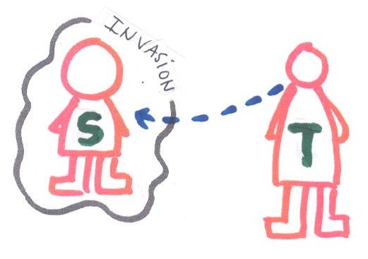 | 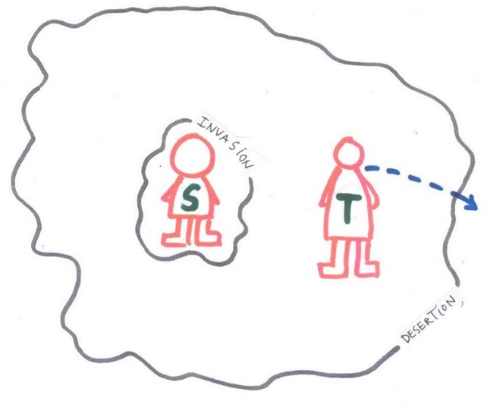

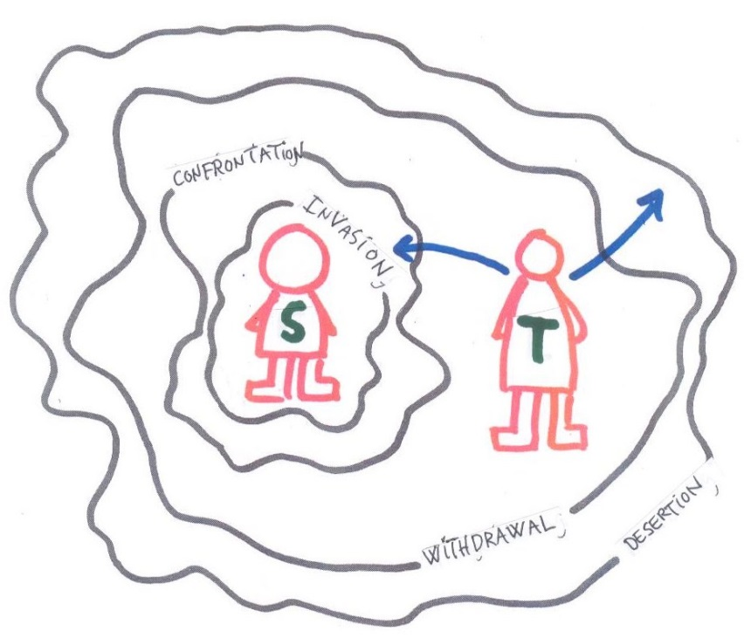
Five characteristics of a teacher who invades:
• Seeks too close to the student with his ideological message.
• Unusual or distorted representation of other people's views.
• The individual is subordinate / the community is always correct.
• Condemns - without being consciously - the student's own thoughts, feelings and will.
• Uses knowledge from the private sphere to manipulate the student.

Five characteristics of a teacher deserting:
• Fortify topics that are relevant to the student. Taboos.
• Taboos certain subjects, eg sex, death, suffering, evil.
• Lack of willingness to influence the student.
• Will not go into a difficult and essential field for the student.
• Lack of empathy.

Five characteristics of a teacher who confronts
• Consistent and clear speech.
• Willing to break taboos.
• Provides freedom within safe limits.
• Stands for something and is willing to move in the meeting with the student.
• Words and actions are relatively well connected.

Five characteristics of a teacher who makes a withdrawal
• Detects and admit own errors.
• Provides room for questions, doubts and dialogue.
• Have patience to wait for the student's readiness.
• Allow the student to be at peace when necessary.
• Does not deprive the student of a relevant responsibility.

Conversation 1:
Discuss the model and its applicability to your students and school!

Invasion and desertion is: betrayal (danish: svigt)
Confrontation and withdrawal is: respect
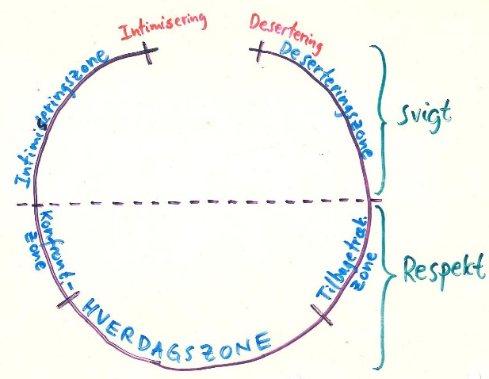
If the adult goes too close to the child, his own perspective and the child's perspective are blended to such an extent that the adults cannot separate their own needs from the child, and he is almost inevitably using the child in his own project.
It therefore also applies to being so far away from the child and in such a close contact with himself that the adult can distinguish his own needs from the child and given the child what it needs.
The exciting, but difficult art of education, education however, consists of being so close to the child that there is a good contact between the child and the adult, but at the same time being so far from the child that both the child and the adult get a good contact with myself.

Conversation 2:
How do we help ourselves and each other to invade and desert at least and to confront and retreat (withdrawal) to the appropriate extent and the right way?

Good influence requires freedom

If you love somebody, set her free.

If she comes back, she's yours.

If she doesn't, she never was.
”In the souls no forced knowledge can grow.” (Platon)

A respectfull teacher owns:
Self-awareness
Indivisibility and empathy
The ability to deal with freedom and firmness
Conversation 3:
Discuss the mentioned personal characteristics / characteristics of the teacher who, respectively, promotes or inhibits his / her ability to influence with respect.

CASES
I. Ali and Peter
Ali, who is in 9th grade, is very well formulated. During the last three to four lessons in social studies, he has argued for the abolition of democracy. He is highly accused of some form of Muslim theocracy in Denmark, Finland, Portugal, Germany, and Norway. The teacher in social science, Peter wishes - and is committed to - promoting freedom of the mind in class.
How does he go up to Ali and confront him with the democratic values ​​without hanging him out or making him laugh at the others in the class? In the name of spiritual freedom, Peter must not prevent Ali from advancing as he does. But how does Peter avoid both the intimacy and the desertion in the meeting with Ali and his classmates?

II. Jens and the environment
Jens has 7.b in Danish and biology. He is a charismatic person and a glowing environmentalist. Not least, the agricultural responsibility for the environment takes him a lot. Jens also believes that, with the words of the primary school's purpose of "understanding human interaction with nature," he is in a good right to influence the students in point 7.b with his views. However, in the class there are two students whose parents struggle hard to drive profitable farming. The parents of these two students certainly do not agree with Jens. They feel that with all their "environmental problems" he undermines their existence and even with tendentious pseudo-science skills.
How does Jens act in his education so that he avoids the important environmental issues, but does not particularly intimate the two mentioned students? How does respectful teaching in these subjects look like when Jens is the teacher in this class?

