**A selection of digital tools**

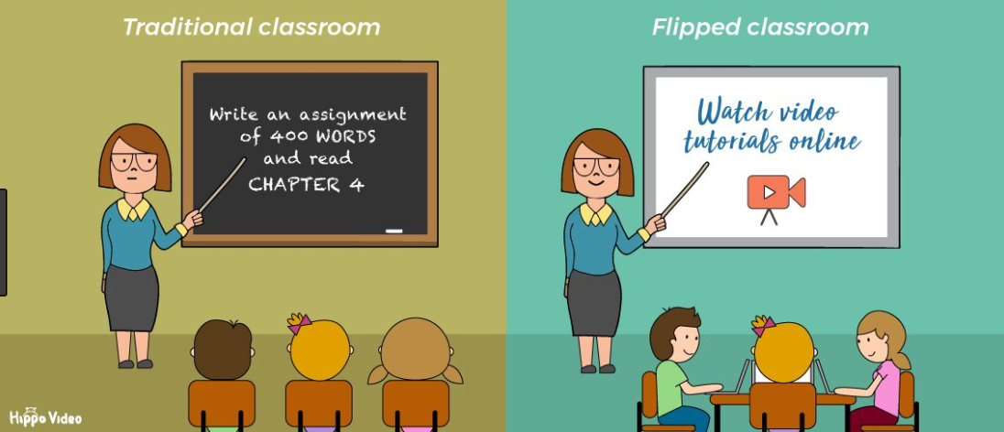





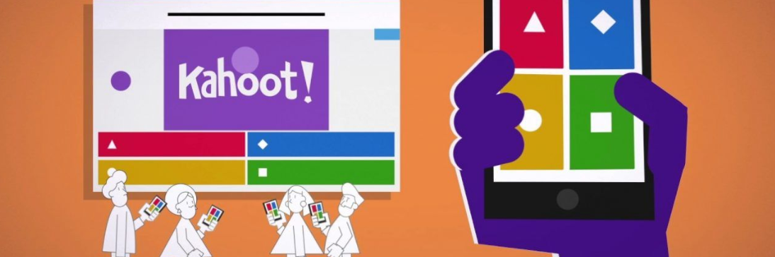

Made by teachers at SPUS

|  |  |
| --- | --- |
| Which digital tool? | **Flipped classroom** |
| What is the tool useful for? | It may be used in any subject, but it is often used in Math. When the students arrive at school, they are prepared for the topic and are ready to work with tasks, discussions etc. The teacher has more opportunities for individual follow up and continuous assessment. |
| Website and short explanation of how to use it. | <https://www.youtube.com/watch?v=26pxh_qMppE>  In traditional education, the teacher teaches a topic at school and then the students go home to work with tasks. By using flipped classroom, this it switched around. The students have homework prior to a lesson. It might be a film on YouTube or other websites. There are many good films online already. Some textbooks have films on their sites. The teacher might also make his or her own films. This might be more useful for the students as they know the teacher in the film and his or her methods. |
| Pros, cons and experiences with the tool. | You have the chance to watch it repeatedly. Easier to do the homework. The teacher has more time to help each student during the time in class. There will be more time at school to do the assignment and debate.  A negative part is that you cannot ask during the “lesson”.  Some of the students thinks that it is easier to get distracted at home. They also think that it would be best if the teacher made their own videos, even though that is more time consuming. |

|  |  |
| --- | --- |
| Which digital tool? | **Kahoot** |
| What is the tool useful for? | May be used for revision of concepts or facts. It is useful for learning definitions and grammar tasks. Is adjustable for every subject. Students and teachers may make Kahoots for different subjects. Students may “test” each other as a valuable learning process. |
| Website and short explanation of how to use it. | [www.create.kahoot.it](http://www.create.kahoot.it/)  Make a user profile to make and use existing Kahoots. In addition to quizzes, it is possible to make discussion groups, polls and a function called. Jumble is a game where the students must put the answers in the right order, like events during WWII. |
| Pros, cons and experiences with the tool. | A negative aspect might be that the students do not see the learning possibilities, only the fun of using their smart phones in class.  On the positive side, it is a motivational activity where you can revise concepts and factual knowledge. It is easy to make and very self-explanatory. The students think that it is a fun way to both learn and check how much they have learned. |

|  |  |
| --- | --- |
| Which digital tool? | **Prezi** |
| What is the tool useful for? | Presentations, used much like PowerPoint. |
| Website and short explanation of how to use it. | <https://prezi.com/dashboard/>  You make a profile on prezi.com where the presentations are stored. It works like Power Point but has a different design and look. It is also possible to search for existing Prezi-presentations online. |
| Pros, cons and experiences with the tool. | One of the advantages is the interesting design that captures the attention of the students, also the presentations are available if you are online, and you can find other presentations by googling the topic.  Some downsides are that it is difficult to save offline, it is a bit complicated to learn the programme and some of the tools cost money. |

|  |  |
| --- | --- |
| Which digital tool? | **Quizlet** |
| What is the tool useful for? | Learning new words, verbs and concepts. |
| Website and short explanation of how to use it. | <https://quizlet.com>  Website where teachers may add words and phrases the students can practice on. The teacher makes groups and adds sets of words. The students can search for their class or the sets of words or the name of the teacher.  There are different functions on the website like quiz, flash cards with an audio function, a meteor game, match two words, etc. In addition, there is a function called Quizlet Live, where the students are divided into random groups and each student has an answer on their phone. The point is that the students must work together as a group to decide what the right answer is. |
| Pros, cons and experiences with the tool. | Students find it more interesting to practise words this way than reading and writing. In addition, there is an app the students can download in addition to the website. The students find it easier to learn new words by using Quizlet. Quizlet live is more social.  A downside is that it is not possible to learn verbs in more than two tenses. Some of the students think it is easy to get distracted by other things on the computer or the smart phone. |

**Other useful links and programs**

Microsoft Office (Word, Power Point, Excel, etc).

Smart Notebook: <https://www.youtube.com/watch?v=8zeQo5H8HBY>

Digital storytelling: <https://www.youtube.com/watch?v=LVKeO5IIR_A>

<https://www.youtube.com/watch?v=pGJyrScH_hk>

<http://www.bbc.co.uk/learningenglish>

