The meeting in Finland January 28th till February 3rd

Monday 28th
Everybody had pleasant journeys and met already at the airport, where our loving hosts picked us up by cars and brought us to the hotel.

Tuesday 29th
In the morning, we were greeted by vice Principal Markku and the wonderful flute of Siri.
Then we checked out the Finnish online exams while touring the school.
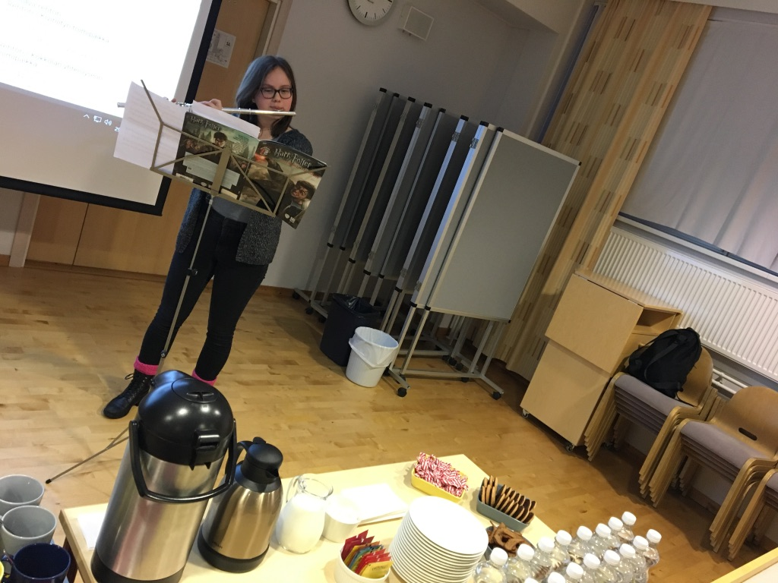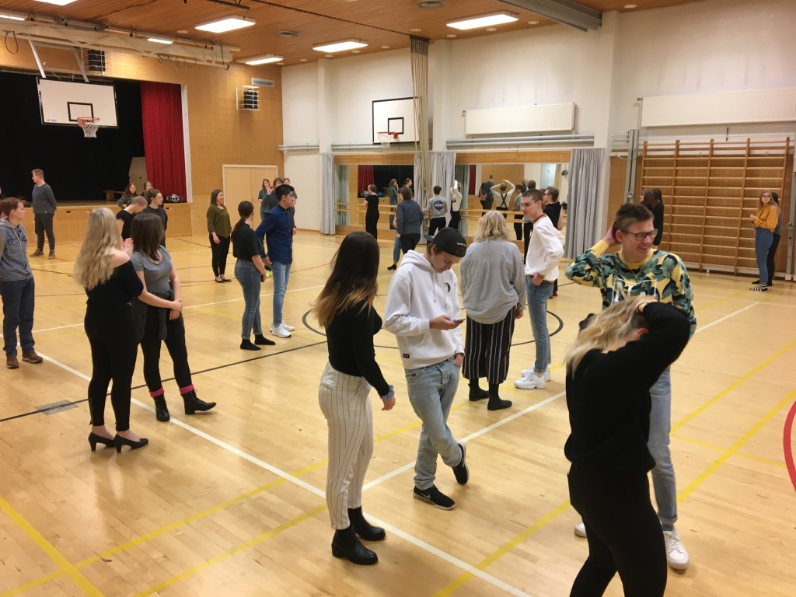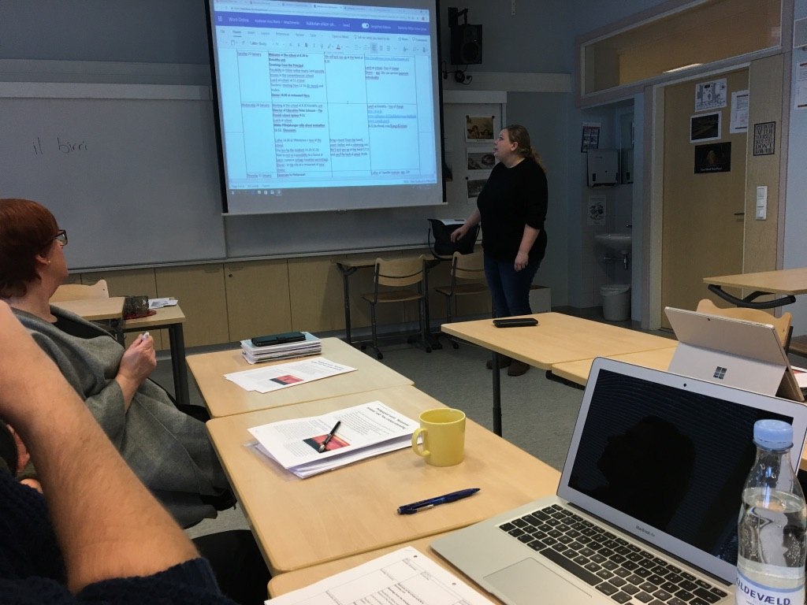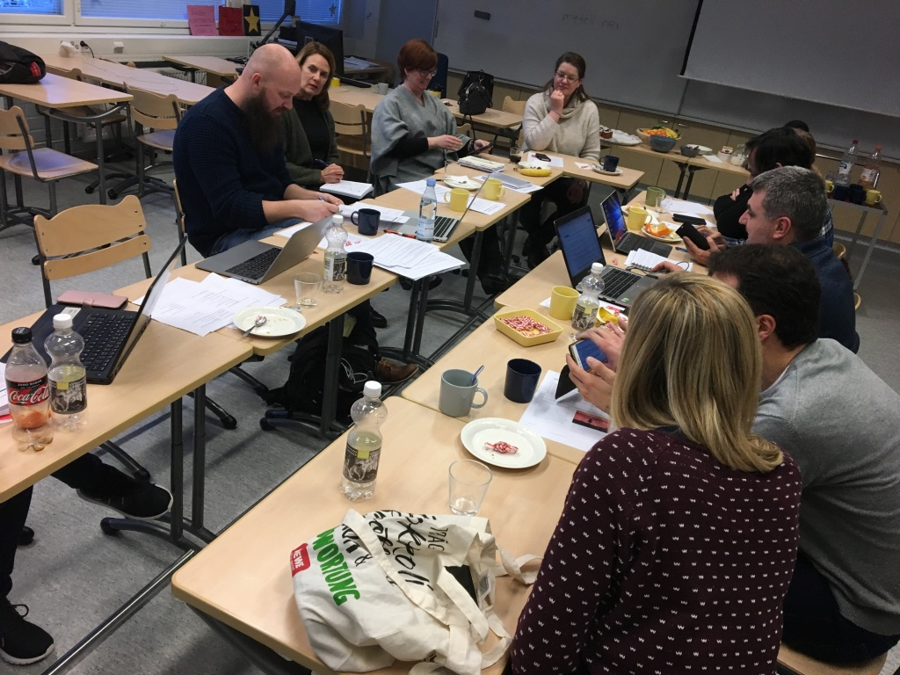
After a nice lunch provided by the school, we had our first teachers meeting.
On the schedule was a lot of going through the complete timetable of the project in order to see if everything was done and documented. A few tasks were pending and assigned (see meeting minutes for details)

Wednesday 30th
In the morning we were greeted by director of education in Kokkola Peter Johnsson. He gave a lecture on the Finnish education system and answered questions from the Erasmus team. Of course, a lot of attention was given to PISA and “The Finnish Model”.
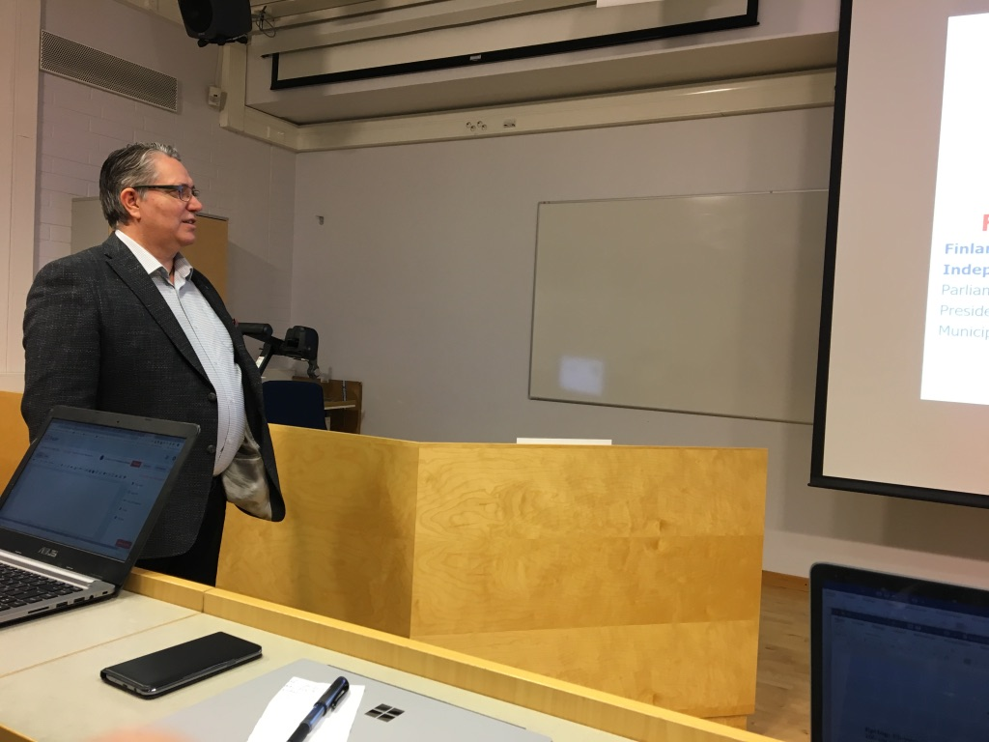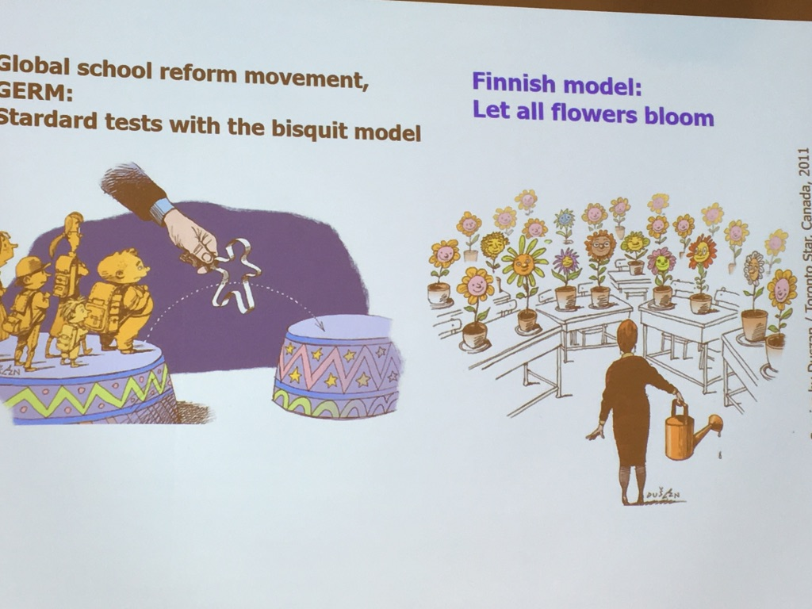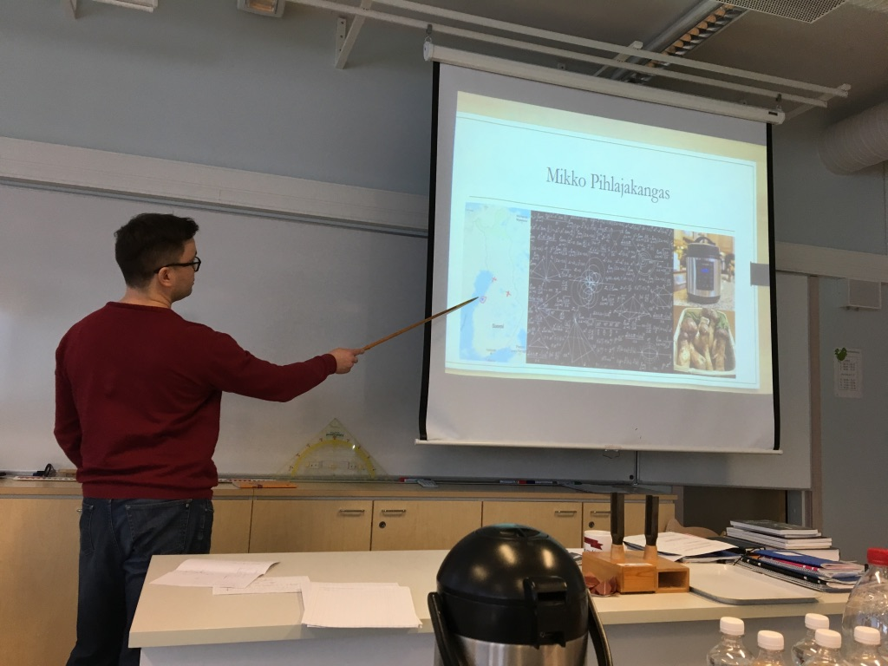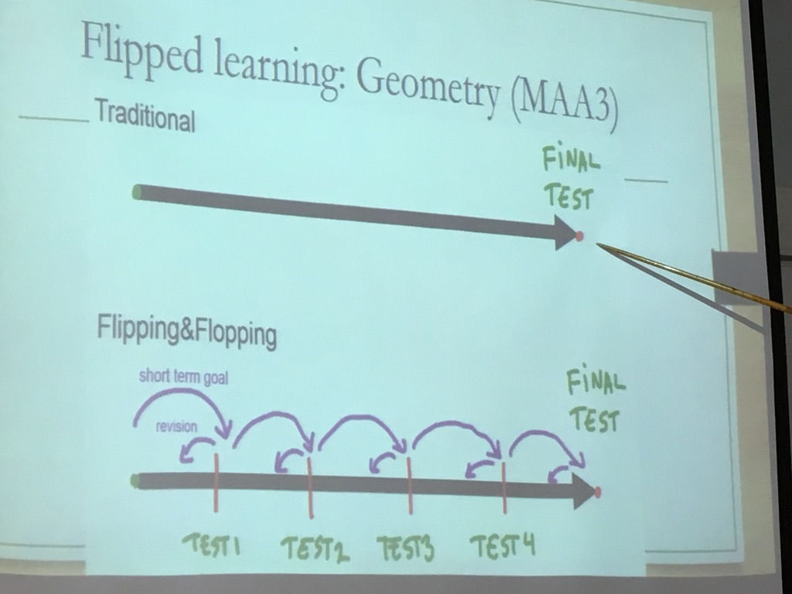
After a nice lunch provided by school, we had a lecture on Evaluation by Mikko Pihlajakangas.
We were very inspired by his combination of “flipped classroom”, micro-evaluations, student-performed evaluation and self-paced assignments. Several delegations applauded and wanted to implement parts of Mikko’s thoughts at home.

After a coffee break, we had a wonderful guided tour by 4 Finnish students giving us great opportunity to hear about the city and especially their thoughts on Finnish life and school system. Very enlightening indeed and nice to be able to connect with the Finnish youth directly.
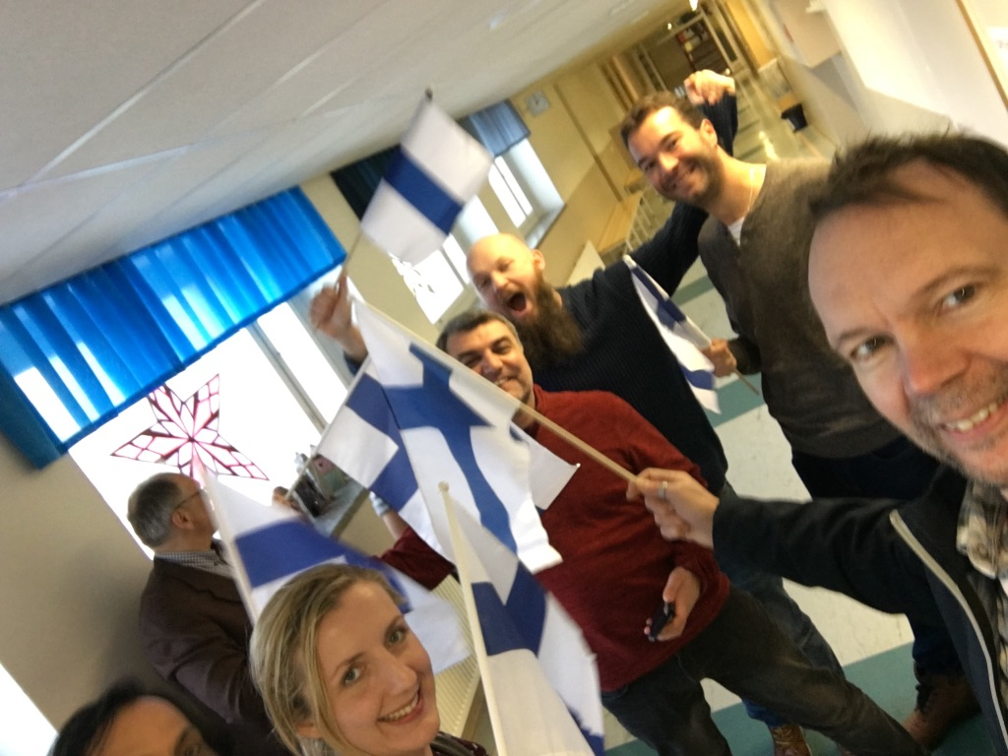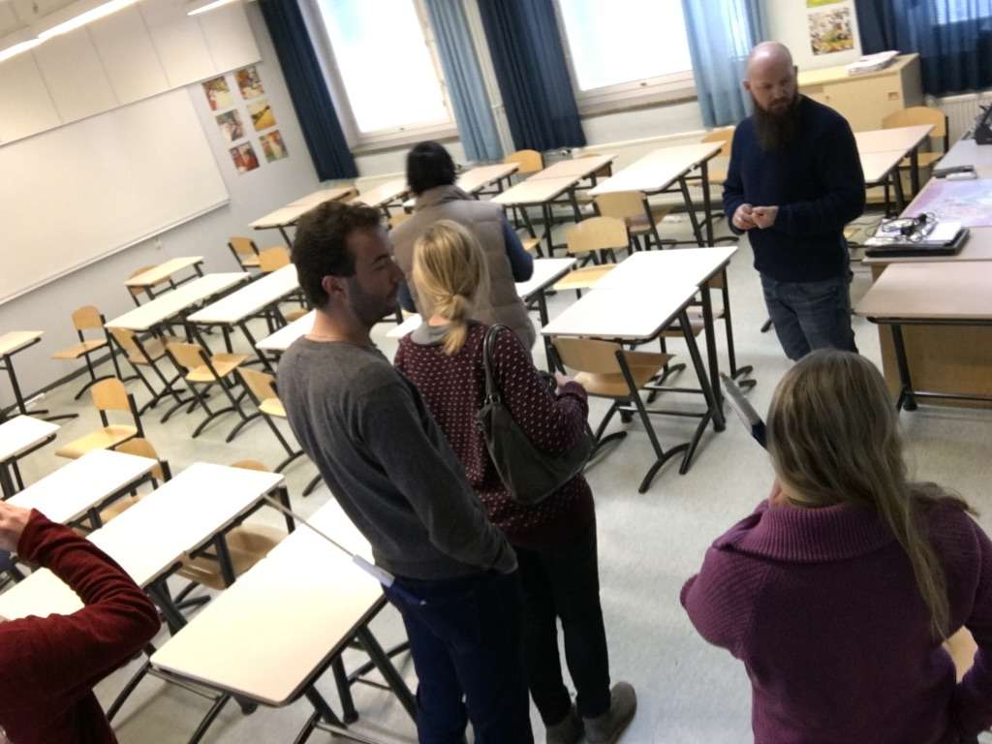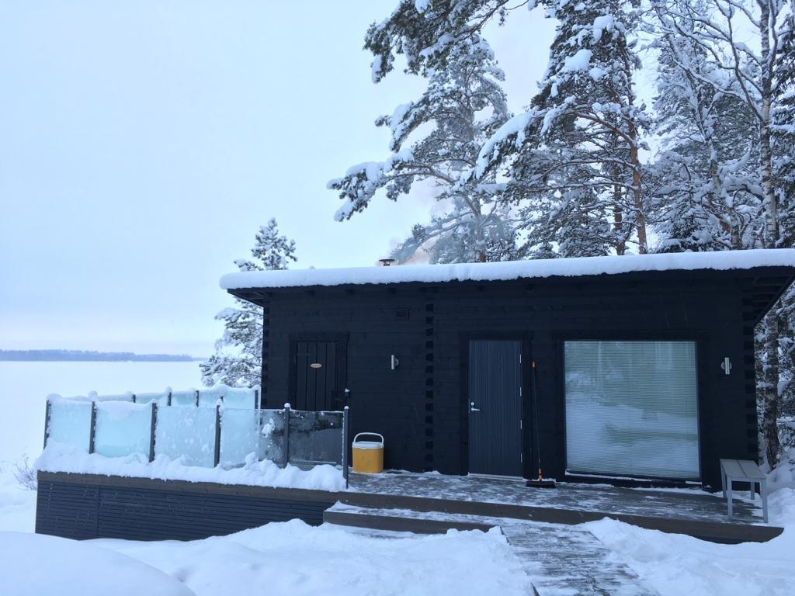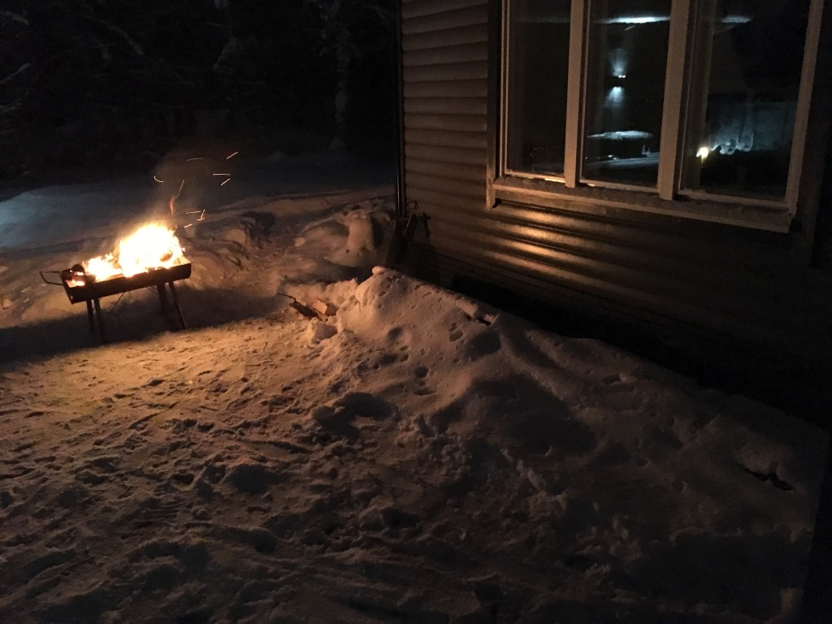
Finally, we experienced sauna “the Finnish way”. Very good team building activity indeed. We had great opportunity to talk about and experience culture.

Thursday 31st
We went by car to Pietersaari to experience 2 very interesting local attractions. First, we visited the elf’s at Tyynelän tonttula - the elf’s served us great coffee. Later we visited the Nanoq arctic museum. Pentti Kronqvist himself gave us great insight and epic narratives about arctic expeditions and great explorers.
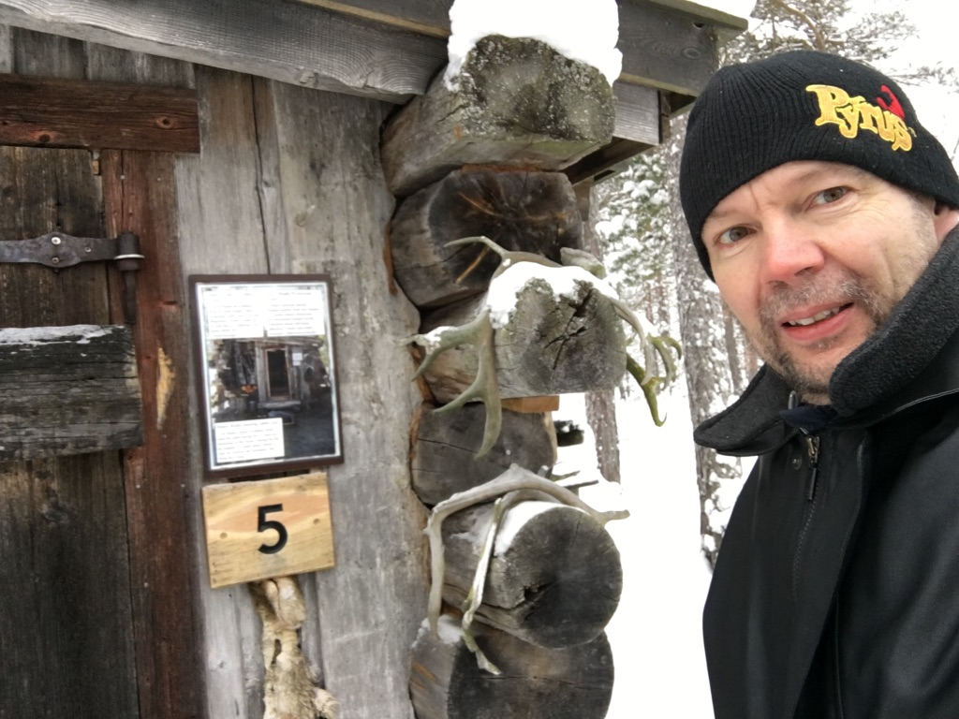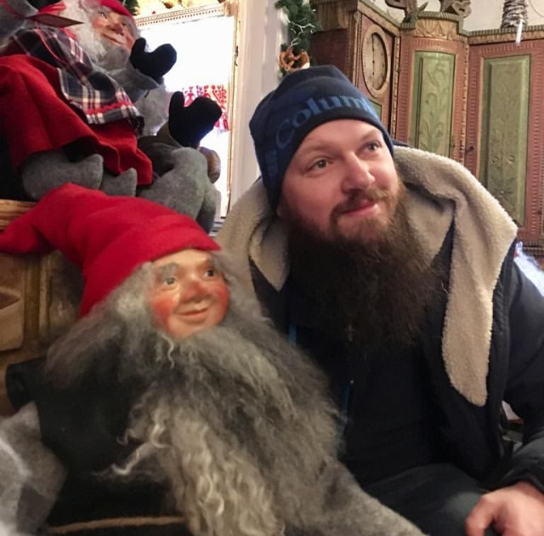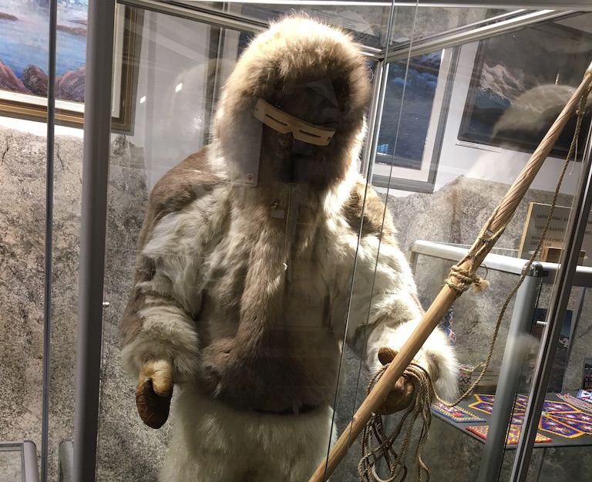

Finally, we went sight-seeing in Petersaari.

Friday 1st of February
Friday started with an extremely well planned and well executed pedagogical workshop. We matrixed in national and transnational groups and pinpointed the challenges and joys of teaching and raise the “So-Me” (social media) generation. Each national team took home at least 3 points to implement in order to provide better learning and student-teacher relations and well-being of students.
After lunch we had a wonderful and very “hyggelig” train ride to Helsinki. Small delays gave us plenty of time to extend the discussions of the morning.

Saturday 2nd
…was all about Helsinki!! We visited a lot of major historic attractions accompanied by a history expert. Weather was cold and beautiful and so was Helsinki.

Sunday 3rd
…was travel day. Tears and hugs and take-off. Unfortunately, the weather gave the Danes a delay of more than 24 hours. Luggage is still lost as we write .

