SLAVERY

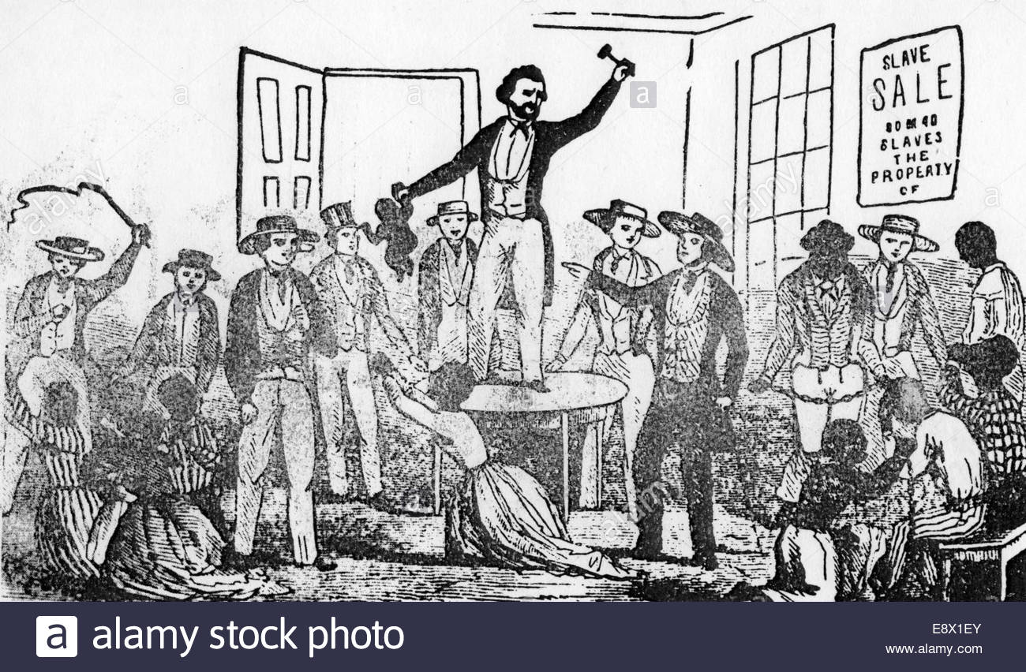
Slavery existed in the United States until 1865.

Slaves were considered property, instead of people. This picture shows a slave auction, where slaves were bought and sold like objects.

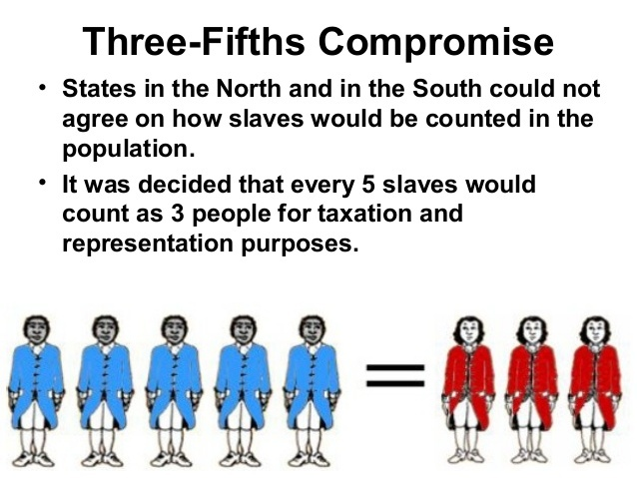

THE ADVENTURES OF HUCKLEBERRY FINN BY MARK TWAIN

A few illustrations of Huckleberry Finn and his friend Jim, a slave.
Huck is Jim’s best friend and helps him to escape.
Jim is like a father figure for Huck.
This novel shows that slaves are capable of feelings
and that it’s not fair to consider them as “properties”

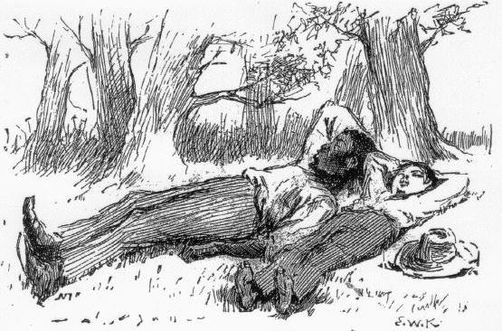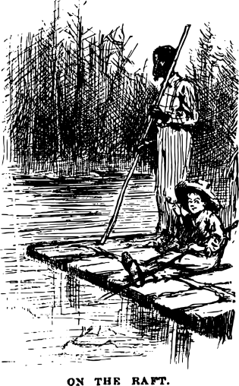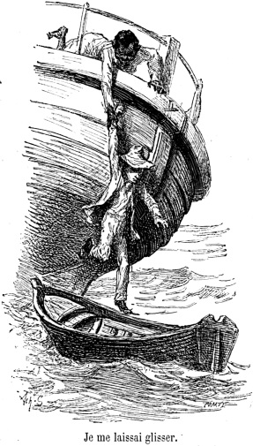

Huck says:

“He was low and homesick; because he hadn’t ever been away from home before in his life,”

“I do believe he cared just as much for his people as white folks does for their’n,”

“I was the best friend old Jim ever had in the world and the only one he’s got now,”

MINSTREL SHOWS AND BLACKFACE

A theatrical form by non black performers to represent caricatures of black people.It spread racial stereotypes.The aim was to entertain a white audience.

Frederick Douglass wrote against the institution of blackface minstrelsy, condemning it as racist but maintained "It is something to be gained when the colored man can appear before a white audience”.

These shows took advantage of black culture ( slaves’songs and dances , Ethiopian instruments) and introduced it on stage.

Some black people began to perform on stage.

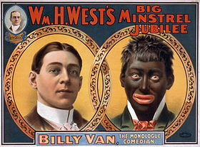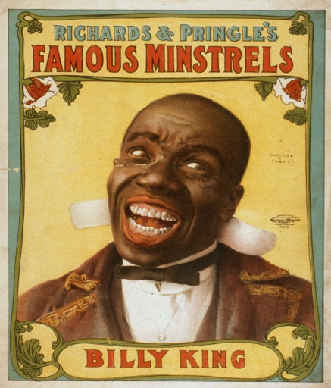

Behind the shows representing happy-go-lucky and entertaining caricatures of black men and women, there was pain and oppression.

A poem : Minstrel Man By Langston Hughes

Because my mouth
Is wide with laughter
And my throat
Is deep with song,
You do not think
I suffer after
I have held my pain
So long?

Because my mouth
Is wide with laughter,
You do not hear
My inner cry?
Because my feet
Are gay with dancing,
You do not know
I die?

“Turkey in the Straw” is a well-known folk song that became popular in minstrel shows during the late 1820s and early 1830s. The poster above shows a minstrel performer in blackface. Blackface means that white performers painted their faces black. These caricatures of black people were very disrespectful.
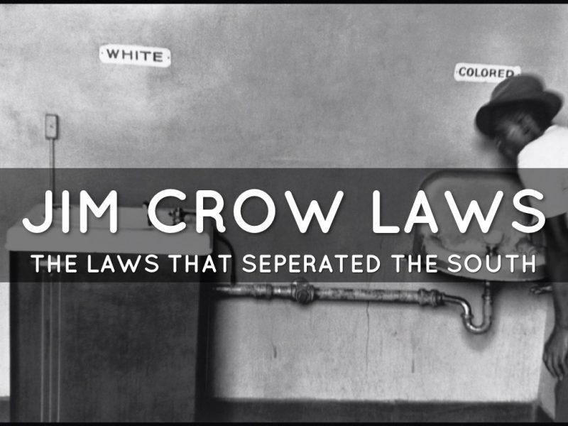
Jim Crow Laws created legal segregation. This means that things like restaurants, bathrooms, and schools were separate for black people and white people. In theory, things were “separate but equal”—In reality, this was not true.
The places for black people were worse than the places for white people. Because of this, white people were unfairly given better schools and facilities.
Jim Crow Laws
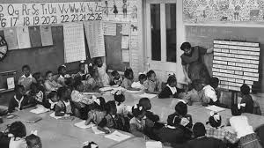

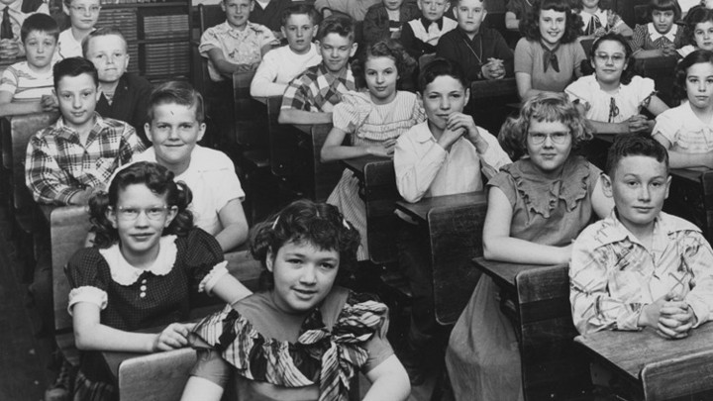
These two pictures show segregated schools in the United States.

In the all-white school, the students are smiling at their desks. In the all-black school, there are not enough seats for all the students. Some of them are standing at the side of the classroom.

Tuskagee Airmen
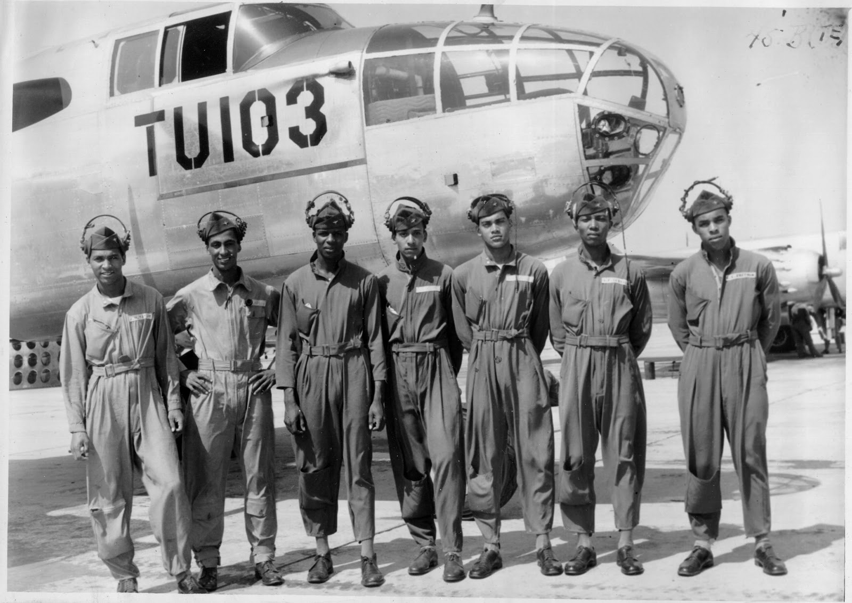

During World War II, the United States military was still segregated.

The Tuskagee Airmen were an all-black group of pilots. They were celebrated for their bravery in World War II.

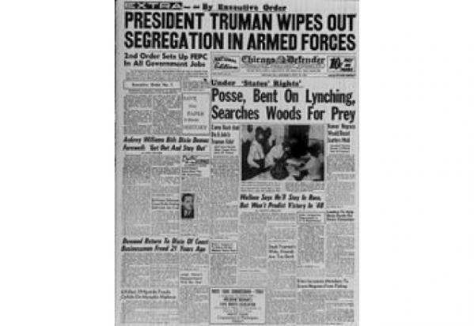
In 1948, President Harry Truman ended segregation in the United States Army.

The army could no longer separate black and white soldiers. This was a major change, because it forced black and white soldiers to work together.

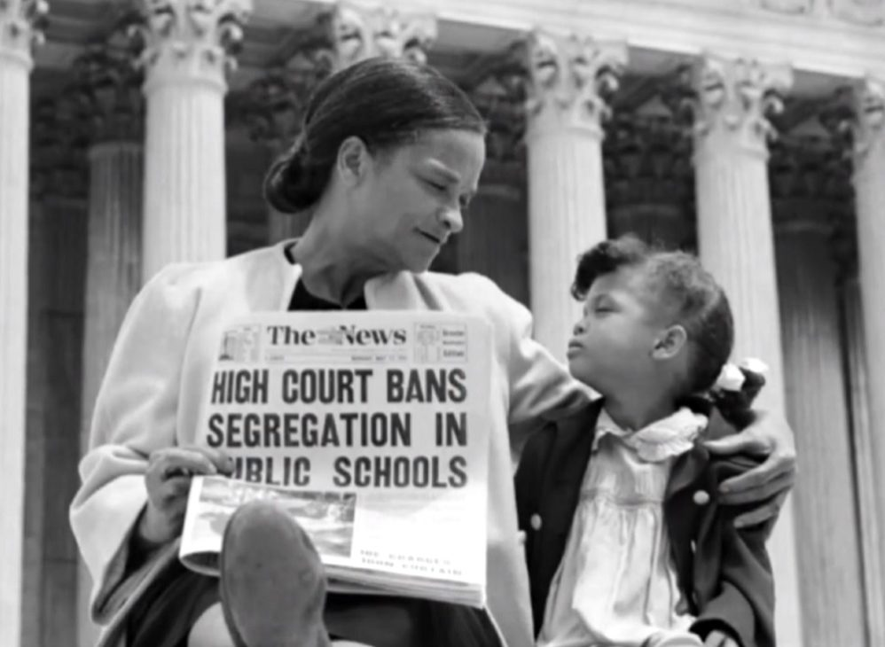
Brown v. Board of education was a very important court case.

It decided that there would be no more segregation in public schools. So, black students and white students would no longer be separated. They would all go to school together.

This was very important because it created equal education opportunities.

Brown v. Board of Education
The Little Rock Nine

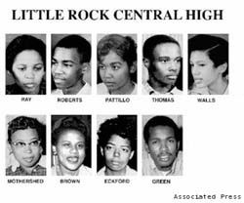
These nine students were the first black students to attend all-white schools.

Although public schools were legally desegregated, it was still difficult for some people to accept the new reality. These students faced discrimination and protests as they tried to go to school.

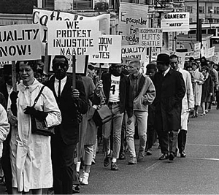
This is a picture of a peaceful protest during the Civil Rights Movement.

People marched with signs reading, “Equality Now!” or “We Protest Injustice”

Peaceful protests were an effective way to fight for equal rights without using violence.

Greensboro Sit-in

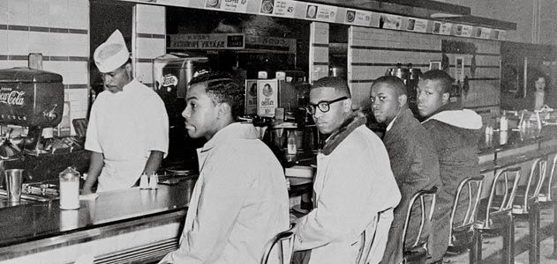
In 1960, these peaceful protesters sat at the counter of a restaurant that refused to serve black people.

It is called the Greensboro sit-in because it happened in Greensboro, North Carolina.

The goal of the sit-in was to call attention to the problem of segregation, and promote equality.

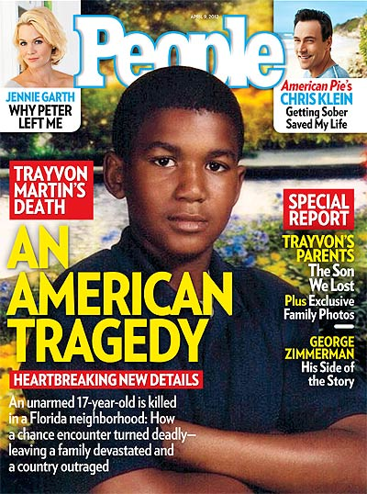
Trayvon Martin was a young black man who was unjustly killed by a neighborhood watch officer. After a long trial, the watch office (George Zimmerman) was found not guilty. People across the United States were outraged.

This brought attention to many other cases in which innocent black teenagers were killed by police officers. Many Americans were very upset, and people began protesting.

Black Lives Matter

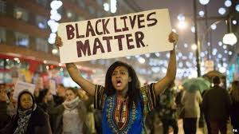

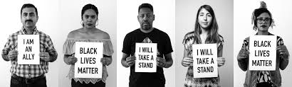
“Black Lives Matter” is an important movement in the United States.

There are many complicated details involved in Black Lives Matter.

Simply, it is the result of many cases of unnecessary police violence against black people. This situation highlights racism in American society. The movement reminds us that there is a serious problem we need to address as a country.

The New York Times

‘Justice for Laquan!’ Demonstrators Chant, as Chicago Officer Is Convicted of Murder
Things are starting to change. In this case, the police officer who shot an innocent black teenager was found guilty of murder and sent to prison.

