Erasmus+ KA2 Strategic Partnership
Skills for Future Working Life (SFUWOL)

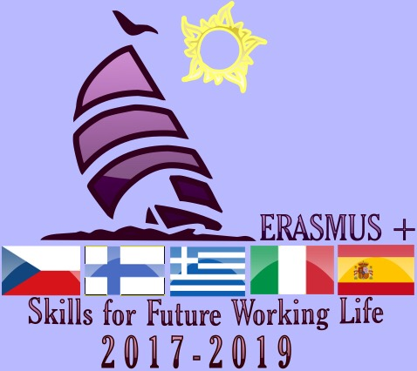

Meeting Evaluation Form

Reference no: 2017-1-IT02-KA219-036543

2nd LTT Activity and TPM

Venue: Volos, Greece

Name of the hosting school: 2nd Upper Secondary School of Nea Ionia

Date of the mobility, 22-28 April 2018

INTRODUCTION

Names of international participants: See Appendix 1

International participants: A total of 24 students and 8 teachers

Local participants: 24 students and 13 teachers
Objectives of the mobility: Career counseling / digital skills
- Help students to realize how the decision-making relating to educational and professional choices is crucial for their further future life.
- Support students to be able to make the right professional decisions, which conform with their work values, goals, achievements, interests, abilities, personal characteristics, experiences and expectations.
- Guide students into creating an online attractive CV (e-portfolio), through use of web-based platforms and applications, which completes their resume and documents what they are referring to, therefore helping them to distinguish themselves in the quest for job search.
- Try to connect students to the labor market by visiting local companies and businesses

The career counseling activities which took place:
1. Psychometric tests provided by EOPPEP (National Agency of Certification of Qualifications and Vocational Guidance)

A) questionnaires about Labor Values. This is a questionnaire which consists of 64 statements. They present some valuable aspects which can be provided by a profession and sought after by future employees. By completing the questionnaire, the students learn what values they would like or expect from their future profession.
B) Test of Professional Decisions. The specific Test of Professional Decisions helps towards the investigation as to the extent to which the following three key factors affect the students’ ability to reach correct and effective career choices, namely:
a) Lack of clear interests, namely the inability to determine the predominant professional interests and hence the confusion regarding their professional identity (i.e. interests, the gradients and their values),

b) Be lacking in professional maturity with regard to the role of work, namely the small degree of significance that the role of work and caree can perform in general in their life,
c) Detection of obstacles in their immediate family and social environment, with regard to the implementation of their professional preference.
2. Electronic portfolio (theory and practice)

a. Presentation of an e- portfolio: similarities and differences with the written CV, advantages and potentials.
An electronic portfolio (also known as an e portfolio, e-portfolio, digital portfolio, or online portfolio) is a collection of electronic evidence assembled and managed by a user, usually on the Web. Such electronic evidence may include: input text, electronic files, images, multimedia, blog entries, and hyperlinks.
E-portfolios are both: demonstrations of the user's abilities and
platforms for self-expression
If they are online, users can maintain them dynamically over time.
One can regard an e-portfolio as a type of learning record that provides actual evidence of achievement.

b. Step by step instructions for the creation of an e-porfolio by the students in the computer laboratory.

3. Study visit in a local mill industry, the Loulis Mills
a) Presentation of the company: Executive managers presented the operation of the factory, the possibilities for labor absorption and guided the participants in the premises of the factory.
b) Career guidance: Business executives of the company informed the students about the special skills and educational qualifications needed for a successful career in the modern European work environment.

THE AGENDAS

L/T/T ACTIVITIES

Sunday22/04 | 21.30 | Athens airport- Arrival of the teams.  Transfer to Volos.  Accommodation of teachers at Hotel Philippos. Accommodation of students at their hosts’ houses.  http://www.philippos.gr/  Teachers: Official reception_ common dinner
Monday 23/04 | 8:00-8.30 | Meeting at school. Welcome speech by Mr. D. Bazianas, school’s headmaster. Going through the agenda
 | 8.30-9.00 | Countries' short presentations of participants
 | 9.00-10.30 | Student's workshop. Participant students will present the CVs and the dream maps they have prepared
 | 10:30-11.00 | Coffee Break
 | 11.00-14.00 | Students work shop: Career guidance work sheets
 | 14:30 | Lunch
 | 16:00 | Guided tour around Volos  "Best of Ancient & Modern Volos Walking Tour"''Historic District of Volos Walking Tour''  http://www.pelionculture.gr/en/best-of-ancient-and-modern-volos-walking-tour/  http://www.pelionculture.gr/en/historic-district-volos-walking-tour/
 | 20:00 | Dinner
Tuesday 24/04 | 08:00 | Departure to Meteora, an UNESCO World Heritage Site (all day study trip) http://whc.unesco.org/en/list/455  https://www.visitmeteora.travel/
 | 13:00 | Lunch at Kalabaka or Trikala.
 | 17:00 | Return to Volos
 | 20:00 | Dinner
Wednesday 25/04 | 9:00-14.00 | Study visit at Loulis Mills, a local company to Amaliapolis, a village close to Volos. Presentation of the industry and career councelling by the executive manager of the comrany.
 | 17.00 | Visit to Makrinitsa and Portaria, two traditional Pelion villages http://www.discoverpelio.com/village/portariahttp://www.discoverpelio.com/village/makrinitsa
 | 20:30 | Dinner
Thursday 26/04 | 8:00-10.00 | Career counselling session/ Workshop: e-portfolio (theory and practise)
 | 10.00-1030 | Break
 | 10.30-13.30 | Career counselling session/ Workshop: e-portfolio (theory and practise)
 | 14.00 | Dinner
 |  | Free afternoon
 | 19.30 | Farewell dinner
Friday 27/04 | 07.00 | Early departure. All day study visit to Athens.  UNESCO World Heritage Site of Acropolis and the Acropolis Archaeological Museum  http://whc.unesco.org/en/list/404  http://www.theacropolismuseum.gr/en
Saturday 28/04 | 09.00 | Certificates’ ceremony  Individual departure of all groups from Athens Airport

T/P/M ACTIVITIES

Sunday22/04 | 21.30 | Athens airport- Arrival of the teams.  Transfer to Volos.  Accommodation of teachers at Hotel Philippos. Accommodation of students at their hosts’ houses.  http://www.philippos.gr/  Teachers: Official reception_ Common dinner
Monday 23/04 | 8:00-8.30 | Meeting at school. Welcome speech by Mr. D. Bazianas, school’s headmaster. Going through the agenda
 | 8.30-9.00 | Countries' short presentations of participants
 | 9.00-10.30 | Student's workshop. Participant students will present the CVs and the dream maps they have prepared
 | 10:30-11.00: | Coffee Break
 | 11.00-14.00 | Transnational meeting
 | 14:30: | Lunch
 | 16:00: | Guided tour around Volos  "Best of Ancient & Modern Volos Walking Tour"''Historic District of Volos Walking Tour''  http://www.pelionculture.gr/en/best-of-ancient-and-modern-volos-walking-tour/  http://www.pelionculture.gr/en/historic-district-volos-walking-tour/
 | 20:00 | Dinner
Tuesday 24/04 | 08:00: | Departure to Meteora, an UNESCO World Heritage Site (all day study trip) http://whc.unesco.org/en/list/455  https://www.visitmeteora.travel/
 | 13:00: | Lunch at Kalabaka or Trikala.
 | 17:00: | Return to Volos
 | 20:00 | Dinner
Wednesday 25/04 | 9:00-14.00 | Study visit at Loulis Mills, a local company to Amaliapolis, a village close to Volos. Presentation of the industry and career councelling by the executive manager of the comrany.
 | 17.00 | Visit to Makrinitsa and Portaria, two traditional Pelion villages http://www.discoverpelio.com/village/portariahttp://www.discoverpelio.com/village/makrinitsa
 | 20:30 | Dinner
Thursday 26/04 | 8:00-10.00 | Career counselling session/ Workshop: e-portfolio (theory and practise)
 | 10.00-1030 | Break
 | 10.30-13.30 | Transnational meeting
 | 14.00 | Dinner
 |  | Free afternoon
 | 19.30 | Farewell dinner
Friday 27/04 | 07.00 | Early departure. All day study visit to Athens.  UNESCO World Heritage Site of Acropolis and the Acropolis Archaeological Museum  http://whc.unesco.org/en/list/404  http://www.theacropolismuseum.gr/en
Saturday 28/04 | 09.00 | Certificates’ ceremony  Individual departure of all groups from Athens Airport

EVALUATION

- Project Meeting

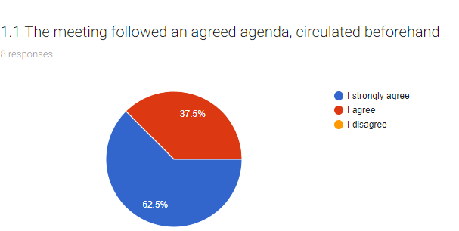
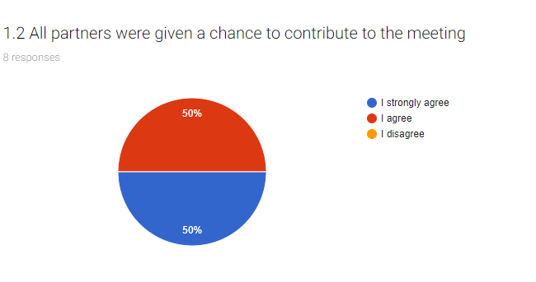
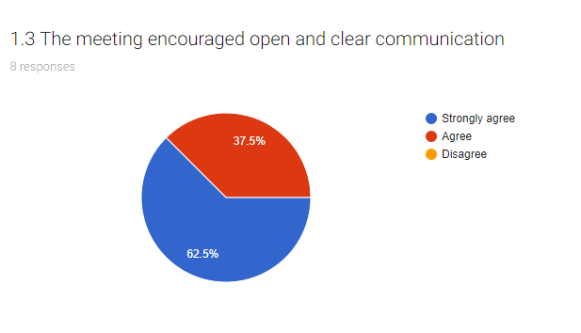
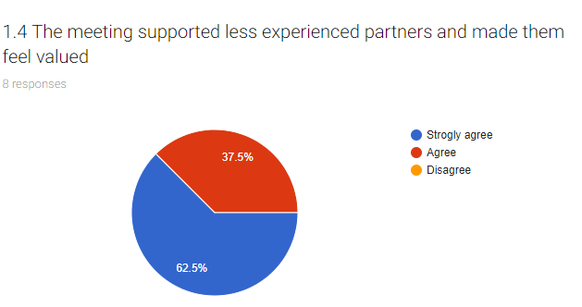
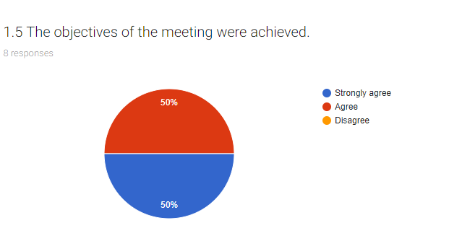

2. Structure, Content and Delivery of Event

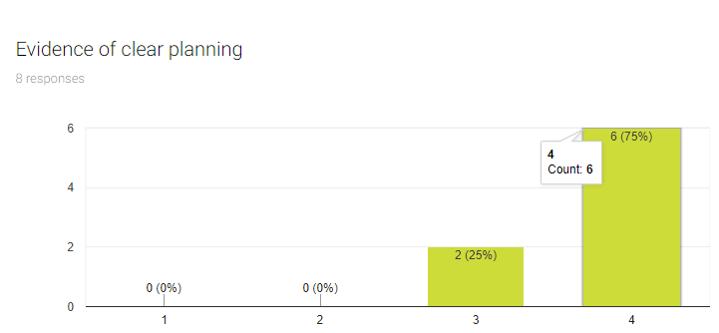
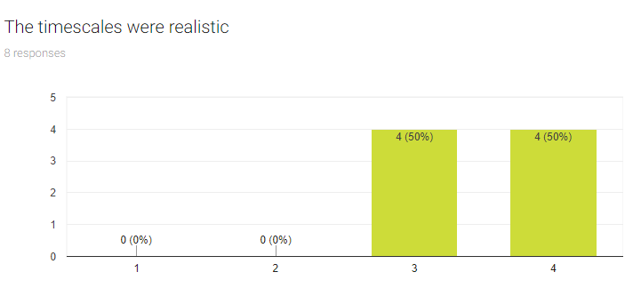
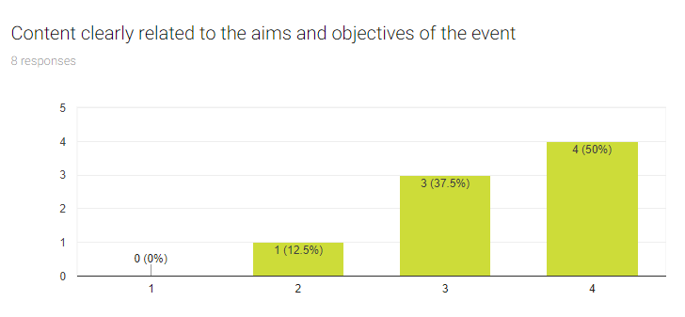
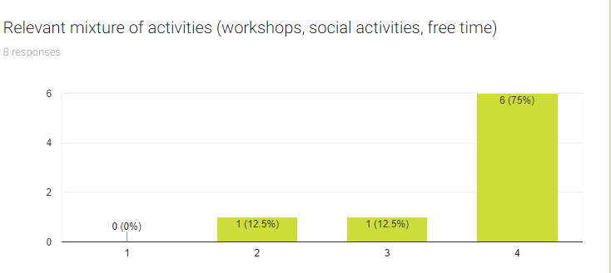
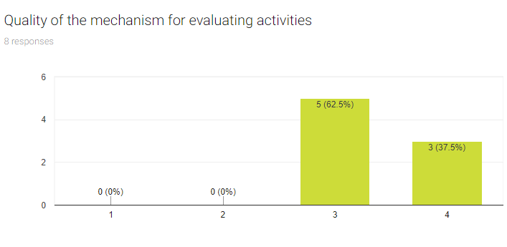
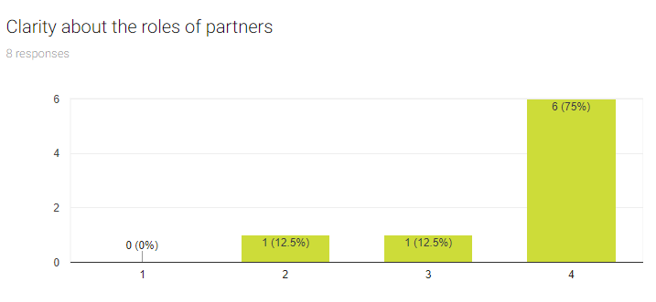
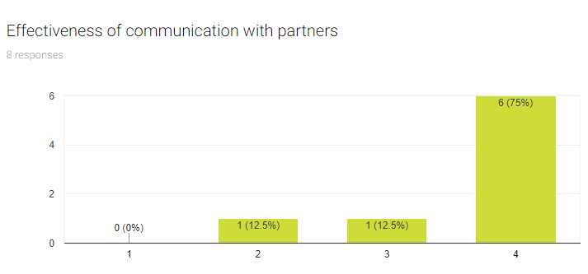

3. Quality of the trans-national element

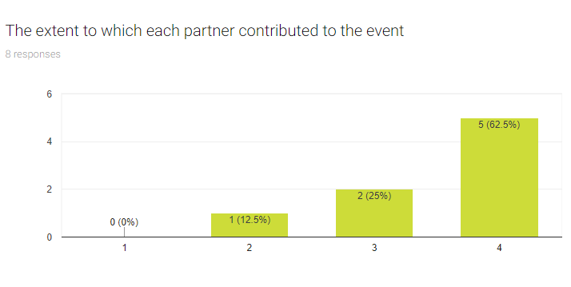
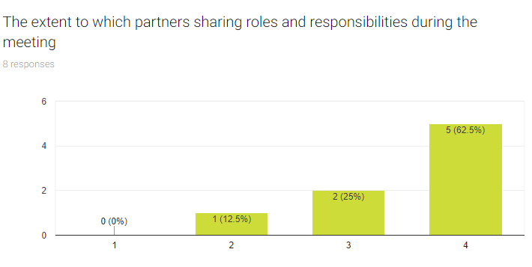
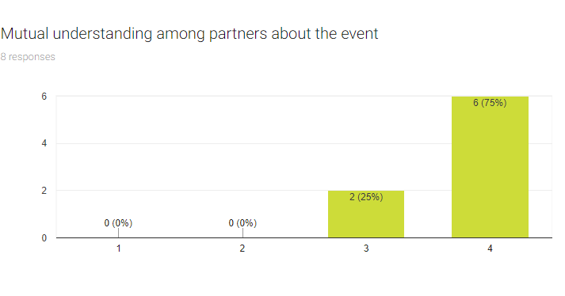
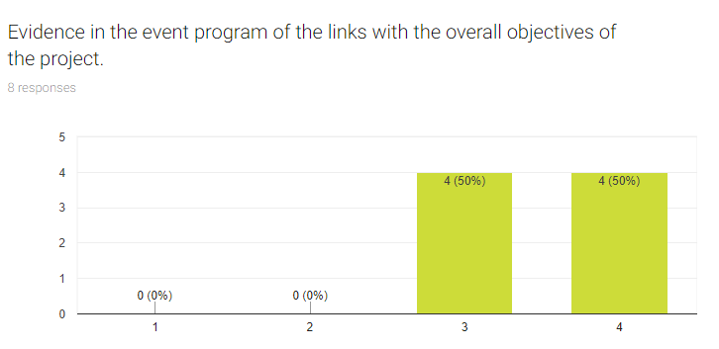
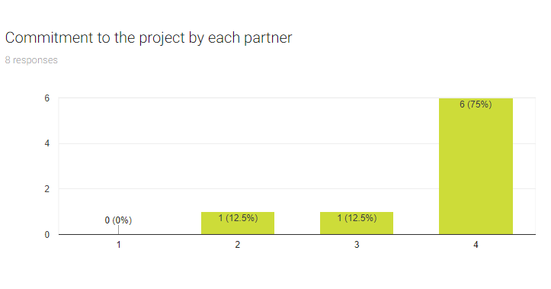
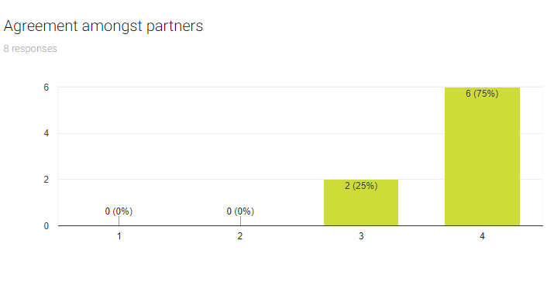
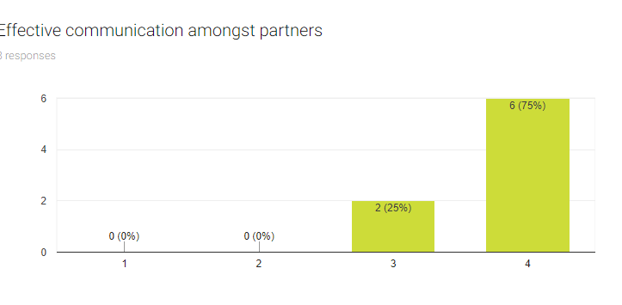
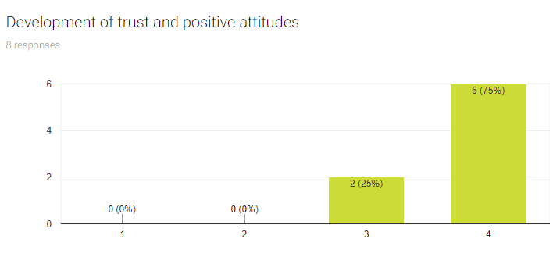

4. Quality of the domestic arrangements

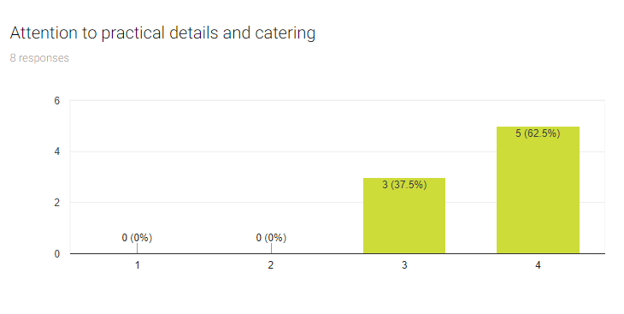
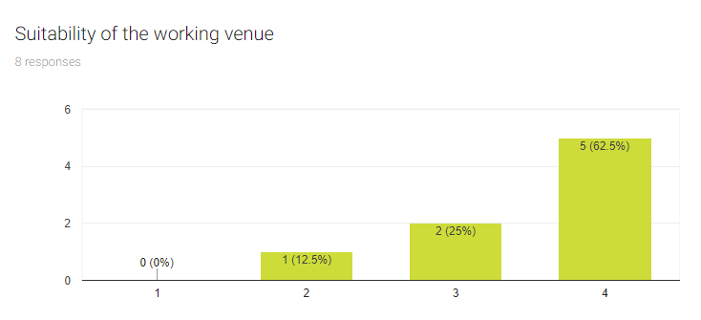
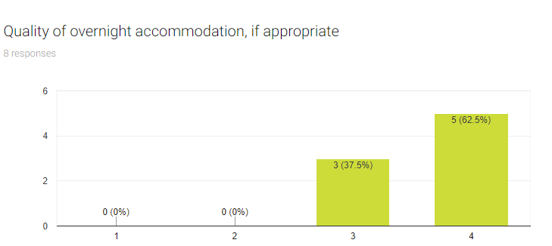
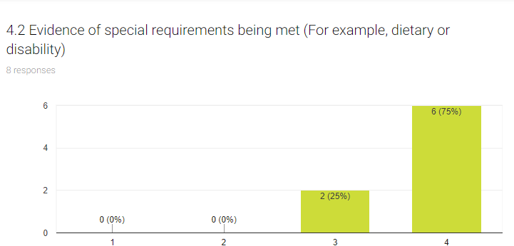

5. Personal Comments

What did you find most useful?
The Finish partner found more useful our official meeting, the study visits, conversations during free-time about the project, students’ learning about different cultures &customs & languages &skill for working life at the workshops.
The Italian partner found more useful the visit to the bread factory, during which the students had the opportunity to understand the possibility of employment and what a real company requires in young people who are looking for a job.
The Spanish partner found the atmosphere great for working.

What do you think could be improved (for future events)?
The Finish partner mentioned that visits could include more info about working/career in the places we visited and people telling about their professions.
The Spanish partner mentioned that the presentations were too long and the problems with the internet connection made it worse. In future meetings we shouldn't reply so much on online presentations. In addition, asked for more time for teacher's meetings.

Regarding the evaluation of the meeting by the students we had the following results:

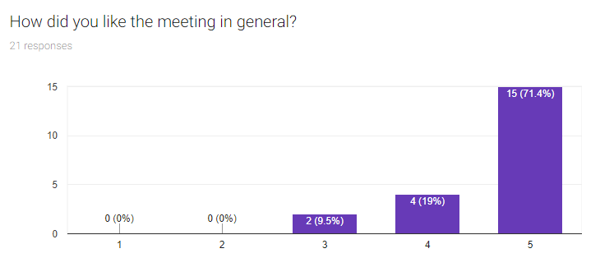
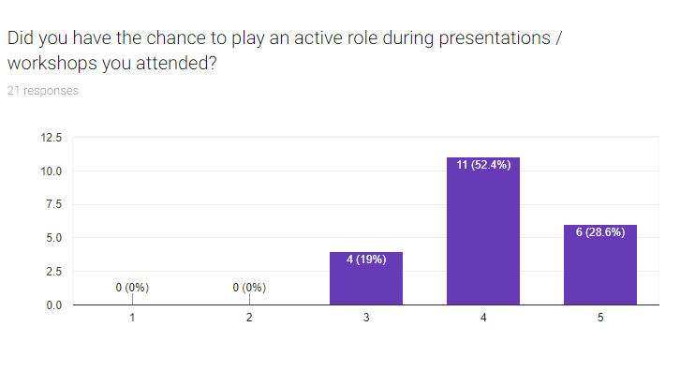
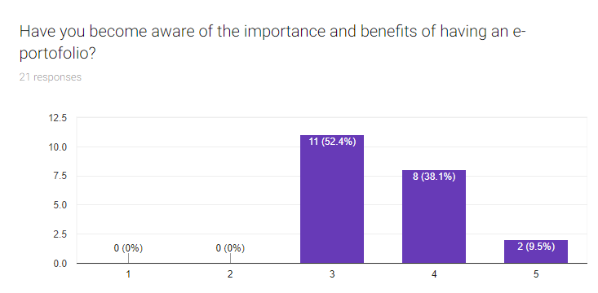
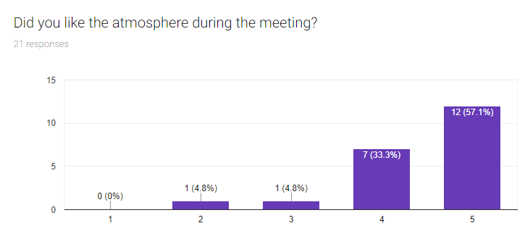
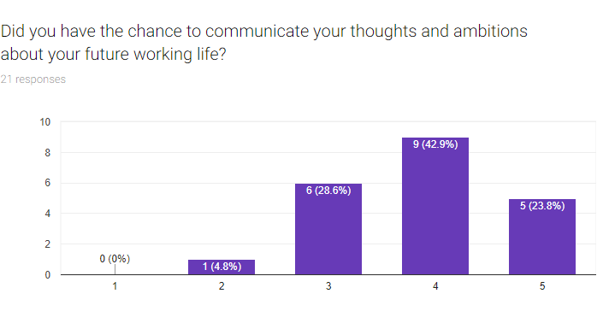
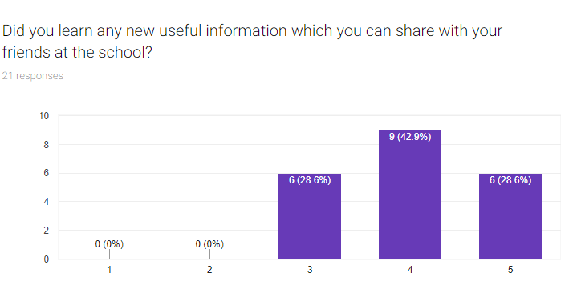
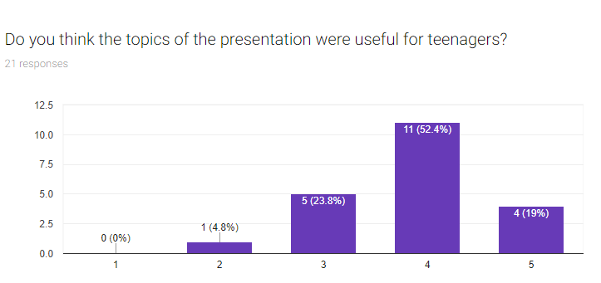
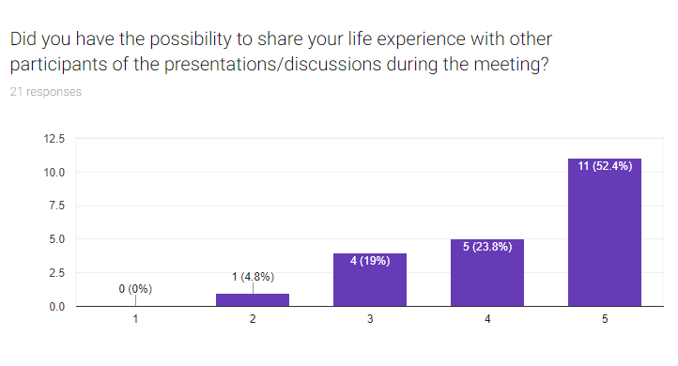

Appendix 1

List of participant’ s names

Country | Members |  | Names
Italy | teachers |  | Mr Giorgio Marsan  Mrs Antonia Frontino
 | students |  | Livia Albanese  Aurora Cao  Giulia Cicerano  Alessandra Borrelli  Martina Abbondandolo  Margheritadi Santo
Finland |  | teachers | Mrs Anu Kalliopuska  Mrs Anna Laitala
 |  | students | Viivi Holappa  Jenny-Juulia Leskelä  Soile Mikkonen  Liisa Hahtonen  Emma Väänänen  Henna Laukkanen
Czeck Republic |  | teachers | Mrs Katerina Noskova  Mr Tomas Bilek
 |  | students | Natalie Stichova  Daniela Humlova  Petr Kares  Kristyna Vachova  Tereza Rampova  Barbora Bila
Catalunya |  | teachers | Mrs Marta Codina Castell  Mr Joan Maria Sotoruiz
 |  | students | Chaymae Kchetal el Bouzaidi  Andrea Molina Camprubí  Sara Maria Restrepo Vanegas  Tánia Rodriguez Cervilla  Gurpreet Singh  Ishak Smaili Khalladi
Greece |  | teachers | Mr Dimitrios Apostolou  Mr Evangelos Anastasiou  Mr Dimitrios Chrysikos  Mr Georgios Giannisis  Mrs Sofia Mentsiviri  Mrs Theodora Efstathiou  Mr Pantelis Masloumidis  Mrs Georgia Reveka Loukidou  Mrs FoteiniTsiropoulou  Mrs DespoinaTsiachri  Mrs Aristea Tziortziou  Dimitris Mpla?  Theodoros Theodoridis
 |  | students | Tsitsikli Sofia-Maria  Maria Kritsini  Maria Anna Vali  Eleni Tsoukala  Dimitra Fragkou  Maria Anna Vali  Maria Vamvaka  Thomai Polychroni  Katerina Gkritzali  Vasiliki Kogia  Katerina Sdrolia  Zoi Grantza  Vasileios Styllas  Eleni Trigka  Konstantinos Kounas  Thomas Paizanos  Nasos Choutzioumis  Evaggelia Mpatskini  Mekgi Giachgia  Eleni Georgantzi  Chara Lytra  Sotiria Zigra  Kosmas Archontis  Georgios Stavaras

