EVALUATION REPORT OF LTT MEETING IN NETHERLANDS
Project Name: Surfing Our Roots
Project Number: 2018-1-LT01-KA229-046991
Date: 3rd June- 7th June 2019
Venue: Netherlands
Participating Countries: Turkey, Greece, Netherlands, Lithuania, Portugal
In this meeting we aimed to explore the cultural heritage of Amsterdam, Almere, Lauwersoog, Waddenzee, Enkhuizen and Bataviastad, to share students’ experience and outcomes, what is done at the schools,to improve students’ communication and collaboration, intercultural skills, to develop digital literacy, to raise intelligence and tolerance and to gain more confidence in being a part of the Erasmus project.
It was Short-term exchanges of groups of pupils. There were 4 students, 4 teachers from Turkey, Hatay, 4 students, 3 teachers from Turkey, Çorum, 4 students and 2 teachers from Greece, 4 students, 2 teachers from Lithuania, 6 students, 4 teachers from Portugal and many teachers with students from Netherland. All the teams arrived in Almere by the 2nd of June, Sunday, except the Lithuanian team which arrived on 3 of June, Monday. Students and teachers met at Finn Hotel and host families came to take students from the hotel, except for Greek students. Students from Greece stayed in the hotel with their teachers.
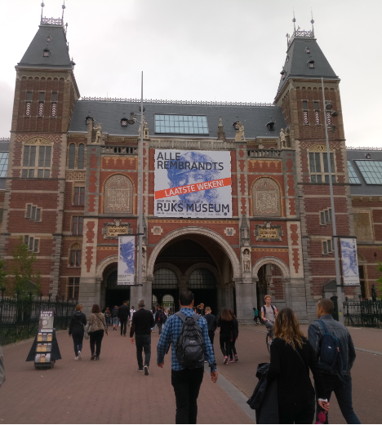 | 3rd of June, Monday,a bus came to the hotel to take us to the partner school in Almere. Students came in the bus, and we went to Amsterdam. We visited the Rijksmuseum. We learnt about the history of the Rijksmuseum from the 1800 to 2013. Rijksmuseum is the Dutch national museum dedicated to arts and history in Amsterdam.
The museum is located at the Museum Square. The museum has on display 8,000 objects of art and history, from their total collection of 1 million objects from the years 1200–2000, among which are some masterpieces by Rembrandt, Frans Hals, and Johannes Vermeer. The museum also has a small Asian collection, which is on display in the Asian pavilion. It was very useful to start up to learn the Dutch culture.
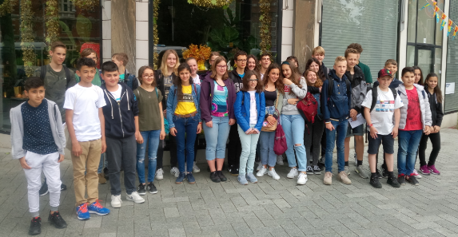 | After the Rijksmuseum, the teams had free time to explore Amsterdam. Next, we went sightseeing in Amsterdam by canal cruise. We learnt about the city’s history from its humble medieval beginnings to the economic and cultural boom times of The Golden Age.
We Floated amongst the UNESCO World Heritage sites, endless bridges and houses in typical Dutch architecture and urban development.Then we visited the Holland experience, a unique flying experience, soaring over the Dutch must‐see locations.We learnt about the diversity, beauty and richness of the Netherlands.
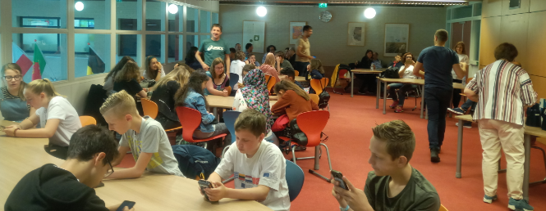 | 4th of June, we went to the Oostvaarders College. After the welcome that the school had prepared for us, students went to the classrooms to attend lessons and teachers had a meeting. All partner countries presented what they have done so far in the project.
We discussed the activities we had finished and checked the quality of the activities and decided on what kind of improvements we could make them excellent. After the meeting at school, we went to the center of Almere with students from 6 partner schools. We divided students and teachers into different groups and we learnt about the history of the city. We enjoyed this activity a lot since it was great to explore Almere by walking around. After the activity finished, host families came to pick up students from downtown.
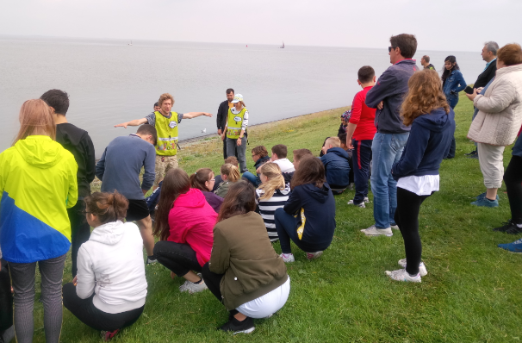 | 5th of June was the day for a fieldtrip to Lauwersoog. We discovered the World Heritage Waddensea and National Park Lauwersmeer in a unique way. We learnt about fishing prawns and crabs, we learnt many intersresting things about the sea, we learned about the construction and use of the barracks, the ebb and the tide. After that, we visited the Pieterburen, a seal sanctuary that rescues seal puppies that have lost their mothers.
The zeehondencrèche take care of the puppies until they’re old enough to survive by themselves and therefore there are seals there all year around. Students enjoyed these activities a lot. İn the evening we went back to Almere, students were picked up by host families and teachers went to the hotel.
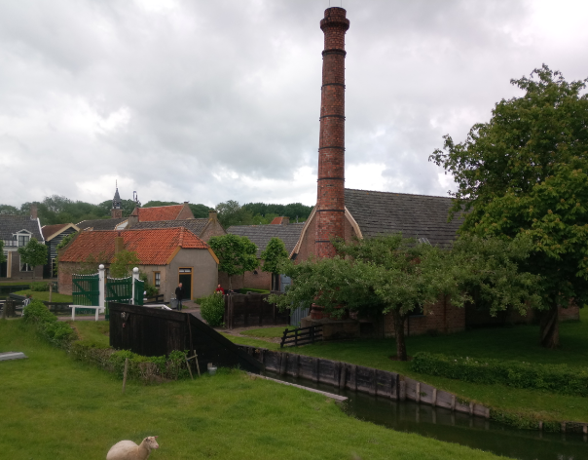 | 6th June started with the visit to Enkhuizen and Enhuizenmuseum. Enkhuizen was at the peak of its power and was one of the most important harbour cities in the Netherlands with many historic buildings and monuments. There, we really traveled in time and we got knowing the Netherlands better.
We saw a huge outdoor museum with the traditional houses and the professions of the time, children's toys and traditional costumes. A fishing village unchanged in time. People have done amazing work there. Students were divided into different groups and participated in a variety of workshops such as basquet makers, blacksmith workshop, etc.
It was a fastastic experience for our students because all of them travelled back to time. We took pictures and walked in museums and we enjoyed the nature. After that we visited the Bataviastad and the Bataviahaven. We visited batavia a replica ship, which was one of the jewels in the crown of Batavialand. We learnt its history. The ship is made entirely of Danish oak and decorated with several hundred hand-carved figures and ornaments. The rigging and armaments were also reconstructed. This day was unforgettable for our students, they learnt a lot of things by doing activities and visiting different places. İn the end of the day students went to the host families and the teachers to the hotel.
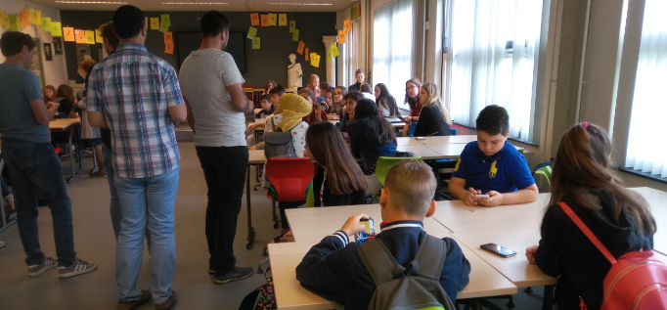 | 7th June, teachers went to school, where the students prepared the posterpresentations about all the activities that had done this week for the exhibition in the evening. Teachers and students worked on green screen products. We visited for a last time the city of Almere and in the evening we had a farewell dinner with host families.
This evening was a very sad day for us, we saw many students had already started to cry because they were leaving. The whole week was full of understanding cultures and especially exploring Netherlands. We had a very great time in Netherlands and we would like to thank our partner schools staffs in Almere.

