Questions Netherlands:

Nowhere in the world will you find such an expansive and varied area created under the influence of ebb and flood, where changes are noticeable daily.
What is the name of the Sea in the Netherlands which has been a World Heritage site since 2009?

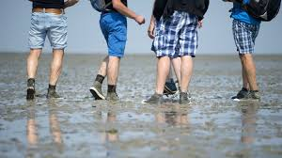

Waddenzee, Noordzee, IJsselmeer, Zuiderzee

The 19 windmills of Kinderdijk were built between 1738 and 1740 and are an internationally known Dutch symbol. The place entered Unesco Heritage List in the Netherlands in 1997.
In which province is it situated?

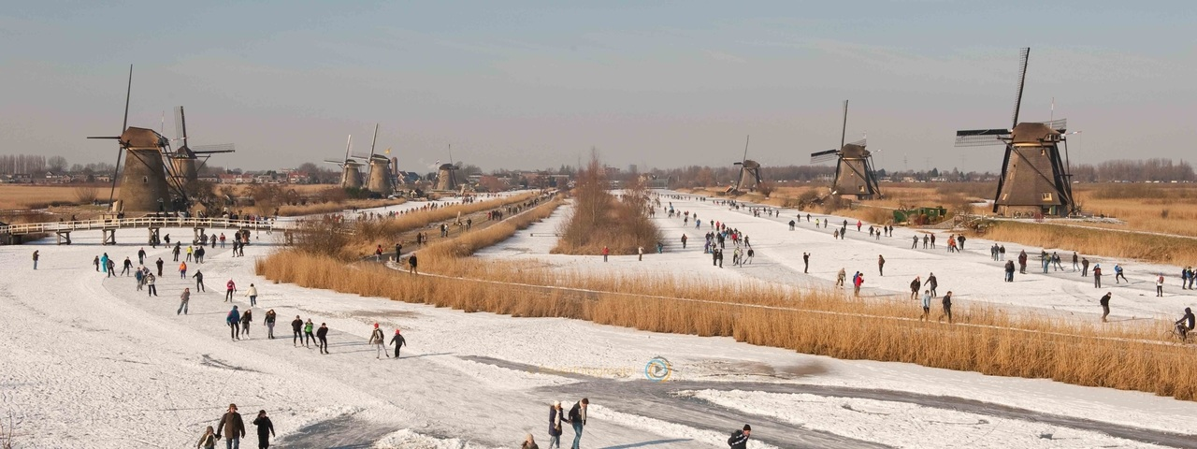

North-Holland, South-Holland, Flevoland, Zeeland

The Amsterdam Canal District (17th century) has been added to the UNESCO World Heritage list in 2010. This canals area, with its 14 km of canals is a masterpiece of town planning, hydraulic engineering and architecture. How many bridges does this canals area has?

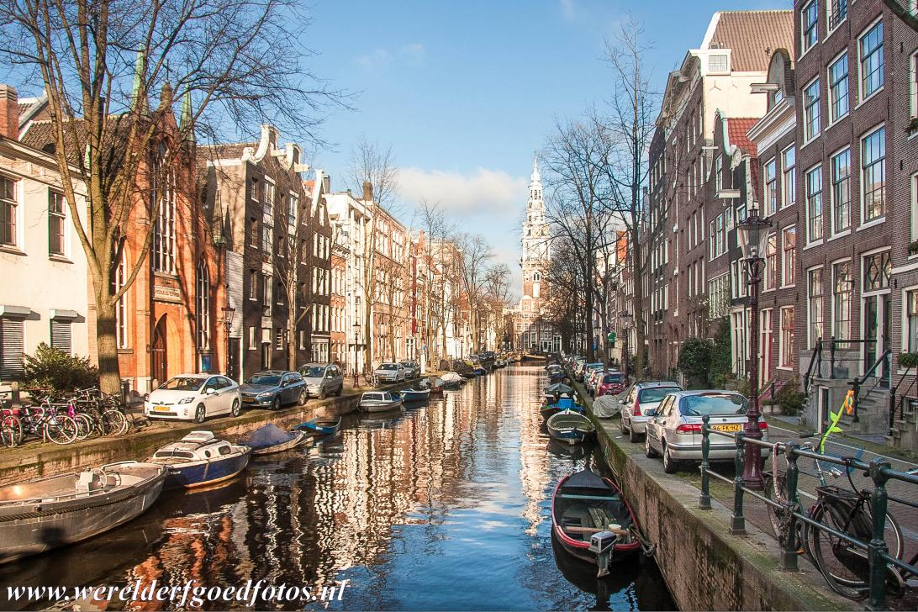

100, 80, 60, 40

This Defence Line was built between 1880 and 1914 and is a circular series of fortifications around
a capital. The line is 135 km long and consists of 42 forts and 4 batteries. This kept the capital out of range of any enemy canons. The Defence Line was added to the UNESCO World Heritage list in 1996.
What is the name of the capital?

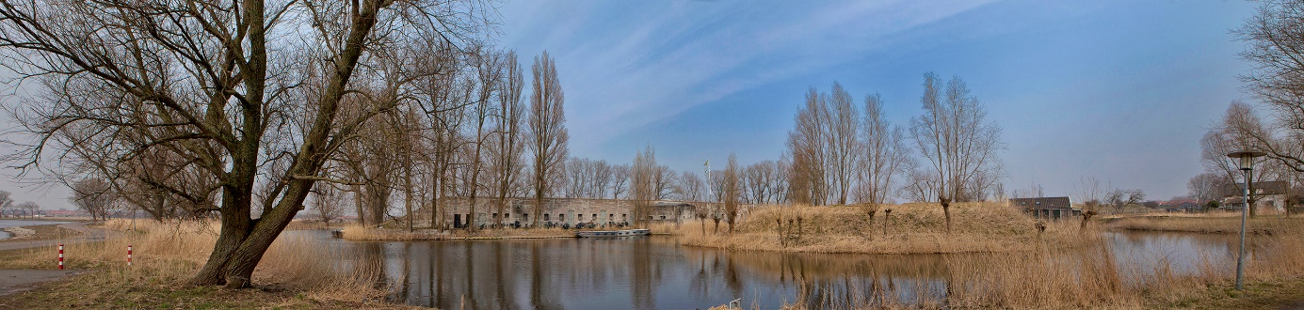

The Hague, Amsterdam, Groningen, Rotterdam

This town is characterised by a mix of architectural styles and Caribbean colours. Its island is part of the Kingdom of the Netherlands. There are many Dutch influences, but also Spanish and Portuguese. The historic town centre has been a World Heritage site since 1997. What is the name of this town?

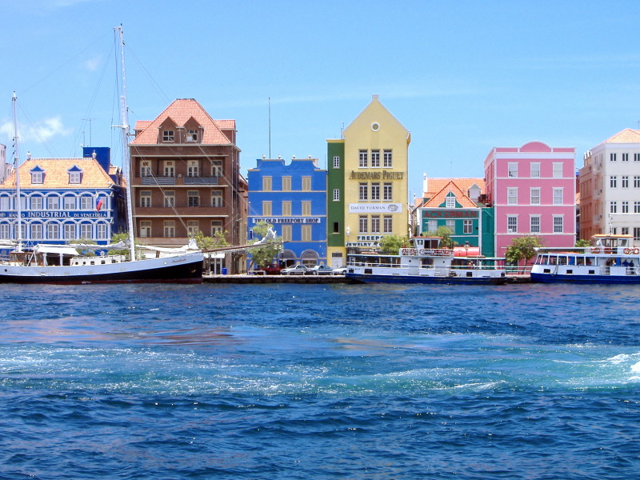

Tera Corá, Westpunt, Willemstad, Sint Michiel

