SIMON AND JUDE ANNUAL FAIR ŠTÚROVO

1. THE FAIR:
We saw a lot of exhibitors that offered many interesting things. From all the stands in the fair, there were mostly food products and drinks such as:
- all types of roasted meat, baked potatoes ,vegetables and other foods

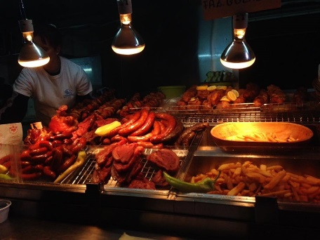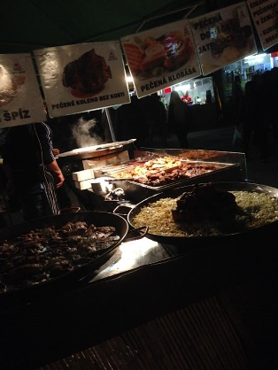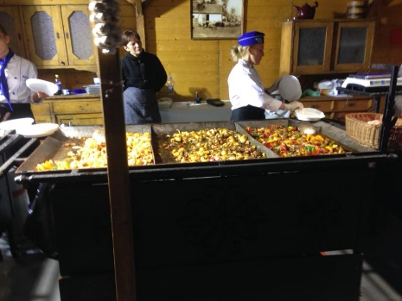

- sweets
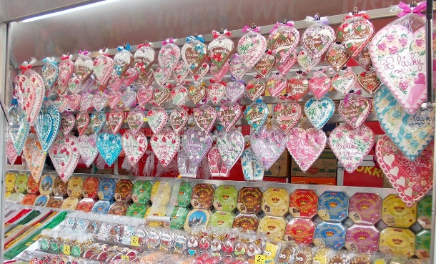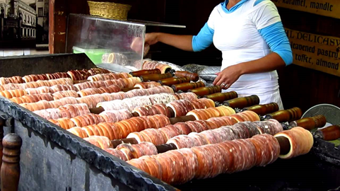

But there were also many stands with clothes, accessories, handmade decorations and traditional clothing:

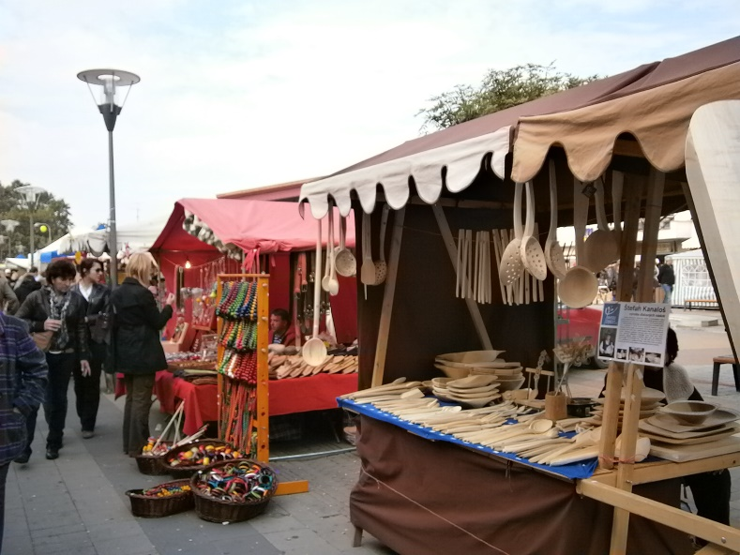
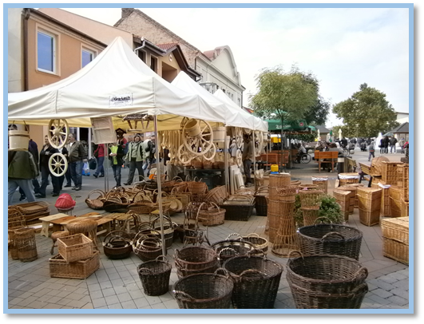
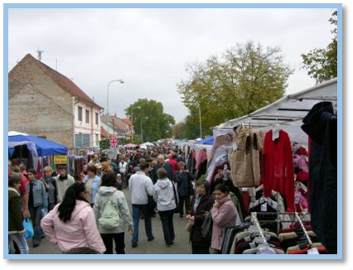
2. TYPICAL PRODUCTS:
The most typical products we've seen were:
- Trdelnik
- Oplatky
- Medovina (drink)
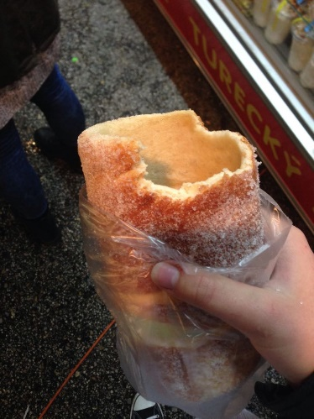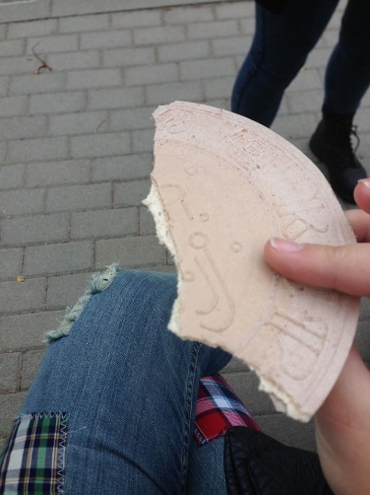
TRDELNIK: Is sweet dough baked on wooden cylinder shaped sticks that turn on medium high heat so that the dough is evenly baked and they come in 3 flavors: Vanilla, cacao, and nut flavor.
OPLATKY: Are very thin big biscuits that come in every flavor possible. And in one packaging there come about 10 biscuits.
MEDOVINA: is an alcoholic beverage created by fermenting honey with water, sometimes with various fruits, spices, grains, or hops.

We have also spoken with few of them and learned that most of them come from different parts of Slovakia and Hungary but some from other European countries or even from India or Asia, but there was no one from Slovenia nor were there any products from our country.

3. PRICES:

PRODUCT | Price in Šturovo | Price in Ljubljana
Sweets /piece | 1,5€ – 3€ | 3€ - 4€
Grape | 2.30€ | 1.60€
Baked meat | 2€ | 6€
Honey | 8€ | 10€ - 16€
Scarf | 10€ | 15€
Clothes | 5€-30€ | 15€ - 50€
Wine | 5.5€ | 6-10€

4. INFLUENCES:
- POSITIVE
- Increases market sales.
- Increases tourism.
- Comparing prices from other countries.
- Preserving tradition.
- Modernization.
- Socialization aspect.

- NEGATIVE
The most negative effects are ecological such as:
- Littering.
- Damaged private and public properties.
- Heavier traffic and pollution.
- The noise and lights may disturb citizens living in the vicinity .

The fair itself was a very interesting thing to experience. You see people from different countries and cultures coming together and having a great time. It was special in every way and if we ever decide to visit Slovakia again Simon and Jude annual fair will definitely be on the must-see list.

