Text A

What Is Work-Life Balance?
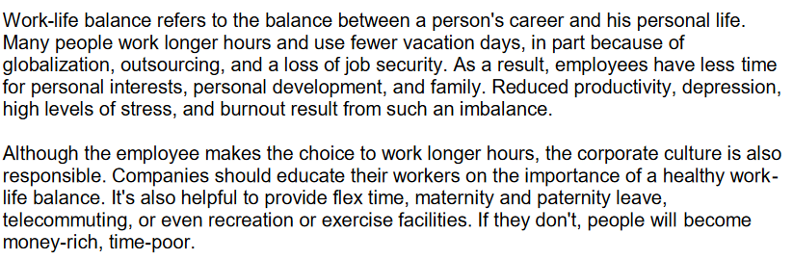
http://www.headsupenglish.com/lower-intermediate/minilessons/worklifebalance.pdf [8.10.16]

Text B

Models to achieve work-life balance
We all want to spend more time with our loved ones. Are new working models the answer?
Melissa Hill reviews the promises and dangers of various flexible-working schemes.

Telecommuting
Relying on your phone and computer to get your work done while you stay in your snug slippers can be a relaxed lifestyle. However, it is worth making sure that you can actually get work done with your family being around. If not, you may still need an office of your own. If your employer is willing, agree to work from home one day each week for a trial period so you can both find out early on what problems there might be, if any.

Freelance work
There are a variety of skills that companies outsource to freelancers, and it can be a fun and lucrative way to work. However, make sure you don’t become dependent on a single company for workflow. Many small businesses have gone under because they relied too much on one single big client. Not only can it get unreliable to receive money. Finding new clients is work-intensive and it can make you less available for your family.

Home business
One at-home mother who left her business that she had founded commented that she would never start a business from scratch again. New businesses often need an overwhelming amount of loving attention. Test home business ideas slowly. If your priority may be to spend more time with your family, find a business that can fit around the children’s schedule.
www.independence.co.uk [8.10.16]

