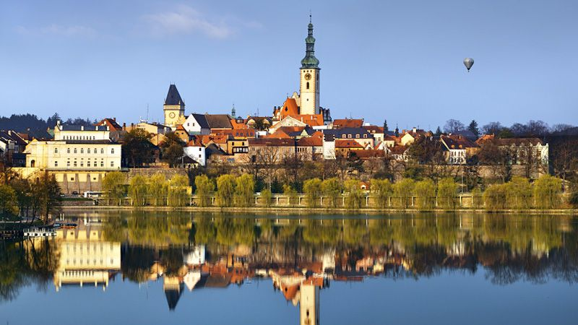
How to attract Chinese tourists to Tabor

Main informations about Chinese tourists
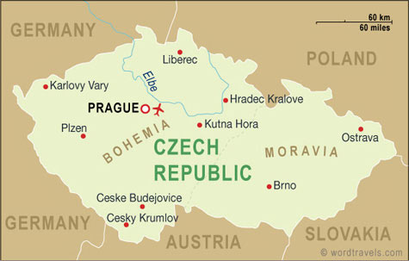
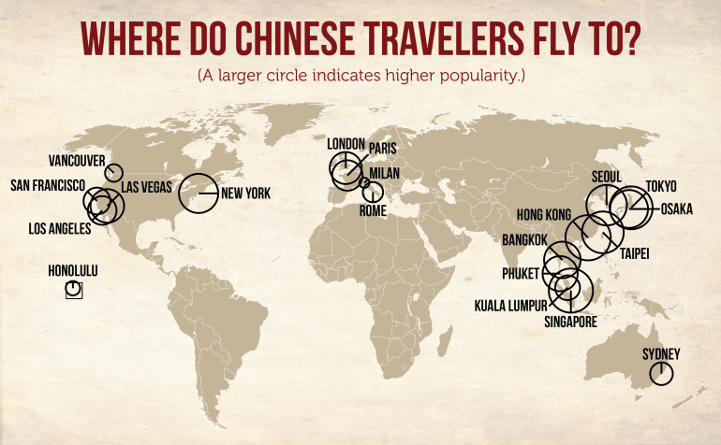
The Chinese are the sixth strongest group of foreign visitors to the Czech Republic and their numbers are growing the most quickly of all. Last year, a total of 285,404 Chinese tourists arrived in the Czech Republic, which was 35 percent more than in 2014. Upswing in the position of the middle class that can afford to travel more is behind the Chinese tourism boom. The Chinese arrive for a relatively short time. Last year they stayed for an average 2.7 days, compared to 5.9 days
They travel everywhere around the world, but in the last couple of years the Czech Republic is more and more popular.

Most people visit Tabor because it's one of the most popular destinations in South Bohemia. But you shouldn't go to Tabor simply because everyone else goes. Here are some real reasons to visit Tabor.

1. Tabor Attractions
Tabor has so many attractions you can return to the Czech Republic, the big town of South Bohemia. Many tourists come here to visit the Old Town and the New Town.

2. Tabor Events

Tábor is a perfect location for period festivals. The historic centre with several squares, crooked lanes and large green areas behind the town walls return back to the first half of the 15th century, to the time when the town was controlled by the Hussite captain Jan Žižka of Trocnov. And again, today, nearly six hundred years later, this famous warrior symbolically takes over the control of the town for the three days. He is accompanied by noisy drummers and a faithful crowd of Hussite warriors carrying lighted torches during his parade through the town. After the festive opening, which includes a fireworks display, it is up to each visitor what they choose both to eat and do.

3. Public Transportation in Tabor
Most of Tabor's sights can be reached on foot, but if hoofing it doesn't appeal, or if the weather isn't cooperating. Most attractions are only a few minutes away.

4. Nightlife in Tabor
Tabor has a lively nightlife. In Tabor are many clubs, e.g: Apollo, Kotnov, and - all serving famous (and cheap) Czech beer mean that, after shops and museums close, you will still have plenty to do. Party all night if you choose.

5. Tabor Shopping
Looking for designer clothes or unique jewelry? How about seasonal ornaments and decorations? Souvenirs, all-natural soaps, puppets, glass, or antiques? You can easily double your luggage when you visit Tabor, so pack light or bring an extra bag. Finding souvenirs of your stay won't be a problem.

6. Tábor Music
If you're looking for live classical music, Tábor's churches and palaces offer evening concerts throughout the week and on the weekends. Jazz or other live music can also be easily found. During one of the city's music festivals, its shedule is packed with performances, so check what's on in Tábor before you go.

7. Day Trips from Tábor
If you want to get out of the city, take a day trip to one of the many locations that are easily accessible by train in a few hours. Castles, spas, and medieval towns are all potential day trips and will add another dimension to your trip to the capital.

8. Czech Beer and Spirits
Czech beer, including but not limited to pilsner, can be enjoyed for less than a bottle of water in Tábor. Other spirits, like absinthe and plum brandy, are also on menus in Tábor - try them all to determine which is your favourite.

9. Cost of Tábor Travel
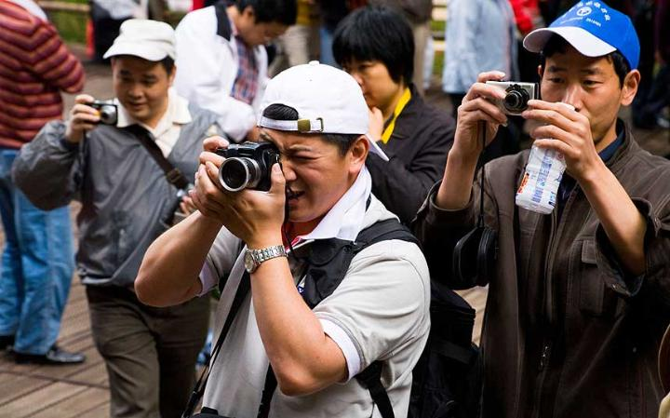
Though a ticket to Tábor from the States might seem steep, the actual cost of your visit can be managable. Though more expensive than other Eastern European destinations, Tábor has plenty of free things to do, and many other attractions are still less expensive than they would be in Western European countries.

Resources:
Picture 1: http://chairmanmigo.com/wp-content/uploads/2014/07/chinese-tourist-travel-map.png
Picture 2: http://www.wordtravels.com/images/map/Czech_Republic_map.jpg
Picture 3: http://www.etbtravelnews.com/wp-content/uploads/2015/07/20150721_C4312_PHOTO_EN_449583.jpg
Picture 4: http://images.says.com/uploads/story_source/source_image/467938/a34e.jpg
Picture 5: http://l7.alamy.com/zooms/df678a989fe342e2bb932a0d06710da0/czech-president-milos-zeman-right-took-leave-of-his-chinese-counterpart-ftywwc.jpg
Picture 6: http://b-i.forbesimg.com/kenrapoza/files/2013/07/2323.jpg
Picture 7: http://files.apartmany-u-kocek.webnode.cz/200000082-14c0815ba0/t-tabor-1.jpg

