Teaching math with GeoGebra

- Preparation
Open the GeoGebra program by clicking on the icon on the desktop or work online by accessing the address web.geogebra.org/algebra

The menu of the page contains several buttons that open sub-menus that can be explored. We are going to use the first six.

- A triangle’s center of mass

Here are the steps to follow
- create an arbitrary triangle ABC
- find the midpoints of each side and connect them to the opposite vertex, constructing the medians [BD], [AE], [CF].
- mark the intersection point of two of the medians by G and perform “the dragging test” to prove that the third median contains point G.
- measure the distances AG, GE, BG, GD, CG, GF and, in the “Input” area, define the ratios AG/GE, BG/GD and CG/GF, noticing that all three of these ratios will always have the value 2, even if we modify the size or the shape of the triangle.

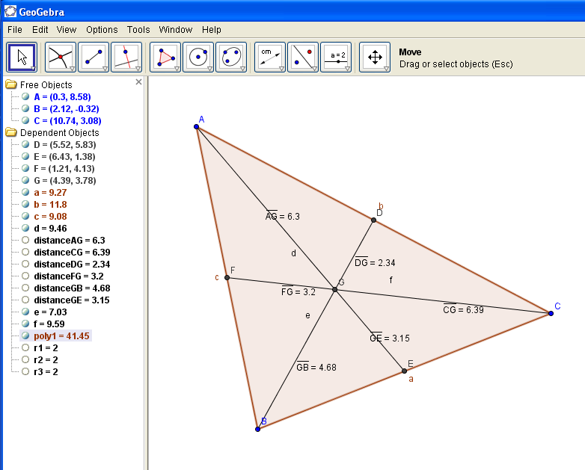

3. The circumscribed circle of a triangle

The steps in doing that will be:
- create an arbitrary triangle ABC
- construct the perpendicular bisector for two of its sides and name their intersection point O
- construct the perpendicular bisector of the third side and notice that this one contains point O, regardless of the size or the type of the triangle ABC. For this, click the “move” button, select one of the vertices and drag it on the screen, changing the shape and the size of the triangle. The perpendicular bisectors will change their position with the sides, without changing the fact that O belongs to all three of them.
- Construct the circle with center O through vertex A and notice that the circle contains also vertices B and C. Perform the “dragging test” to verify that this will happen regardless of the size or shape of the triangle.

When the drawing is complete, we can study what happens if the triangle is right-angled or obtuse-angled, by dragging a vertex and noticing the position of the circumcenter.
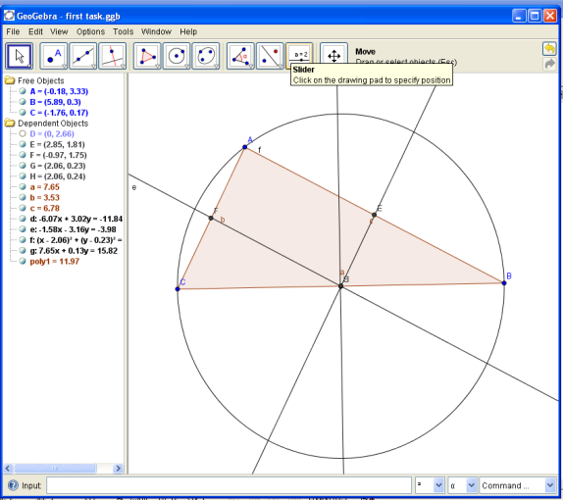

The same steps can be followed for constructing the incenter of the triangle, but replacing perpendicular bisectors of the sides with angle bisectors.

4. Drawing a parallelogram with GeoGebra

The definition of a parallelogram states that its opposite sides are parallel. So we need to draw two pair of parallel lines using the fourth button sub-menu and the second option.
We need then to plot the intersections of the un-parallel lines, to draw the polygon (fifth button) with the respective vertex and to hide the initial lines in order to see only the parallelograme.
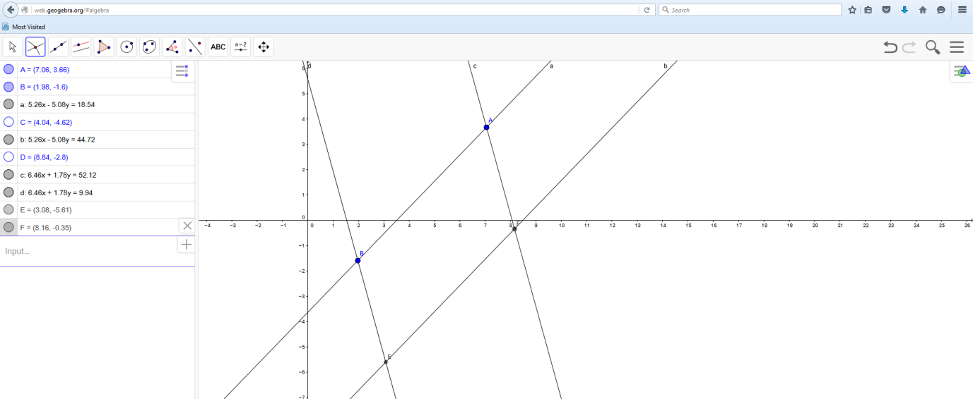

We can even “hide” the axes if unnecessary:
We can perform the “drag” test again to verify that the parallelogram remains a parallelograme even if we move one of its vertex and study its properties regarding sides’ length, angles’ measure and diagonals.

Solving equations systems with GeoGebra

Write the equations in the input space and hit “Enter”. The graphs will be traced.

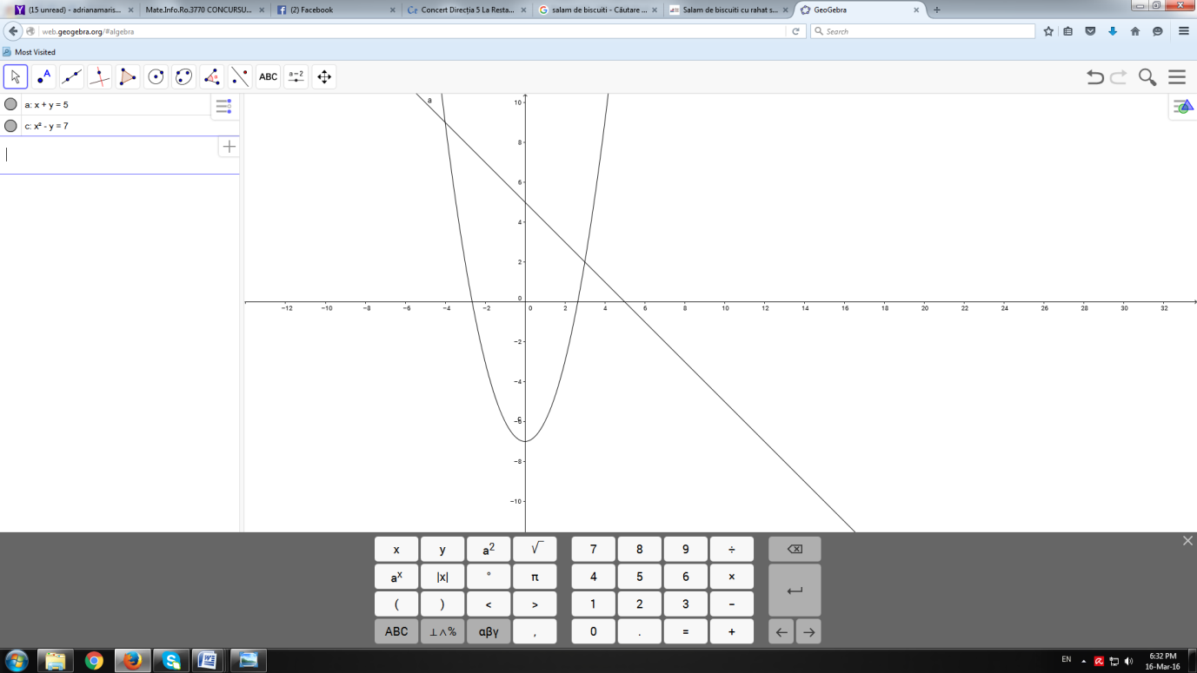

Intersect the two objects using the second menu, fourth icon, and you have the coordinates of the intersecting points as solutions of the equations system.

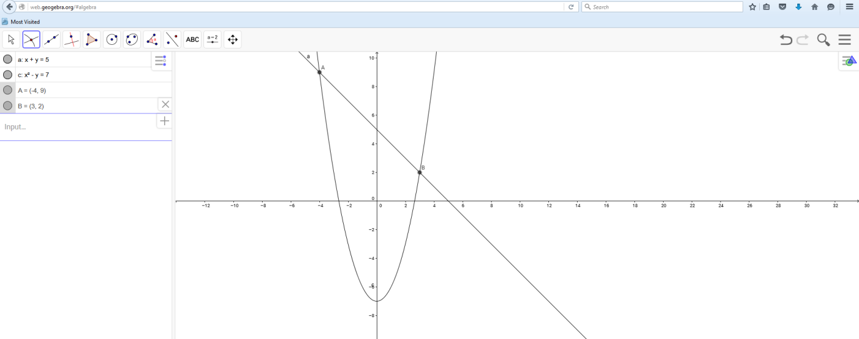

Observation: Using GeoGebra to solve equations systems will not provide exact un-integer or irrational solutions, but approximate ones.

