How to attract Chinese tourists to Tábor, South Bohemia

The number of Chinese tourists are growing increasingly in Czech Republic. But the hotels are not prepared for them at all. Last year, a total of 285,404 Chinese tourists arrived in the Czech Republic, which was 35 percent more than in 2014. More Chinese tourists are visiting the Czech Republic than the Japanese. They often have a large families and social circles so they are travelling together. The travel arrangement packaged tour or independent tour chosen by visitors depends on their experiences. Tourists tend to choose packaged tours and focus on sightseeing with little attempt to explore local culture and lifestyle more in-depth. Last year Chinese tourists spent a whopping 165 billion dollars on their holiday trips abroad. When they travel abroad they want to bring home many souvenirs for relatives and friends. They like to find big shopping center, where they can find everything in the same place. They always travel by packaged tours, because they can not speak too many languages. This is the reason, why they travel in a groups. Chinese tourists choose the most popular destinations, where they can see a lot of sights and they can take many photos. In Czech Republic the capital city is Prague. Prague is the 14th largest city in European Union. Tourists have long enjoyed the city and surrounding area for its rich history, wonderful culture, breathtaking landscapes and cityscapes. Popular landmarks include the Old Town Square, St. Vitus Cathedral, the Astronomical Clock and the Prague Castle. In the shops we can find lot of kind marketing films about the popular destinations, so if they buy the DVD they can see the beautiful sights of the country.

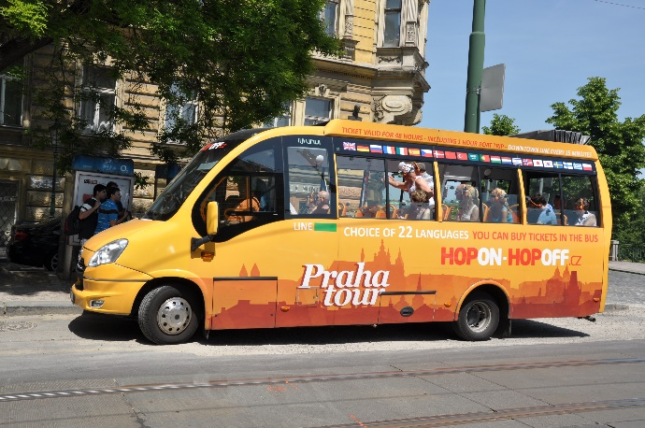

However, primarily hotel and restaurant owners in Prague and other Czech towns profit from the boom of Chinese tourists since they are not interested in landscape and wildlife, so should owners of restaurants and hotels in Tbor do. They should highlight the offered services in which chinese people are interested.
In reaction to the rising number of Chinese tourists, new direct flights from China to Prague were put into operation. However if there was an airport in the city of Tabor and it offered direct flights from China it would have been easier to attract chinese people offering whatever they are interested in.

MfD writes that not only investments in advertisements promoting the Czech Republic, but mainly a film helped attract tourists from Asia to this country, in particular a romantic comedy featuring popular Chinese actors that was premiered in 2014. About 100 million Chinese saw the film in a few weeks after the premiere in 2014 and they admired a romantic scenery with Prague Castle in the background, the presidential seat, on the screen. So another solution for attracting people in Tabor is havving a good commercial on social media and whz not on TV offering the tourists the dreamed of romantic adventures, good restaurants, modern shopping centres and high star hotels offering them the convenience thez are looking for.
Generally, Chinese visitors did not see enough Chinese language services while they
were travelling in Czech Republic. Hotel rooms without Chinese language programs or
subtitles, menus without pictures, and signage without Chinese translations all set
barriers for Chinese visitors to enjoy their stay in Czech Republic. So this is one more thing to think about and work on when attracting chinese tourists to Czech Republic.

