An afternoon in Esztergom
On Wednesday, 7th October, we started the day at school. We had some specimen English lessons, and after having lunch we walked to Esztergom. At first we had to go across the Maria Valeria Bridge, which connects Hungary and Slovakia. Esztergom is an old historical city in Hungary with beautiful buildings and squares. We were divided into two groups, and while one of the groups went to a museum, the other one had an hour to discover the city. Then our group went to the Danube Museum too. We saw pictures about the history of Hungary and the Danube and there was a huge map where we discovered our home town Pápa. We watched a silent movie about the regulation of the Danube. Then all the students and teachers walked to the Basilica. We took a group photo at the stairs of the building and went inside to look around. The church was beautiful with frescos and statues. We wanted to go to the dome of the Basilica so we climbed 510 stairs. The view was amazing: we saw the Danube, the bridge, the hills, Štúrovo and Esztergom. The Slovakian students showed us the whole region. It was an incredible feeling that we were on the top of the city. We took some photos again and went down to join the group and see the statue The crowning of St. Stephen. Some minutes later we started to walk back to Štúrovo. We were very tired because we had to walk during the afternoon but we enjoyed ourselves. We talked a lot and tried to teach our mother tongue to each other which wasn’t easy so we laughed a lot. After that we had a delicious dinner at El Camino restaurant and went back to our accommodation to relax.
All in all, I think it was a very good day because we saw a lot of interesting things and we had a great time.
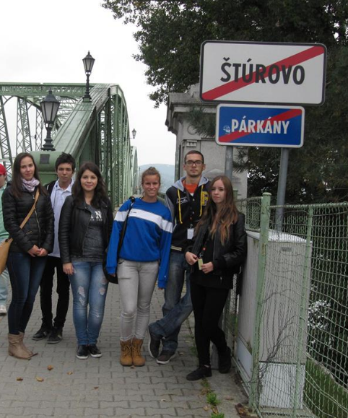
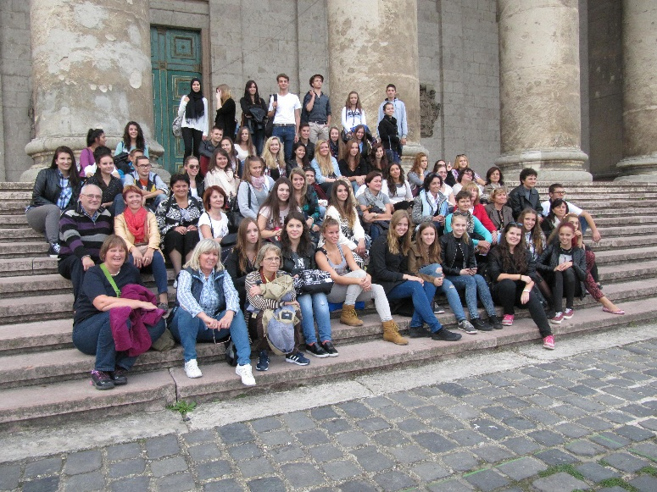
Magyar Anita 10. D (Pápa HU)

