Changes in the school system
The rapid changes and increased complexity of today’s world present new challenges and put new demands on our education system. There has been generally a growing awareness of the necessity to change and improve the preparation of students for productive functioning in the continually changing and highly demanding environment. In confronting this challenge it is necessary to consider the complexity of the education system itself and the multitude of problems that must be addressed.
Clearly, our school system needs a lot of improvements in order to satisfy every child′s needs and encourage them to do their best in school and become more devoted in learning.
In order to improve the quality of education and student′s results, several new methods should be used:
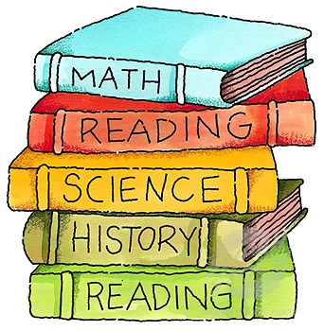
First of all, there should be more than one teacher in a class, because one teacher for 30 students is definitely not enough and maybe that′s the main reason why the majority of a class isn′t rising to the expectations.
Then, several tests should be taken,at least monthly, in order to watch the children′s process and also to be able to figure it out if their methods of teaching are the good one,and if not,they should be changing them constantly until they find the appropriate method, so that every child manages to handle their subject.
Also the tests can be used to measure every child′s capacity of learning,and after that, maybe they could gather them in groups of their intelligence.Then,more teachers will work with them and,this way,not only the good, promoting children will progress,but also the ones who have been left behind before.
Another way to improve the learning skills is that teachers find out what their students like to more and what they are interested more in,and after that they have to make the connections between the subject and the pupil′s interests.
For example if a kid is interested in biology more than in physics ,the teacher can show him physics in nature or maybe in the human body and there is a good chance for the student to get more interested in learning more.
Also,at school children should be asked what they what in the future from their early days and be permitted to choose the subjects they are interested in more and focus on that
Some other good methods children would agree with are shorter leassons and more practical ones,also funny and entertaining ways of teaching and learning,and,why not,even less days of school and more of reasting..
Tia, Adam, Raluca, Matej, Kate, Robi, Sandra

