Innovation Camp
Yellow Team

Introduction
The chinese economical situation is more and more better and then they travel all over the world, so they spend more money in different countries Chinese senior citizens are important to the tourist market because they are likely to have more free time, money and a desire to travel. The chinese people are into travelling in larger groups more than individually and they prefer to stay in 5- star hotel. They bring home many souvenirs for their friends and relatives, so they like collecting gifts, souvenirs. According the avarege South part is more interested than north in travelling because the economicaly situation is better.

Of the total number of Chinese outbound tourists 46 % are travelling for business. This type of traveler will care more about efficiency and the quality of business related services such as:
- high speed internet access
- 24 hour food delivery
- ticket booking services
They are seeking personal stimulation, entertainment and relaxation
Chinese prefere lesser-known destinations like middle european cities.
Leisure tourism makes up 31% of the total amount of outbound tourism from China.
Compared with business tourists, leisure tourists care more greatly about:
- Entertainment and recreational facilities
- TV programs being shown in Chinese
- Tour packages and knowledgeable guides.

Pluses and minuses
Minuses:
https://www.google.cz/search?q=translate&espv=2&biw=1920&bih=925&site=webhp&source=lnms&tbm=isch&sa=X&ved=0ahUKEwjzmbqIrtfPAhXLKcAKHUZUAr8Q_AUIBigB#tbm=isch&q=language+barrier&imgrc=9NwXSy5w89U_MM%3A
• They have no idea where Tábor is.
• That Tábor is half an hour far away from Prague.
• History of Tábor is unknown.
• Lack of shopping centres.
• The language barrier.
• People in Tábor are afraid of tourists.
• Tábor has small amount of commercials.
• Chinese people don´t want to travel to different cities.
• Lack of renting cars.
• Tábor doesn´t offer trips.
• Lack of souvenirs shop.

Plus:
• Tábor is not so expensive like Prague.
• Tábor is the second biggest town in South Bohemia.
• In Tábor are international restaurants.
• Museum of chocolate.
• A lot of festivals. (beer, wine, chocolate, Tábor meetings)
• Historical part of Tábor is in one place.

What should be done
Western shops-We should offer more westren shops with luxury items.
Accommodation-More chinese TV programs in czech hotels.
-More organized excursions for chinese people for not english speaking tourists.
-We should offer more Chinese restaurans, because they like their own traditional food.
-Tábor should be more advertised on the internet, because most of the chinese people have no idea that Tábor even exist.
-Make an app for mobile phones, which could show the most interesting places in the town.
-Organise a bus connection, which is going straight from Prague to Tábor.
-Organise cyclingtours in the nature. Give opportunity to rent a bike.

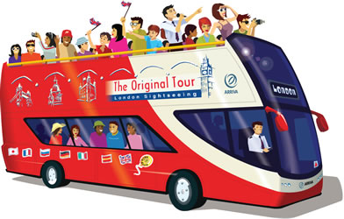
https://www.google.cz/search?q=translate&espv=2&biw=1920&bih=925&site=webhp&source=lnms&tbm=isch&sa=X&ved=0ahUKEwjzmbqIrtfPAhXLKcAKHUZUAr8Q_AUIBigB#tbm=isch&q=bus+tour&imgrc=oXeR32GlntfO2M%3A

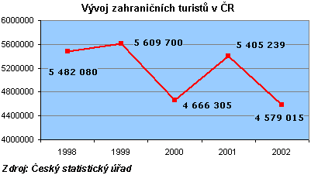

Links
http://marketingtochina.com/7-key-features-of-chinese-tourists/
https://skift.com/2013/12/23/5-habits-of-outbound-chinese-travelers-in-2014/

