Specimen lesson natural resources Austria
1 warmup (5 minutes)
What are natural resources and why are they important for a country?
How do you find natural resources?
What do you need to exploit natural resources?
What is the precondition for exploiting natural resources?
Which disadvantages might it have to exploit natural resources?
Does any of you come from a mining town?

2 Natural resources in Austria (Group Work) 5 minutes
If you have a look at the map, what resources do you discover?
Do you think Austria is rich in mineral resources?
What major industrial plants do you discover?
Why do you think so many coal mines have been closed down?
If you do not have resources in your own country, what can you do to provide them?

3) What can you do with the following resources, what do you need them for? Find out purposes for these materials! (Group Work) (15 Minutes)
SALT (Salzkammergut)
IRON ORE (Erzberg Steiermark)
MAGNESIT (Tauern)
CRUDE OIL (Alpenvorland, Marchland)
NATURAL GAS
LEAD (Carinthia)
COPPER (Tyrol)
GRAPHITE
GYPSUM
SAND ; GRAVEL
4) Energy in Austria
Hydro-electric power plants along the Danube
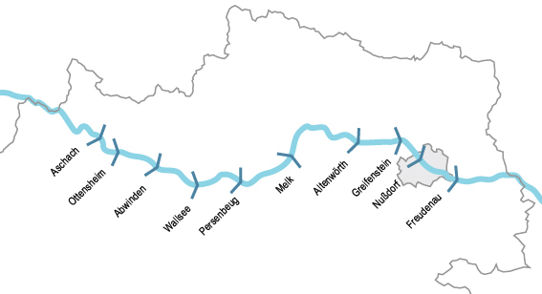

(find out where they are!!!!!)

Caloric power plants
(What are they needed for and how are they powered?)
Renewable sources of energy: photovoltaic power, wind power, geothermal energy, biomass
(Find out about the importance of these sources of energy)
5) Energy requirement for transport
What do you need for:
Road transport, rail transport, air transport, waterways

Attachment 1 hydro-electric powerplants alomng the Danube
- ► Kraftwerk Abwinden-Asten‎ (6 F)
- ► Kraftwerk Altenwörth‎ (3 F)
- ► Kraftwerk Aschach‎ (2 F)
- ► Kraftwerk Freudenau‎ (23 F)
- ► Kraftwerk Greifenstein‎ (1 C, 13 F)
- ► Kraftwerk Jochenstein‎ (2 C, 32 F)
- ► Kraftwerk Kachlet‎ (1 C, 19 F)
- ► Kraftwerk Melk‎ (3 F)
- ► Kraftwerk Ottensheim-Wilhering‎ (1 F)
- ► Kraftwerk Wallsee-Mitterkirchen‎ (1 F)
- ► Kraftwerk Ybbs-Persenbeug‎ (4 F)

