Bulgarian Christmas Traditions And Customs
The name ''Koleda '' represents the Bulgarian equivalent form of the Roman word Calenda. With the word "Calenda" Romans meant the first day of each month. Under the phonetic laws kalends in Bulgarian language became Christmas. The folk etymology made this become truth linking it with the verb "kill" because we kill the festive pig. The celebration begins at 24 and ends on December 26.
Christmas in Bulgaria
Christmas is very liked custom by Bulgarians, because we celebrate the birth of Jesus Christ. We celebrate Christmas on December 25. Bulgarian Christmas is full of customs and traditions that make this time of the year magical.
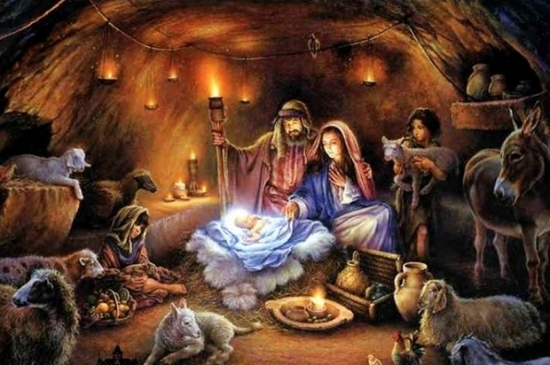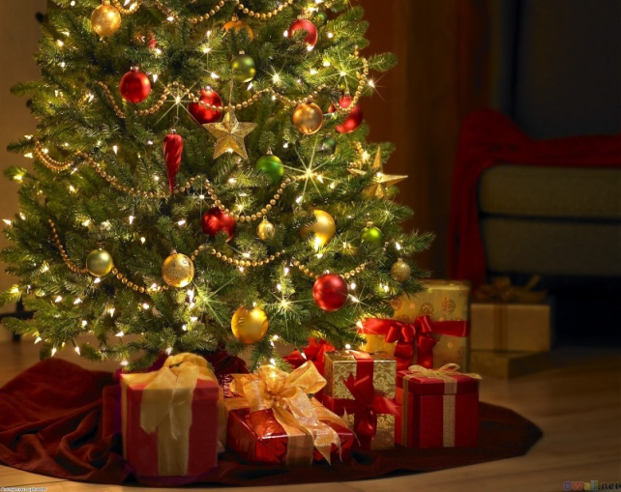

Christmas Eve
Christmas Eve or '' badni vecher '' is the last day of fasting for Advent and, like so many Slavic cultures, an odd number of meatless dishes are served at a grand meal. A budnik or ceremonial wood log is brought into the house and it burns all night long in the fireplace.
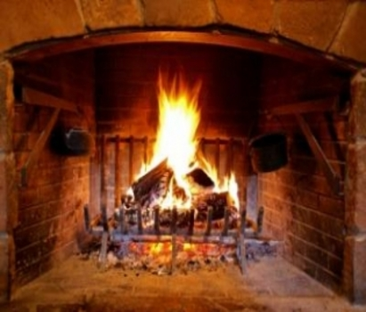
The meals
We prepare 7, 9, or 11 traditional Christmas meals . All of them are vegetarian as it is the last night of fasting. Usually we have cooked beans, a meal from rise and spices wrapped in cabbage, or vines leaves, different kinds of salads, cheese, and most important the Christmas “pita”, or banitza with a coin for luck in it. We often put more luck items in the banitza, so that most of the people can get their chance. . We have a special compote from boiled dried fruits. Also lots of nuts, pop corn and fresh fruit. As an alcoholic drink there is always on the table at least red wine. For a dessert we have fruits and a sweet pita called ''tikvenik''.

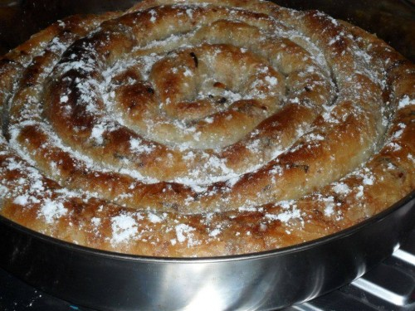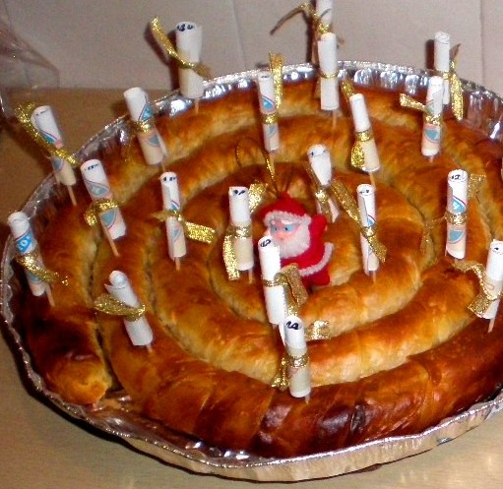

We have a special compote from boiled dried fruits /plumps, apples, pears and apricots with lemon and spices. And lots of nuts, pop corn and fresh fruit. We also drink airan – a drink from the real Bulgarian yoghurt mixed with water and a bit of salt. Adults drink red wine.For a dessert we have fruits and a kind of pastry soaked in a very sweet syrup.
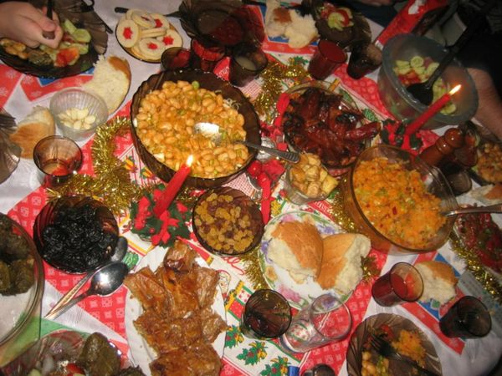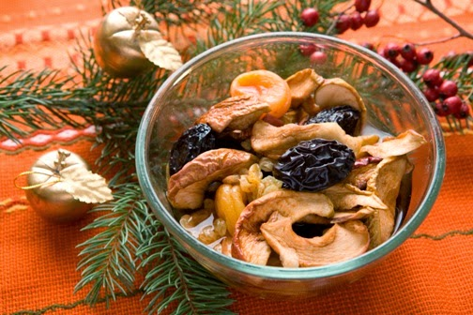

Traditions
We have a very special tradition in Bulgaria. It’s connected to the Winter belief that people should fight the evil forces of Nature like darknessThis ritual, called ''survakane'' is very important for the good health and overall prosperity of people. ''Survakane'' was traditionally performed by young boys and men.
At first a special tree branch is decorated with all kinds of coloured threads, dry fruits, peppers and popcorn. The youngest of the family takes the ''Survachka'', and beats with it at the backs of all family members, reciting special verses with good wishes for health, wealth and fertility. Then they repeat the ritual with the live stock, the trees and plants, in the yard and go outside to meet other youngsters with Survachka. In groups they visit the neighbourhood and for each beating and good wishes, they get special treats and coins.

