Simon a Juda annual fair in Štúrovo
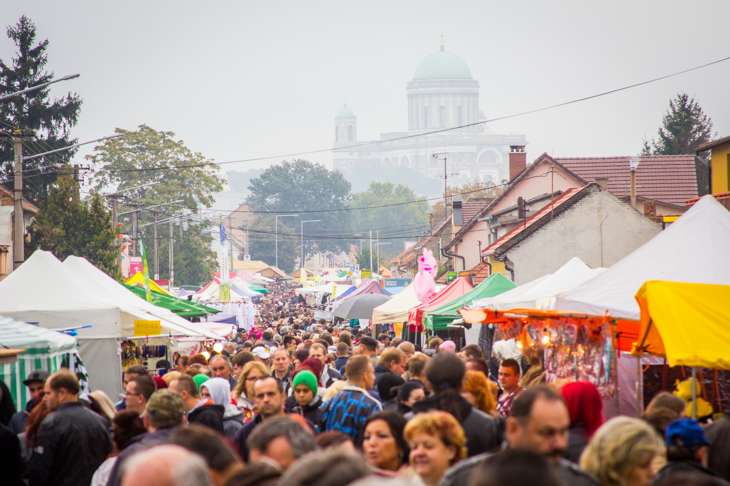 Nowadays the fair lasts for four days. In the past lasted 8-10 days. By the time the fair become one of the largest in the country.

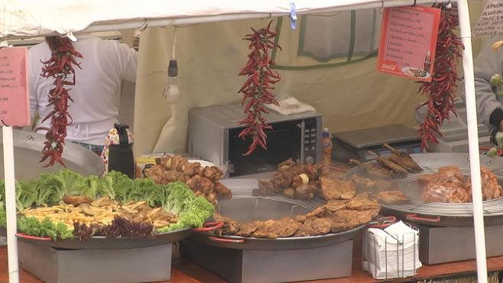
It has four main parts:
- Food part
- Crafted things
- Rollercoasters
- Sellers like a clothes

