„How to attract Chinese tourists to Tábor“

Basic characteristics
- 285.404 Chinese tourists arrived in 2015 to Czech Republic
- The Czech Republic visited 135.335 Chinese tourists in first half of the year 2016, in first half of year 2014 it was 81.469
- Behaviour
- Polite, corious, they want to learn something about our history, sometimes they are a little bit noisy
- Travel habits
- Travel in groups, but also individualy
- They like some historical places, architecture
- The most visited city by Chinese tourists is Prague (Pražský hrad, Orloj, Karlův most)
- Places where they go in South Bohemia:
- Český Krumlov, Tábor, Hluboká nad Vltavou, Červená Lhota, Jindřochův Hradec, Lipno, Holašovice, National park Šumava
Places where can they go near Tábor:
The old town of Tábor (Dean church, Statue of Jan Žižka, Town walls, Museum of Hussites, Tábor´s meeting, Bechyně gate)
- Chýnov cave
- Klokoty
- Bechyně
Language skills:
- English and Chinese, not Czech language
Shopping behaviour:
- They buy a lot of souvenirs and typical czech products
- They visit Pařížská street in Prague, because there are cheaper labels than in other countries
- Chinese tourists want three stars hotels and they also prefer chinese typical food
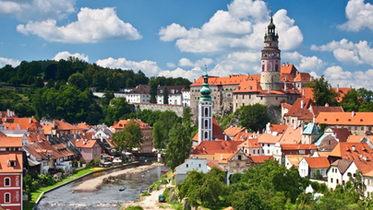
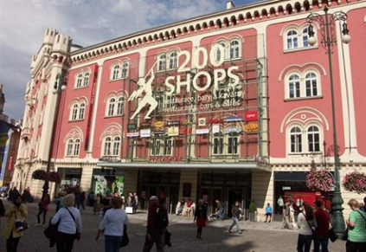
- They visit big shopping malls, for example Palladium, Arkády, Kotva and Chodov in Prague
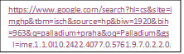
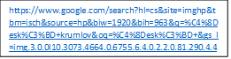

Flight opportunities:
There are many options to fly between China and Czech Republic. We can choose between many airlines. Here you can see some of them:
- Aeroflot
- Hainan Airlines
- China Eastern
- British Airways
https://upload.wikimedia.org/wikipedia/en/thumb/4/42/British_Airways_Logo.svg/1280px-British_Airways_Logo.svg.png
- Lufthansa

The main problem is that there is no direct flight between the two country. There are flights with only one change, these are usually cheaper, then flights where are more then one changes between planes during the trip.
If Chinese people decide to fly here, the flight will last minimum 13 hours, but it can take even 2 days, if they fly with more connections. These flights may cost from 13 000 CZK/person (480 euro) to even more than 30 000 CZK/person (1 100 euro).
There is another option, to fly a nearer country, like Austria or Germany, and then travel by train or rent a bus to Czech Republic.
One of the best flight is with Aeroflot, travelling from Shanghai to Moscow, then from Moscow to Praha. This is one of the cheapest ways. It costs about 13 500 CZK/person (500 euro). This flight takes about 13-14 hours, if the time between changes is not that much, sometimes it can take many hours.
Here are some links from the internet from where you can find and book the tickets you need: www.esky.cz, www.britishairways.com, www.swiss.com, www.austrian.com
If someone is travelling to a city nearer to the Austrian border, and not going to Praha, there is another alternate. They can choose Austrian airlines, travel from Shanghai to Wien, it is cheaper, because it is a direct flight. The ticket/person is about 9 000 – 10 000 CZK (350-400 euro). Then they can continue their trip by train, or bus, if they are travelling with a bigger group.
Ideas to solve the problem:
Accommodations are much cheaper then in Prague, the same goes for resturants, the city could offer other Chinese tourist agencies a cheaper ticket for public transport. Resturants could offer that if you come with 8+ people you all get a free drink, the city could make a deal with a Czech railways and other transport companies for a cheaper ticket to city like Prague, Plzen, Budzevice,…
Shops could start that if you buy more than 100 euros at once with your friends you get a shop discount or a free item of choose that the shop would offer.
The restaurants could offer discounts on traditional dishes so they encourage tourists to try their cuisine.
Information centers could offer tours with a chinese speaking guide, children would get the tour for free and maybe they could offer a diffrent kind of tour for children something fun and interesting for kids.
They could also offer a tour of the city with a boat.

