ADVERTISING AND MARKETING
1 Do you recognize these slogans? What brand do they represent? What is their typical product? Can you think of some other slogans that got stuck in your mind?
”Keep walking”
”Life’s Good”
”Just do it”
”I’m lovin’ it!”
”Connecting People”
”Simply clever”

2 Listen to the following text about advertising. Fill in the gaps with the words you hear.
What is advertising? Is it ____________ truth or is it making things look better than they really are? ____________ lying? Companies pay a lot of money for adverts. Some of the ads you see ____________ magazines look like art. The commercials on TV look like mini movies. Do they really change our ____________ ? Do adverts make you buy things? I think some advertising is a form of lying. Is BMW really “The ____________ driving ____________ ” like they say in their ads? British Airways used to say they were “The world’s ____________ airline,” but had to stop saying it because it wasn’t true. Personally, I get ____________ watching ads on television. They always ____________ a good programme. I like ads in magazines. They’re usually ____________ interesting.
From:http://www.listenAminute.com/a/advertising.html

3 Match the words below with their meaning.

- artwork A) a little drawing that represents the company

- body copy B) a word or short sentence that gives the main
of the advert

- slogan C) a photo or drawing

- logo D) words that are in smaller letter that give more
information about what is being advertised

- headline E) a short phrase that is easy to remember and
represents the company e.g. “Just do it”

4 Look at the advertisement below and label the diagram using the vocabulary from exercise 3 .

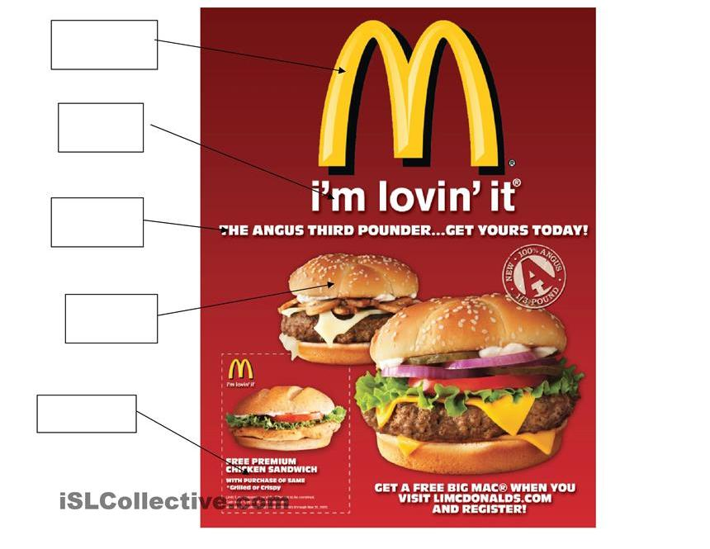

5 Use the words to fill in the gaps.

animals exaggerate get attention sexy commercial special offers
customers slogans prime babies celebrities catchy tune peak

- If you want to approach potential__________________ you have to _______ their _______________ first.
- ______________ are often used in advertising. Such as “Think different” in APPLE adverts.
- ________ time and _________ time are the times when most people watch TV.
- To persuade the customers about the quality of their product, they often ___________________.
- Famous brands often use _________________ in their adverts as they can afford to pay them.
- Often young and __________ people, cute______________ and adorable _________________ are used in adverts.
- Many people really hate _________________ breaks on TV and they gladly change the channel.
- It is not only about visual effects; sometimes people just sing the ___________________.
- Often they try to get the interest of potential customers by _________________________.

6 Discuss the following questions in pairs/groups. Take notes so that you are able to summarize your ideas.

How many adverts do you see every day?
Do you remember at least one advert from yesterday? Give details.
Do you enjoy watching adverts on TV or the Internet, seeing them in papers or listening to them on the radio?
How do you react to advertisements?
Do you think ads should be banned from some places or kind of media?
What makes an advertisement memorable?
Can you think of an advert that actually made you go to the shop and buy the advertised product?

__________________________________________________________________________________________________________________________________________________________________________________________________________________________________________________________________________________________________________________________________________________________________________________________________________________________________________________________________________________________________________________________________________________________________________________________________________________________
_____________________________________________________________________________________________________________________________________

7 Read the following opinion about marketing. Fill in the gaps with the phrases below. Then listen and check.
- also hate viral d) my blood boil g) of a great idea
- is a funny thing e) definitely an art h) of a genius
- make me angry f) are just untrue

Marketing (1) _____________________. Sometimes I like it, other times I hate it. There is (2)___________________________to marketing. Some of the advertising campaigns you see are the work (3)_______________________. Someone has thought (4)_______________________, slogan and advertising campaign to sell us or tell us something. I like it when I can see the creativity. There are other kinds of marketing that (5)___________________________. Ads and campaigns that are directed at children make (6)___________________________ – especially the McDonalds ads that do not mention food, but show lots of free, cheap toys.
I (7)___________________________ marketing – that’s when you receive spam mail trying to sell you something. I also get annoyed with marketing campaigns that have slogans that (8)_______________________, like smoking is cool.

From: http://www.listenAminute.com/m/marketing.html
8 Make your own advert. Work in pairs/groups.

Think of your favourite product or service and prepare an advertisement. Think about the effects, the target group and try to make your product or service the number one on the current market. Invent a brand name, logo and slogan.

