How to improve school system?

- How would you improve the quality of education?
- School system changes.
- Decrease the drop out rate.
Shorter lessons (1,2)
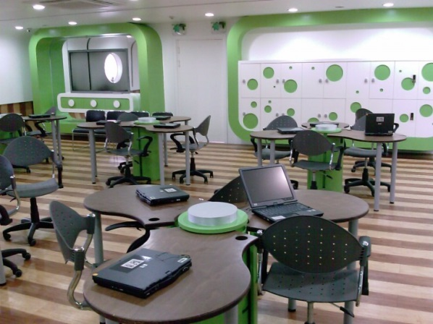
- So we can concentrate more on the subject
- 35 min lessons
Interactive lessons (1,2,3)
- Teachers should speak more with pupils
- Using modern websites to make the lesson more fun
Cancel the useless things in subject (2)
- Canceling the lyrics of the poems
- Memorizing useless texts
Coffee breaks
- 10 minutes
Schsool starts at 9 and ends at 13 (2)
- Students wouldn’t be that tired
- More freetime
Teaching kids how to learn (3)
- Memorizing techniques
- quizzes
Coop. learning (1,3)
- working in groups
- doing presentations together
Train logical thinking (1,2,3)
- by training our logical thinking, we develop our thinking outside the box
- helps us in real life struggles
Block system (2)
- Less types of lessons in one schoolday
Extra money for the teachers for private lessons (1,3)
- Job as a teacher is important in a country, because
they educate the new generation, therefore
they should be paid more
- In private lessons teachers have more time
to explain your things better
Have more lessons in which you
are interested (1,2,3)
- If we are interested in maths and informatics,
we should have more of these lessons
More organized scholarship system (2)
- Money motivates us to learn
- Grade average over 4.6(Slovenia) – you can get bonus money

