HOW TO ACTTRACT CHINESE TOURISTS TO TÁBOR, SOUTH BOHEMIA

Czech Expecting Over 350,000 Chinese Tourists in 2016
-This is a significant increase on last year’s numbers, that were estimated at 285,000.
-The increase is largely thanks to the introduction of a daily flight from Prague to Beijing.
-Further flights are planned between Prague and other Chinese cities.
-The number of Chinese tourists to the country has more than doubled over a three year period.

-Chinese tourists can be seemed as good people, nice tourists but some of them can be pushy, loud, impolite, unruly and they are everywhere, some of them can even spit on the streets and shouting to get the waiter's attention in a crowded restaurant.
-Like for real, if you are in Prague there is not a single sight without any Chinese tourist. Not every Chinese tourist is a rude one, and if they are well educated they usually behave better than those who have had a lower standard of education.

Where Chinese travel in the Czech republic
-The most visited town in the Czech republic by Chinese is Prague.
-Nevertheless the number of tourists visiting the UNESCO-listed Cesky Krumlov, south Bohemia, and other towns, such as Olomouc, north Moravia.
-Apart from foreigners, more and more Czechs prefer spending their summer holiday at home and many seek stays in spa towns, such as Karlovy Vary and Marianske Lazne, west Bohemia. Domestic clients help compensate the stagnating or declining number of foreign visitors to Czech.
-The Chinese are the sixth strongest group of foreign visitors to the Czech Republic and their numbers are growing the most quickly of all, but hotels are not prepared for them from the linguistic and other points of view.

Intruduction
-Chinese outbound travelers continue to be the main driving force for the growth of international tourism, but the concentration of visitors in a limited number of place is increasingly creating a number of problems.
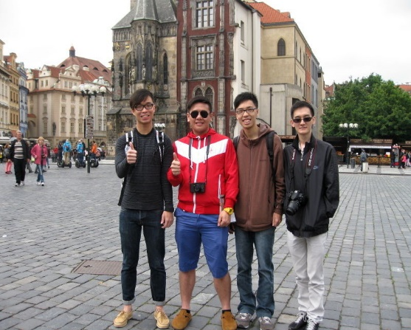
-The Telegraph reported that the Chinese are often avid consumers spending on average nearly 650 pounds (1000 dolars) on foreign high streets.

Chinese expect
-high-speed internet
-24 hour food delivery
-ticket booking services
-entertainment and recreational facilities
-tv programs being shown in Chinese
-tour packages and knowledgeable guides
-Non-smoker hotels must display "No Smoking" inscriptions in Chinese because about 70 percent of Chinese smoke

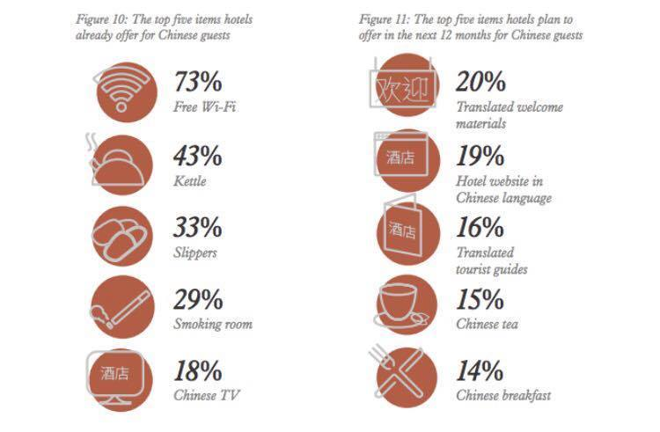
How Chinese tourist travel
-they travel in groups, because many of them don’t speak english
- they are used to do things in groups because of the communist systém
-70% of Chinese people travel throug agency organized groups.
-They travel only for 1 or 2 days to one country and then they travel to another

What social media to include?
-internet
China had 564 million Internet users, 50.9 million more than the year before, and representing nearly 40% of the Chinese population
-The Chinese have created their own networks, just like facebook, Myspace, Youtube and foursquare – but with more users.

The most popular social media sites:
Twitter - it’s used by more than 22% of the Chinese Internet population of almost 540 million people.
Sina Weibo- is actually much more than just that – it has over twice as many users as Twitter.
Tencent Weibo- is just like Twitter’s “retweeting”. It has about 200-250 million users.
Renren- it’s essentially China’s Facebook. It has about 150 million users.

Our country and Tábor is not for everyone, therefore our target group is mostly chinese people around the age of 0-99. Children can play alone on playfields while their parents are taking pictures of sigths and walking around our town. Terrain in Tábor is quite demanding but every old tourist can make that. Tábor is very flexible town with many possibilities and opportunities to do.

