Christmas traditions in Bulgaria

Christmas Eve
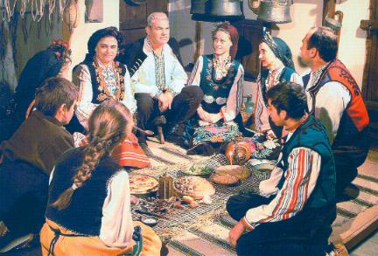
The family feast of the year is Christmas. On Christmas the whole family remains at home, celebrating. On great holidays as Christmas and Easter, most families like to go to church to watch the ceremony, which is very solemn and beautiful and the chorus is so wonderful. At home the whole family usually prepares all the traditional Bulgarian Christmas meals, which are the same for each family, but may differ in number. The meals should always be an odd number, and with no meat.

The meals
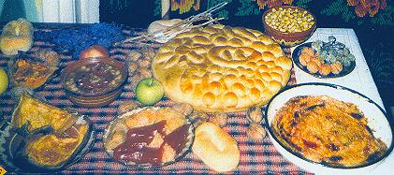
We prepare 7, 9, or 11 traditional Christmas meals. All of them are vegetarian as it is the last night of fasting. Normally we have cooked beans, a meal from rise and spices wrapped in cabbage, or vines leaves, different kinds of salads, cheese, and most important the Christmas “pita”, or banitza with a coin for luck in it. We often put more luck items in the banitza, so that most of the people can get their chance. We write little notes with good wishes which, wrapped in aluminium foil we put in the pita, or banitza before baking. We have a special compote from boiled dried fruits /plumps, apples, pears and apricots with lemon and spices/. And lots of nuts, pop corn and fresh fruit. Adults drink red wine. For a dessert we have fruits and a kind of pastry soaked in a very sweet syrup.
Traditions
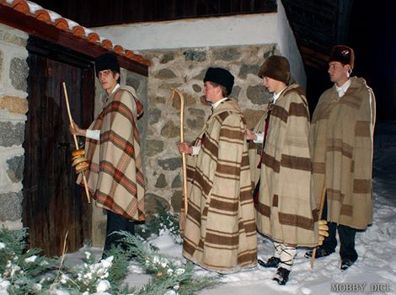
We have a very special tradition in Bulgaria, which comes from ancient times /before Christ/. It’s connected to the Winter solstice and the belief that people should fight the evil forces of Nature /darkness, cold, frost, blizzards, drafts, infertility and all of the kind/. This ritual, called SURVAKANE is very important for the good health and overall prosperity of people and agriculture. SURVAKANE was traditionally performed by young boys and men, but nowadays it’s a privilege for all children.

At first a special tree branch is decorated with all kinds of coloured threads, dry fruits, peppers and popcorn. The youngest of the family takes the Survachka, and beats with it at the backs of all family members, reciting special verses with good wishes for health, wealth and fertility. Then they repeat the ritual with the live stock, the trees and plants, in the yard and go outside to meet other youngsters with Survachka. In groups they visit the neighbourhood and for each beating and good wishes, they get special treats and coins.

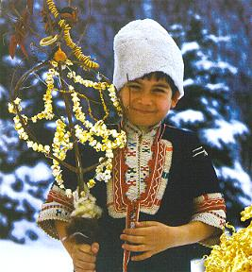
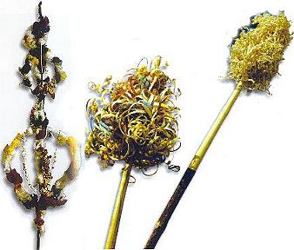
Written by Valentina Angelova and Elitsa Lalkova

