Traditions in Bulgaria on Christmas

Christmas in Bulgaria is one of the most cherished holidays in the year. It is the time when the whole family gathers together. The night before — Christmas Eve is also very important. It is the time when the whole family unites and prepares the holiday dinner.

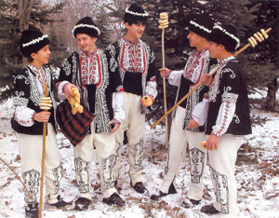
Traditions
It is interesting that during the evening a group of young boys or men called “Koledari” go from house to house and sing songs for health and good luck. The owners are supposed to give them money, fruits or some kind of bakery.
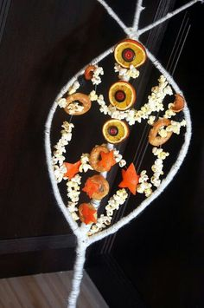

There is tradition called “Survakane”. Children make “Survachka” from special tree and decorate it with popcorns, peppers and dry fruits. With it children beats the back of a family member and wish health and wealth.

Another tradition requires that after dinner the table should stay untouched until the morning. It is said that the spirit of Jesus Christ will come and dine the dishes that are left

The meals
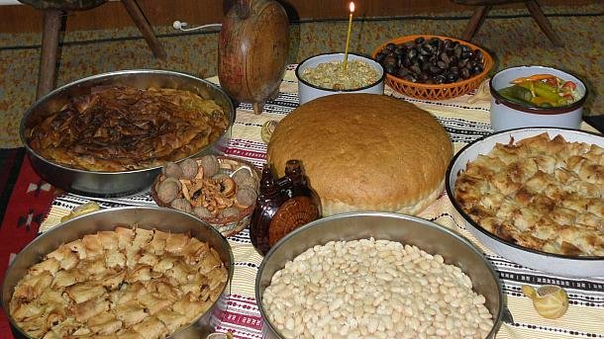
The tradition requires an odd number of different dishes to be served. Usually there are 7 ( days of the week) 9 (months that women are pregnant) or 12 (months of the year) meals but they have to be meatless. People can’t eat meat from 15th November to the Christmas Eve and this tradition should be respected by everyone.

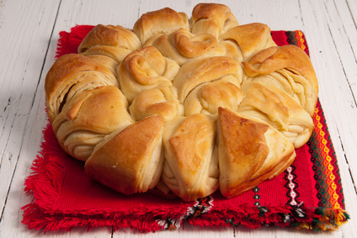
On the table must be served the traditional round and decorated ritual bread – “Pita” Some people put a coin in it when they baked it and the person who finds the coin is believed to have good fortune for the rest of the year.

We also served a dessert called “Banitsa”. People write little notes with good wishes, wrapped them and put in the “banitsa”.
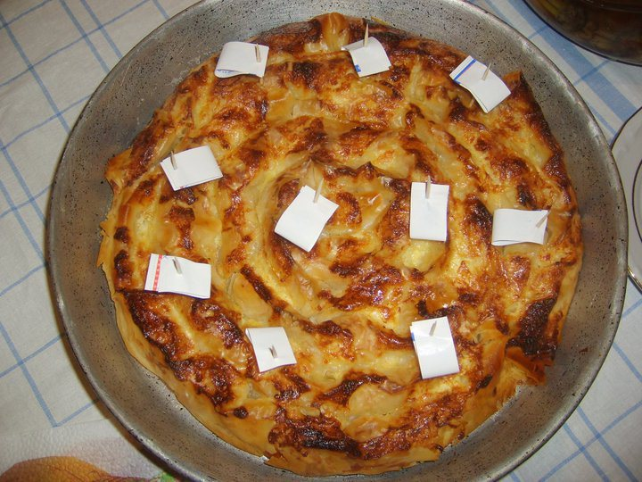

Written by: Simona Stoyanova

