Tests twice a year and without marks

- Less stress for the students
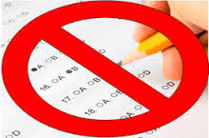
- Better results
- More free time
- Knowledge is not connected to the marks, so we shouldn't get marks anymore.
- We should have tests twice a year.
- We could remember more of it.
- No homework just work in school and exercises

Curriculum should be shorter and more simple

- We should choose what we want to study about, not the teachers.
- Every schoolday should start with a good P.E. lesson.
- We would be more fresh and active during the day.
- We should have longer breaks between the lessons, to have time for repeating.
- We should go on more excursions and study in place about geography for example.
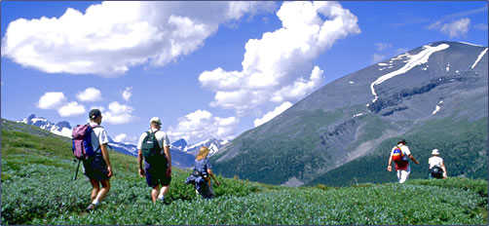

More interactive classes

- It is way more exciting to learn with tablets in the classrooms.
- We should watch more videos in connection with the subject.
- Everyone should have an own laptop in the classroom.
- We wouldn't need to write that much.
- Use your way to connect to teachers.
- Easier to make groupwork activities.
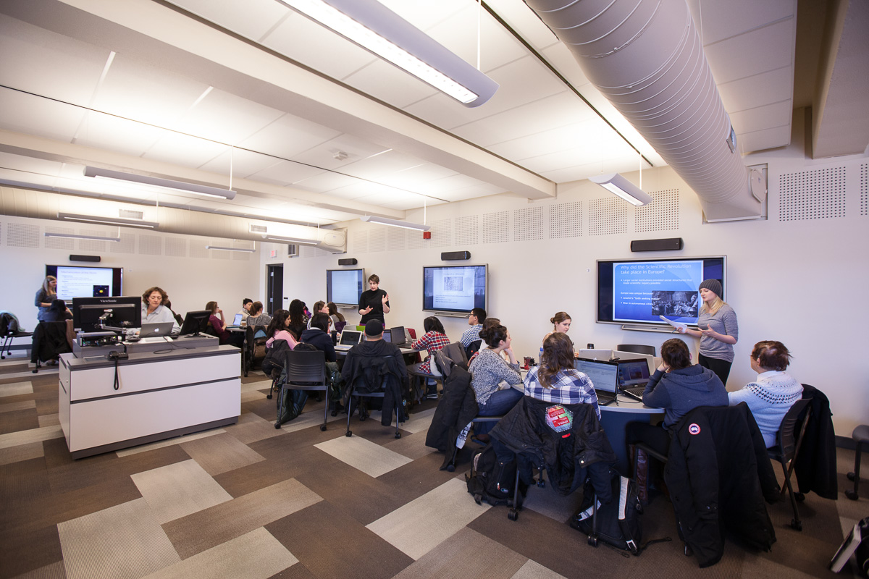

GREEN TEAM
Szimona – Hungary Madalina - Romania
Valentina – Bulgaria Vendula – Czech Republic
Sanel – Slovenia Daniel - Slovakia
Csaba - Slovakia

