ONLINE MEETING SUMMARY
Completing tasks and going on …
- Page “Our Project”

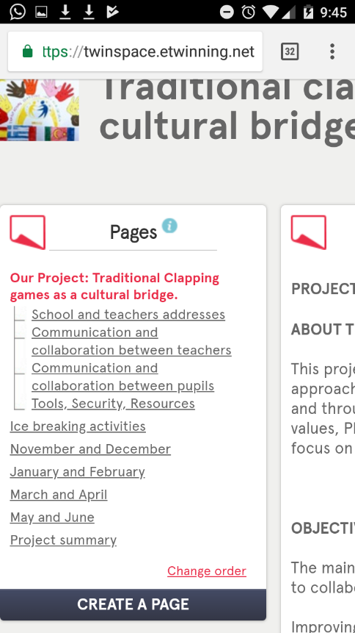
Turkish and French teams have to complete the subpage “tools, security, resources” only the part about network security. You can read what partners have written and write about what you do in your schools.

- “Ice breaking activities” Page
Turkish team has to send a letter or a postcard to partners. Add photos in “postcards” subpage.

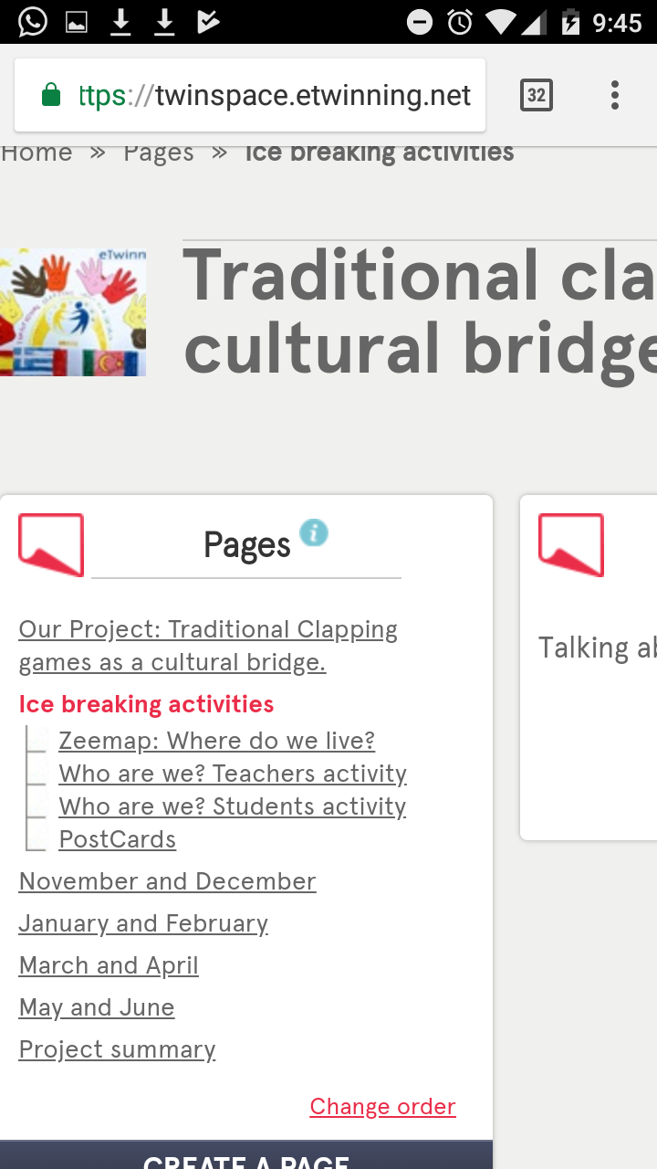

- FORUM
Greek, French and Turkish teams have to add a new thread. Your teams have to choose a name. It is a way pupils communicate with the members of his/her team. You can see how other partners did it. On the other hand, they have to answer partners threads. When all the members have written their suggestions, we, as coordinator, choose the most properly name.
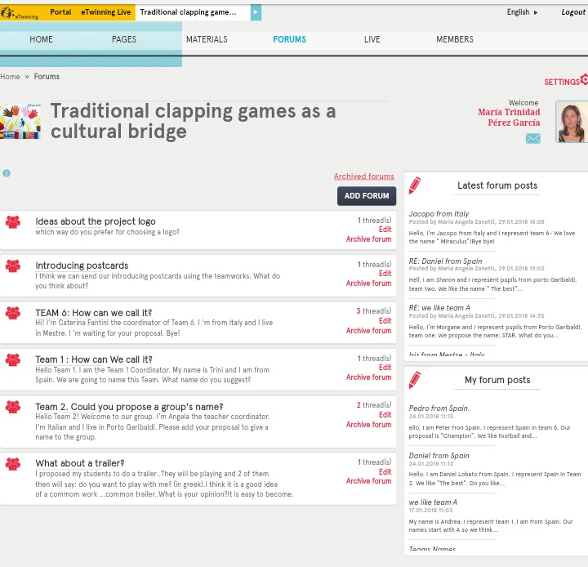

- “January February” Page
French and Turkish teams have to add a clapping game in their group. It is important you add the lyrics too. You can choose the same clapping we use in the trailer or you can add other. It is up to you.
When you have time you have to train and record partners clapping and add them in the group. This activity is very similar we did about dances last year.

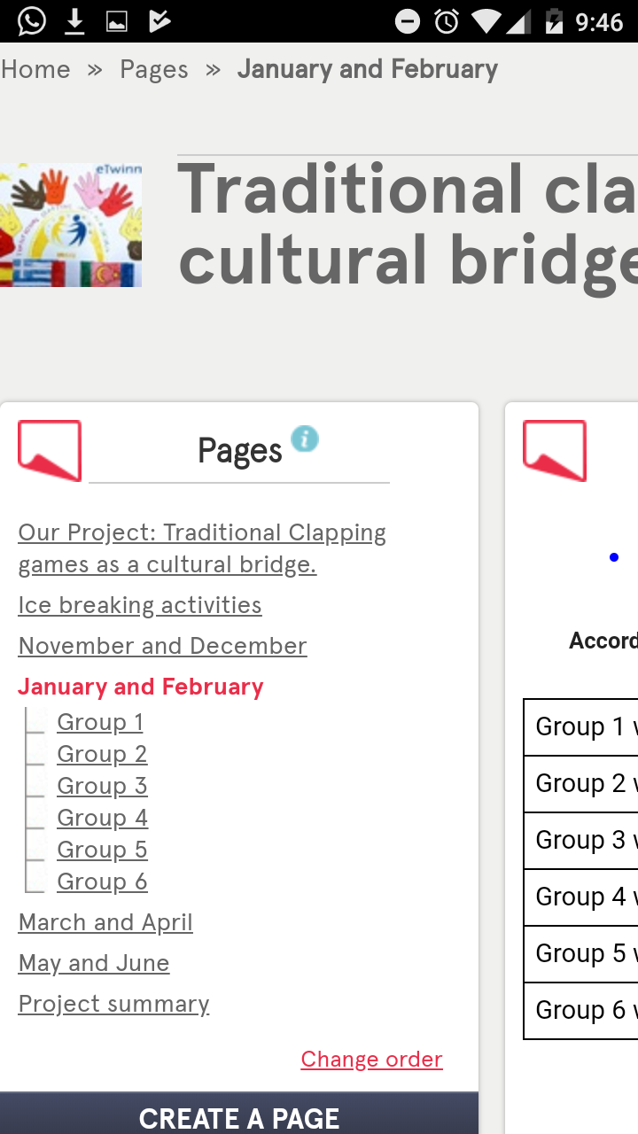

- March April
Coding clapping – creating a clapping game in teamworks using coding. Each subgroup create a movement and English lyrics for this movement. Alessandra will explain how to create a coding page.

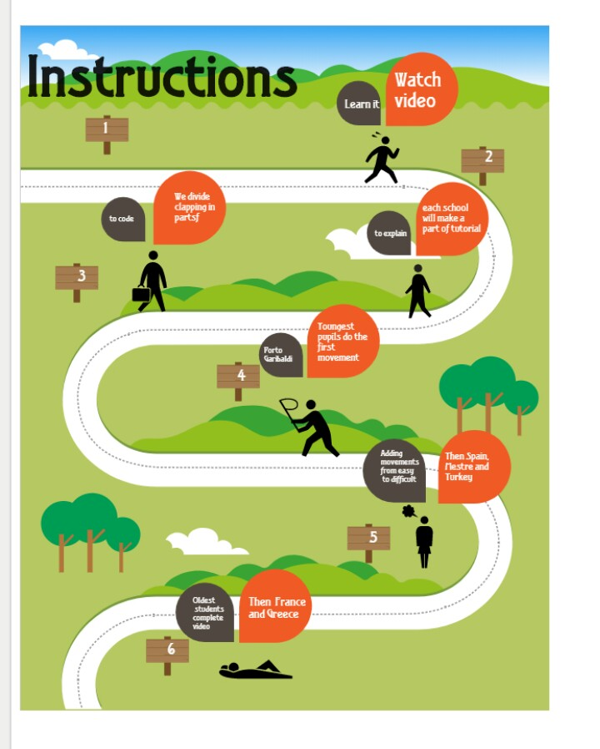

- eTwinnning award for cultural heritage
1st idea (Katerina Trini idea)
In our event, we told about choosing a famous artist from each country and one picture (with hands) by the same artist.
Pupils have to find out about the artist and record a video where they talk about him/her.
They draw the pictures too and then, we add a QR where people can watch their videos about the artist.
Example:
Can you see on the right? This is the QR code.
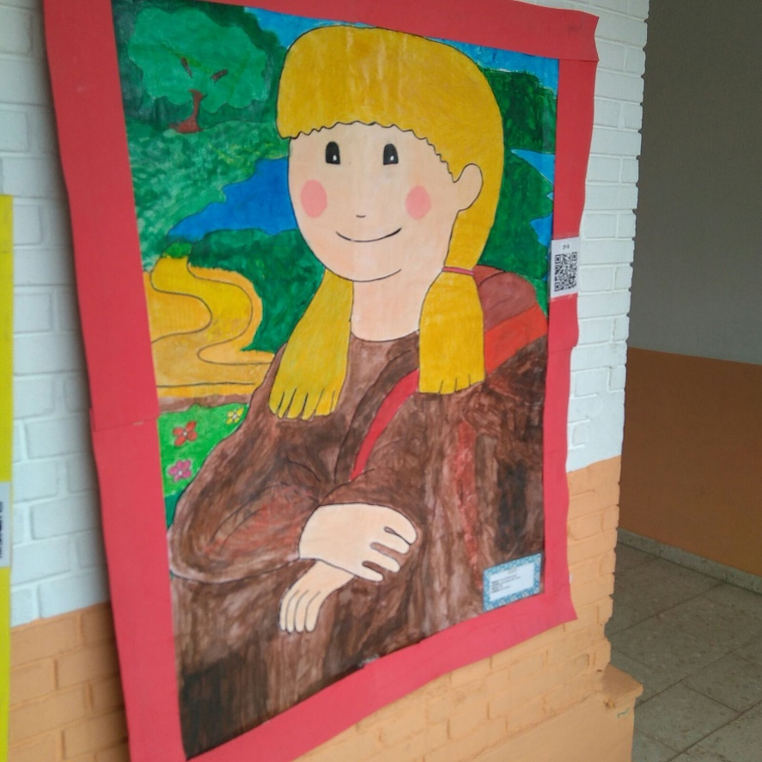

2nd Idea (Caterina idea)
In my opinion, this idea is more related to our Project and it is a way to involve parent and disseminate our past traditions.
Ask parents and or grandparents for coming to talk and play traditional clapping games they played when they were Young. Take photos, videos and include them in our ebook and our website.

Maybe we can leave art for next Project and do this 2nd activity as our final activity before dissemination. What do you think about?

ALL DATES ARE FLEXIBLE. DO NOT WORRY!!!
Thanks dear friends

