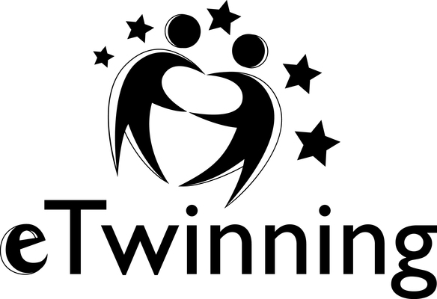
Name:
Class:

EU Games
TwinSpace activities for the eTwinning project – Session 1 – Monday 7 March 2016

- Log in to your TwinSpace with the help of the voucher given by your teacher.
- Click on the envelope below your name to check the messages in your TwinMail. Reply to them if necessary.
- Click on Forums, next on Task 1: Your profile and read the instructions to edit your profile and to leave messages on the members’ profiles in English and in French.
- Click on Forums and on Task 2: Word cloud logo. Follow the instructions.
- Click on Forums and on Task 3: Ice breaking activity. Post a message in English and French by respecting the assignment.

NB: When you post messages in French in reply to the Spanish pupils, correct their mistakes and try to help them improve their French.

Checklist – Session 1 – Monday 7 March 2016:

Tasks | Tick the box if you’ve successfully done the tasks. | Points given by your teacher:
I checked the messages in my TwinMail. I replied to them if necessary.
Task 1: I edited my profile in English and in French. |  | 2 1 0
Task 1: I left a message in English on the profile of a Polish pupil. | Indicate the name of the pupil: | 2 1 0
Task 1: I left a message in French on the profile of a Spanish pupil. | Indicate the name of the pupil: | 2 1 0
Task 2: I submitted words in English and French.
Task 3: I posted a message in English. |  | 2 1 0
Task 3: I posted a message in French. |  | 2 1 0
 | Total:

Don’t forget to logout from your TwinSpace!

Personal notes, comments, suggestions…

